University of Macau

Faculty of Science and Technology



Contour Tracing for Hole Detection in Wireless Sensor Networks

***by***

**MOK KUAI UN, Student No:DB625378**

Final Project Report submitted in partial fulfilment  
of the requirements of the Degree of   
Bachelor of Science in Computer Science

Project Supervisors

Prof. Yain Whar SI, Lawrence

Mr. Se-Hang Cheong, Eric

25 May 2020

**DECLARATION**

I sincerely declare that:

1. I and my teammates are the sole authors of this report,
2. All the information contained in this report is certain and correct to the best of my knowledge,
3. I declare that the thesis here submitted is original except for the source materials explicitly acknowledged and that this thesis or parts of this thesis have not been previously submitted for the same degree or for a different degree, and
4. I also acknowledge that I am aware of the Rules on Handling Student Academic Dishonesty and the Regulations of the Student Discipline of the University of Macau.

Signature : ________________

Name : MOK KUAI UN

Student No. : DB625378

Date : 25 May 2020

**ACKNOWLEDGEMENTS**

The author would like to express his utmost gratitude to UM for providing the opportunity to carry out a project as a partial fulfilment of the requirement for the degree of Bachelor of Science.

Throughout this project, the author was very fortunate to receive the guidance and encouragement from his supervisor.

# ABSTRACT

In our works, we proposed an approach of hole detection in sensor network by using image processing technique that is Contour Tracing Algorithm (CTA). We design a system of CTA includes sensor network pre-processing, perform CTA and output the result image that is number labelling, highlight, then the node identifies in holes. Moreover, to evaluate the proposed algorithms, we implemented a simulation environment and datasets with sparse and uniform sensor networks. We obtained the layout of sensor network for hole detection using the result of ten force-directed algorithms. We evaluated the performance of proposed hole detection using Accuracy, Recall and Execution time. Experimental results showed that the proposed algorithms can detect holes correctly with an acceptable execution time.

**TABLE OF CONTENTS**

ABSTRACT 4

CHAPTER 1. Introduction 11

1.1. Contributions 12

CHAPTER 2. Related Work 12

CHAPTER 3. Overview of Approaches 14

3.1. Force-Directed Algorithm 15

3.2. Hole Detection in Sensor Network by CTA 16

3.3. The concept of Contour Tracing Algorithm 16

3.3.1 The surrounding relationship of the boundary of the binary image 16

3.3.2 Steps to determine the boundary structure 17

CHAPTER 4. System Design of Hole Detection in Sensor Network by CTA 19

CHAPTER 5. Experiments 21

5.1. Experiment Settings 22

5.2. Dataset Preparation 23

5.3. Image Size Scaling 24

5.4. Criteria 25

5.4.1. Accuracy and Recall 26

5.4.2. Number of identified Holes 27

CHAPTER 6. Experiment results 30

6.1. Result of Node Identifier Matching and Force-directed Algorithms 30

6.1.1. Accuracy of Node Identifier Matching of Sparse Sensor Networks 30

6.1.2. Accuracy of Node Identifier Matching of Uniform Sensor Networks 45

6.1.3. Recall of Node Identifier Matching of Sparse Sensor Networks 60

6.1.4. Recall of Node Identifier Matching of Uniform Sensor Networks 75

6.2. Result of Hole Count Statistics and Force-directed Algorithms 90

6.2.1. Hole Count Statistics of Sparse Sensor Networks 90

6.2.2. Hole Count Statistics of Uniform Sensor Networks 106

CHAPTER 7. Ethics and Professional Conduct 126

CHAPTER 8. Conclusion 126

CHAPTER 9. Reference 128

CHAPTER 10. Appendix 130

LIST OF FIGURES

Figure 1: An example of holes in a sensor network. 14

Figure 2: An output text file of the layout after force-directed algorithm (a), (b) image after visualizing the text file 15

Figure 3: The relation of roundedness among connected components from Topological Structural Analysis of Digitized Images by Border Following [2] 16

Figure 4: The workflow of one layout in the system of Hole Detection by CTA 19

Figure 5: An example of result of hole detection of (a) ground truth dataset, (b) layout of force-directed algorithm. 23

Figure 6: Example of (a) sparse sensor network, (b) uniform sensor network. 24

Figure 7: An example of layout with high number of nodes and average degree. 25

Figure 8: Workflow of performance evaluation of hole detection in sensor network by CTA. 26

Figure 9: Workflow of performance evaluation of Hole Count Statistics. 28

Figure 10: Workflow of processing result of force-directed algorithms 29

Figure 11: Accuracy of Node Identifier Matching of (a) 500, (b) 1000, (c) 2000, (d) 3000 nodes and average degree 6 in sparse sensor networks. 32

Figure 12: Accuracy of Node Identifier Matching of (a) 500, (b) 1000, (c) 2000, (d) 3000 nodes and average degree 8 in sparse sensor networks. 35

Figure 13: Accuracy of Node Identifier Matching of (a) 500, (b) 1000, (c) 2000, (d) 3000 nodes and average degree 10 in sparse sensor networks. 38

Figure 14 Accuracy of Node Identifier Matching of (a) 500, (b) 1000, (c) 2000, (d) 3000 nodes and average degree 12 in sparse sensor networks. 41

Figure 15: Accuracy of Node Identifier Matching of (a) 500, (b) 1000, (c) 2000, (d) 3000 nodes and average degree 15 in sparse sensor networks. 44

Figure 16: Accuracy of Node Identifier Matching of (a) 500, (b) 1000, (c) 2000, (d) 3000 nodes and average degree 6 in uniform sensor networks. 47

Figure 17: Accuracy of Node Identifier Matching of (a) 500, (b) 1000, (c) 2000, (d) 3000 nodes and average degree 8 in uniform sensor networks. 50

Figure 18: Accuracy of Node Identifier Matching of (a) 500, (b) 1000, (c) 2000, (d) 3000 nodes and average degree 10 in uniform sensor networks. 53

Figure 19: Accuracy of Node Identifier Matching of (a) 500, (b) 1000, (c) 2000, (d) 3000 nodes and average degree 12 in uniform sensor networks. 56

Figure 20: Accuracy of Node Identifier Matching of (a) 500, (b) 1000, (c) 2000, (d) 3000 nodes and average degree 15 in uniform sensor networks. 59

Figure 21: Recall of Node Identifier Matching of (a) 500, (b) 1000, (c) 2000, (d) 3000 nodes and average degree 6 in sparse sensor networks. 62

Figure 22: Recall of Node Identifier Matching of (a) 500, (b) 1000, (c) 2000, (d) 3000 nodes and average degree 8 in sparse sensor networks. 65

Figure 23: Recall of Node Identifier Matching of (a) 500, (b) 1000, (c) 2000, (d) 3000 nodes and average degree 10 in sparse sensor networks. 68

Figure 24: Recall of Node Identifier Matching of (a) 500, (b) 1000, (c) 2000, (d) 3000 nodes and average degree 12 in sparse sensor networks. 71

Figure 25: Recall of Node Identifier Matching of (a) 500, (b) 1000, (c) 2000, (d) 3000 nodes and average degree 15 in sparse sensor networks. 74

Figure 26: Recall of Node Identifier Matching of (a) 500, (b) 1000, (c) 2000, (d) 3000 nodes and average degree 6 in uniform sensor networks. 77

Figure 27: Recall of Node Identifier Matching of (a) 500, (b) 1000, (c) 2000, (d) 3000 nodes and average degree 8 in uniform sensor networks. 80

Figure 28: Recall of Node Identifier Matching of (a) 500, (b) 1000, (c) 2000, (d) 3000 nodes and average degree 10 in uniform sensor networks. 83

Figure 29: Recall of Node Identifier Matching of (a) 500, (b) 1000, (c) 2000, (d) 3000 nodes and average degree 12 in uniform sensor networks. 86

Figure 30: Recall of Node Identifier Matching of (a) 500, (b) 1000, (c) 2000, (d) 3000 nodes and average degree 15 in uniform sensor networks. 89

Figure 31: Hole Count Statistics of (a) 500, (b) 1000, (c) 2000, (d) 3000 nodes and average degree 6 in sparse sensor networks. 92

Figure 32: Hole Count Statistics of (a) 500, (b) 1000, (c) 2000, (d) 3000 nodes and average degree 8 in sparse sensor networks. 95

Figure 33: Hole Count Statistics of (a) 500, (b) 1000, (c) 2000, (d) 3000 nodes and average degree 10 in sparse sensor networks. 98

Figure 34: Hole Count Statistics of (a) 500, (b) 1000, (c) 2000, (d) 3000 nodes and average degree 12 in sparse sensor networks. 102

Figure 36: Hole Count Statistics of (a) 500, (b) 1000, (c) 2000, (d) 3000 nodes and average degree 15 in sparse sensor networks. 105

Figure 37: Hole Count Statistics of (a) 500, (b) 1000, (c) 2000, (d) 3000 nodes and average degree 6 in uniform sensor networks. 109

Figure 38: Hole Count Statistics of (a) 500, (b) 1000, (c) 2000, (d) 3000 nodes and average degree 8 in uniform sensor networks. 112

Figure 39 Hole Count Statistics of (a) 500, (b) 1000, (c) 2000, (d) 3000 nodes and average degree 10 in uniform sensor networks. 116

Figure 40 Hole Count Statistics of (a) 500, (b) 1000, (c) 2000, (d) 3000 nodes and average degree 12 in uniform sensor networks. 120

Figure 41 Hole Count Statistics of (a) 500, (b) 1000, (c) 2000, (d) 3000 nodes and average degree 15 in uniform sensor networks. 124

LIST OF TABLES

Table 1: The terminologies of the relation of roundedness among connected components from Topological Structural Analysis of Digitized Images by Border Following [2] 17

Table 2: Decision Rule for the Parent Border of the Newly Found Border B 18

Table 3: Attributes and notations used in the experiments. 22

Table 4: Performance evaluation criteria of Node Identifier Matching. 26

Table 5: Mean, standard deviation, maximum and minimum hole count of average degree 6 in sparse sensor network. 93

Table 6: Mean, standard deviation, maximum and minimum hole count of average degree 8 in sparse sensor network. 96

Table 7: Mean, standard deviation, maximum and minimum hole count of average degree 10 in sparse sensor network. 99

Table 8: Mean, standard deviation, maximum and minimum hole count of average degree 12 in sparse sensor network. 103

Table 9: Mean, standard deviation, maximum and minimum hole count of average degree 15 in sparse sensor network. 106

Table 10: Mean, standard deviation, maximum and minimum hole count of average degree 6 in uniform sensor network. 110

Table 11: Mean, standard deviation, maximum and minimum hole count of average degree 8 in uniform sensor network. 113

Table 12: Mean, standard deviation, maximum and minimum hole count of average degree 10 in uniform sensor network. 117

Table 13: Mean, standard deviation, maximum and minimum hole count of average degree 12 in uniform sensor network. 121

Table 14: Mean, standard deviation, maximum and minimum hole count of average degree 15 in uniform sensor network. 125

1. Introduction

Complex non-convex sensor networks (CNCAH) contain intersecting polygons and edges. In many instances, the layouts of these networks are not entirely convex in shape. This kind of network is suitable to be the image data that can represent the real situation of the deployment of sensor network. In our application, we interest sensors in which their connection range is homogeneous.

Force-directed algorithms [1] have been developed over the last 50 years and used in many application fields, including information visualisation, biological network visualisation, sensor networks, routing algorithms, scheduling, and graph drawing. This is a force-oriented algorithm, which means that the top layout is determined by the force that pulls the tops together into their push away. Attraction only occurs between adjacent tips, and the displacement of the tip between each pair of tips can be mitigated by this alternating system temperature: the transformation algorithm is performed in successive iterations, and the temperature should be lowered so that users provides cooling schedule, attractiveness and offset force. For example, in general, the force-oriented approach defines an objective function that maps each graphical layout to a number in R+, representing the energy of the layout. This function is defined in such a way that low energy corresponds to the layout that the distance between adjacent nodes is close to a pre-specified distance, and the distance between adjacent nodes is good. Then calculate the layout of the graph by finding the minimum value of this objective function.

Hole Detection of Sensor Network is a very useful technology today, even in future. Wireless sensor networks are widely used, from company to school, hospital to home, and military applications to environmental monitoring. In many security-relevant scenarios, such as earthmoving and mining cases, we need to determine if there are topological holes in the spatial topology, so we can send emergency alerts to users to prevent sudden disasters and there is enough disaster. Handle accidents in a timely manner. Node organizing and management is a harsh work, it is important that making sure all areas are covered. A hole in sensor network means exist an area that cannot be sensing or transmitting data, because holes can cause interruptions in sensing or transmitting tasks, detecting holes in coverage areas is a necessary task. In this paper, it will introduce classical methods.

About classical hole detection algorithm, divided into two types, geometrical methods, statistical methods. In this project, statistical method is not our research target, mainly discusses geometrical methods. About geometrical methods, most use image processing, which is a simple and intuitive method. There are nodes and edges in a sensor network, with coordinates and both are the input of the algorithm; these vectors constitute a complete sensor network graph. Doing image processing in the network graph, satisfactory results and high accuracy. Therefore, geometrical method is a preferred choice in classical hole detection algorithm.

We propose a hole detection of sensor network – Contour Tracing Algorithm, that is based on the idea of Topological structural analysis of digitized binary images by border following [2], digital binary image reconstruction analysis. The idea is to determine the surrounding relationship of the boundary of the binary image, that is, to determine the outer boundary, the hole boundary and their hierarchical relationship. Since these boundaries correspond to the regions of the original image, we can use the boundary to represent the original image.

## Contributions

1. Propose an approach based on Forced-Directed (FD) algorithms and Contour Tracing Algorithm (CTA) for hole detection in sensor networks.
2. Design a Contour Tracing Algorithm for hole detection from graphs which are generated by Forced-Directed algorithms.
3. Prepare experiments for the Contour Tracing Algorithm, including dataset preparation, experiment settings, and image size scaling.
4. Evaluate the performance of Contour Tracing Algorithm with respect to 10 Forced-Directed algorithms based on performance indicators such as accuracy, recall and number of identified holes.
5. Related Work

Holes, boundary detection method can be divided into three methods geometrical methods, statistical methods, and topological methods.

Sahoo, et al. [3] proposed SBNS and DBNS algorithms for sequential and distributed boundary node selection. The SBNS algorithm assumes that the receiver is a boundary node, and then uses a right-hand rule to select the boundary nodes in a sequential manner. The BNS algorithm defines limit nodes as boundary nodes, and then connects them to form a loop that surrounds the boundary. An extreme node is defined as a node that has a maximum or minimum value in its coordinates compared to a one-hop neighbour.

Destino and de Abreu [4] proposed a graph theory-based centralized boundary recognition algorithm (BRGT) based on graph clustering technology, which can divide the network into small units that avoid connection holes. Then, the concentration nodes are used to identify the boundary nodes of each cluster. The detection of boundary nodes is performed by the fusion of adjacent clusters. Only nodes that are on a single cluster boundary and not connected to two or more clusters are selected as boundary nodes. The algorithm is centralized, and the base station must collect the entire network topology to begin the discovery process, which is not suitable for large sensor networks.

Funke [5] introduced a topological hole detection (THD) algorithm based on the contour idea. After four beacons are selected, nodes with the same number of hops from the beacons should belong to the same contour. These contours are divided into connected components due to the presence of holes or when encountering outer boundaries. For each connected component, a local beacon is selected and the calculation of the shortest distance to that beacon is performed. The node with the highest distance value must be on both “ends” of each connected component. These nodes are marked as boundary nodes. The algorithm is implemented in a distributed manner in by selecting the largest set of independent nodes in the network. Then a contour line is constructed for the six-hop neighbourhood around each seed node.

Hsieh and Sheu [6], a four-stage distributed boundary recognition algorithm (DBRA) is described. The first stage is to select a closed node (CN) that roughly surrounds the holes and boundaries of the induction field. It should be noted that for simplicity, the authors use the term obstacles instead of holes and boundaries of the induction field. In the second phase, these closed nodes are connected to each other to form a coarse boundary cycle (CBC) for identifying each obstacle. A third stage is proposed to discover the exact boundary nodes (BN) and connect them to refine the CBC to the final boundary. A final stage is proposed to maintain the integrity of the BN when the boundary is interrupted due to a node failure.

Wang, et al. [7], by flooding the entire network from the seed node, a shortest path tree is constructed. The algorithm then searches for nodes that are defined as the nodes’ least common ancestors (LCA) that are relatively far away and their paths to the LCA are separated. By using the cut out the nodes, the algorithm artificially merges the holes into one hole to construct a compound cycle R, then synchronizes the nodes of R and floods the entire network to find the outer boundary. This algorithm has been criticized for flooding the entire network and the synchronization of periodic R nodes, which requires more execution time and communication overhead.

Dabba and Beghdad [8] proposed the BCP based on three phases: the first phase is to detect nodes close to the boundary and treat them as boundary nodes. The second phase is dedicated to finding transmissions and internal nodes. The final stage focuses on replacing the border nodes with transit nodes in the event of any failure. In this algorithm, local Voronoï polygons (LVP) are used to detect boundary nodes. The algorithm assumes that each sensor node has four edges. If the node receives at least one message from each of the four edges, its LVP is limited, so the node will decide to be an internal node. In another case, the LVP is infinite and the node sets itself as a boundary node. The main inconvenience of this algorithm is the perception of the four sides of each node.

Khan, et al. [9] introduced a self-detection algorithm (SDBR) for boundary recognition. Each node can decide whether it is a boundary or an internal boundary by constructing its 2-hop neighbour graph. The node will then check if this graph forms a closed loop or open path. A broken path indicates that the node is on a boundary, and in the case of a closed loop, the node is marked as an internal node. The main disadvantage of this algorithm is that it selects rough boundaries, in which several internal nodes are incorrectly identified as boundary nodes.

1. Overview of Approaches

In this chapter, we described the definition and corresponding constraints of hole in sensor networks. We defined that a hole in sensor network is an irregular shape composed of nodes and edges. We focus on inner holes in sensor network. Therefore, outer (outward) holes in sensor (highlighted in yellow) are not considered in our application. In addition, holes in a sensor network must satisfy the following constraints:

* No node was allowed inside the hole.
* A hole must be a closed and contoured area.
* The area of hole (area of contoured) must larger than $1.25×number of nodes ×4$ pixels.
* Triangular areas do not consider as holes in sensor networks. In our application, we interest sensors in which their connection range is homogeneous. If nodes are connected directly (e.g., connected in 1-hop) this implies that the distance among them are closed. Therefore, we do not consider the contoured area among these nodes as holes.

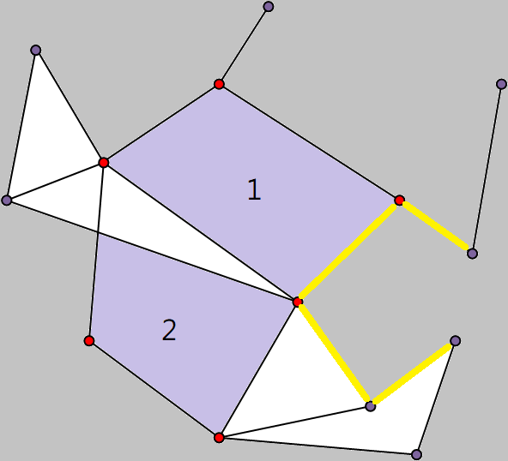

Figure 1: An example of holes in a sensor network.

An example of holes in a sensor network is illustrated in Figure 1 which consists of 14 nodes and 21 edges. Contoured area with purple specifies the region of holes. Red nodes specify the nodes located on a hole. In addition, the sensor network has two holes and labelled as 1 and 2 respectively.



## Force-Directed Algorithm

The force-directed layout algorithm is a graphics drawing algorithm based only on the information contained in the structure of the graphic itself rather than relying on context information. The simplest force-oriented algorithm uses repulsive forces between nodes and attractive forces between adjacent nodes. The physical model produces some local minima in which the graph becomes stable and is drawn in an aesthetic manner. Also known as spring embedders, such algorithms calculate the layout of a graph using only information contained within the structure of the graph itself, rather than relying on domain-speciﬁc knowledge. The main algorithm consists of a main loop, which performs some iterative simulations on the system and then draws the graph. The system will include repulsive forces between all graph nodes and attractive forces between adjacent nodes.

The input of the force-directed algorithm is the ground truth sensor network. We used 10 force-directed algorithms as the input of the approach of CTA, they are Fruchterman Reingold (FR) algorithm [10], Kamada Kawai (KK) algorithm [11], Davidson Harel (DH) algorithm [12], ForceAtlas2 (FA2) algorithm [13], force-directed edge bundling (FDGE) algorithm [14], Fruchterman Reingold with range extension (FRR) algorithm [15], CWBound algorithm [16], JIGGLE algorithm [17], LinLog algorithm [18] and Kamada Kawai with multiple node selection and decaying stiffness (KK-MS-DS) algorithm [19].

The output of the layout after force-directed algorithm in Figure 2 is a text file that include nodes coordinate and connection. This file becomes the input of the approach of CTA for hole detection in sensor networks. Pass the output file to parser, after automatic scale node coordinates and calculating suitable canvas, the result is Figure 2, then it satisfies the requirements for hole detection by CTA.

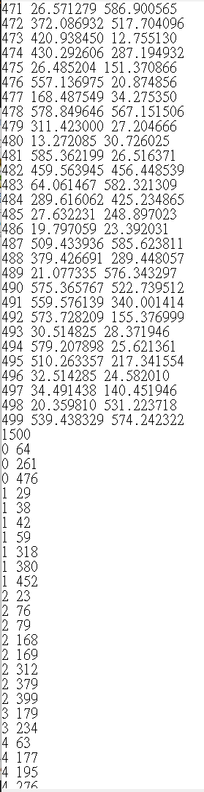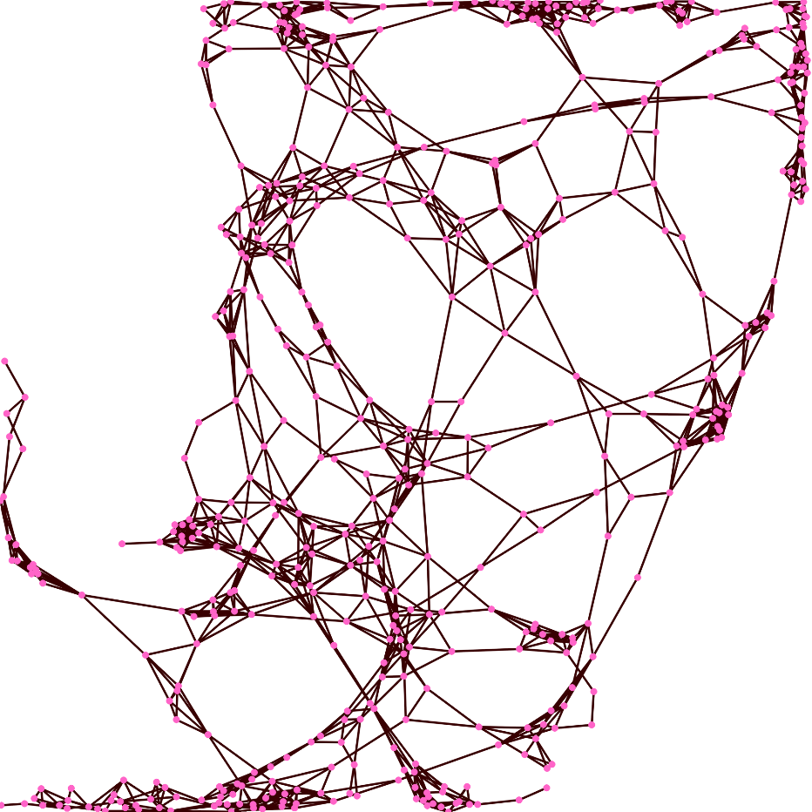

(a) (b)

Figure 2: An output text file of the layout after force-directed algorithm (a), (b) image after visualizing the text file

## Hole Detection in Sensor Network by CTA

We proposed an approach for hole detection in sensor network by CTA is based on Topological Structural Analysis of Digitized Images by Border Following [2], which uses the image processing technique for the hole detection in sensor network. According to the definition and constraints of hole described in Chapter 3.1, the position of nodes and the information of edges are used for the input of CTA in which the identifier of nodes located on the hole will be returned. An image of hole detected from the layout will be the output of CTA. In addition, auto scaling of nodes and the layout is implemented in the CTA which is able to scale the position of nodes and determinate a proper canvas size automatically with respect to variant number of nodes and edges of the layout (i.e. the input of CTA).

## The concept of Contour Tracing Algorithm

### 3.3.1 The surrounding relationship of the boundary of the binary image

The method of CTA to achieve hole detection that is a digital binary image reconstruction analysis. Determine the outer boundary, hole boundary and their hierarchical relationship. Since these boundaries correspond to the regions of the original image, we can use the boundary to represent the original image. In other words, this is an algorithm can detect contours that is only performed in a binary image. This algorithm defines some concepts and the notations are in Table 1.

In Figure 3, S1 is the background and the frame layer. S2 is a bunch of white pixels wrapped. The outermost layer of these white pixel is closely connected with the frame layer. B1 is the outer border of S2, and B2 is the inner border of S2.

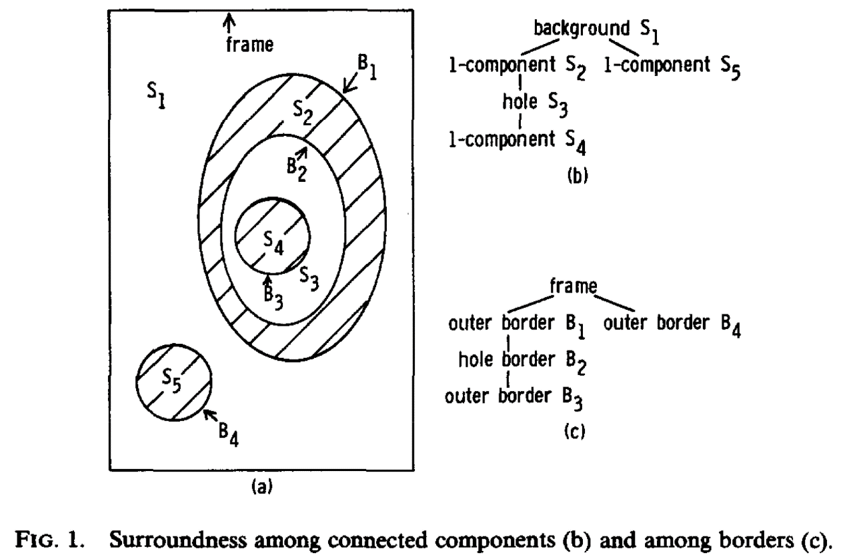

Figure 3: The relation of roundedness among connected components from Topological Structural Analysis of Digitized Images by Border Following [2]

Table 1: The terminologies of the relation of roundedness among connected components from Topological Structural Analysis of Digitized Images by Border Following [2]

|  |  |
| --- | --- |
| Outer border | 1-component boundary surrounded by 0-component. Defined on  1-component. |
| Hole border | 1-component surrounds the boundary of 0-component. Defined on  1-component. |
| Frame | The border of the image. It can be imagined that the whole picture is surrounded by a 1-component, so it can define the frame as a hole border, and the parent of the 1-component border in the image is the frame. |
| NBD | The border number in the current calculation, where frame border is 1. |
| LNBD | When searching for the starting point, the last border number encountered, the initial value is 1. Determine the affiliation of the new contour and other contours |

### 3.3.2 Steps to determine the boundary structure

**Step (1)**: First, we set the boundary value NBD of the external frame to 1.

**Step (2)**: Then ignore the outermost frame, and then start from the leftmost side of the second line of the picture to determine:

If the number is 1, and the pixel on its left is 0, then let us make (i, j) this pixel, and then let (i2, j2) = (i, j-1) be the pixel on its left. Finally, we make NBD = NBD + 1, and this pixel is the outer border pixel.

If this number is greater than or equal to 1, and the right pixel is 0, then we let (i, j) be this pixel, and then let (i2, j2) = (i, j + 1) be its right pixel, and consider this pixel as the hole border pixel.

**Step** (3): To determine whether this pixel is on the hole border or outer border, using this table 1 to decide.

Table 2: Decision Rule for the Parent Border of the Newly Found Border B

|  |  |  |
| --- | --- | --- |
| Type of the border *B’* with  the sequential number LNBD | | |
| Type of *B* | Outer border | Hole border |
| Outer border | The parent border of the border *B’* | The border *B’* |
| Hole border | The border *B’* | The parent border of the border *B’* |

Here *B’* represents the border of the last pixel we followed this step. *B* indicates what border our current pixel is. If this is the first time, there is no last pixel, then it is the outer border.

**Step (4)**: Starting from pixel (i, j), there are 8 pixels (3 * 3) in the vicinity of it, and then we take pixel (i2, j2) as the starting point, and then follow these 8 pixels clockwise moves. Until a pixel is found that is not 0, and let this pixel be (i1, j1). If these 8 pixels are all 0, let the center point (i, j) be -NBD, and then jump directly to the last step.

**Step (5)**: If (i1, j1) exists, then we let (i2, j2) = (i1, j1), (i3, j3) = (i, j).

**Step (6)**: We start from the pixel (i3, j3), take (i2, j2) as the starting pixel, and then move counter clockwise to traverse 8 pixels in the vicinity of (i, j). Find the first pixel that is not 0, then let it to be (i4, j4).

**Step (7)**: If the pixel (i3, j3 + 1) before (i3, j3) is 0, then we assign the pixel value of the pixel (i3, j3) to -NBD. If the pixel before (i3, j3) is not 0, and the pixel at (i3, j3) is 1, then assign the pixel value of (i3, j3) to NBD.

**Step (8)**: If (i4, j4) = (i, j) is the initial value, and (i3, j3) = (i1, j1), then we jump to the last step. If the condition is not met, we return to Step (6) and continue to calculate until the condition is met.

**Step (9)**: We go back to the pixel we chose at the beginning, which is (i, j) and then we move one to the right, and if we have reached the end, we change to the left of the next line. If our pixel at (i, j) is not 1, we make LNBD equal to the absolute value of the pixel at (i, j).

1. System Design of Hole Detection in Sensor Network by CTA

Hole detection by image processing could directly detect the holes in sensor network through an image. The proposed CTA has high accuracy and easy for performance evaluation and observation. Nevertheless, image processing relies on the position of node and the resolution of image of sensor network. In other words, images be detected should be high resolution and clear details of nodes and edges in hole detection. Figure 4 is the workflow of one layout in the system of Hole Detection by CTA.

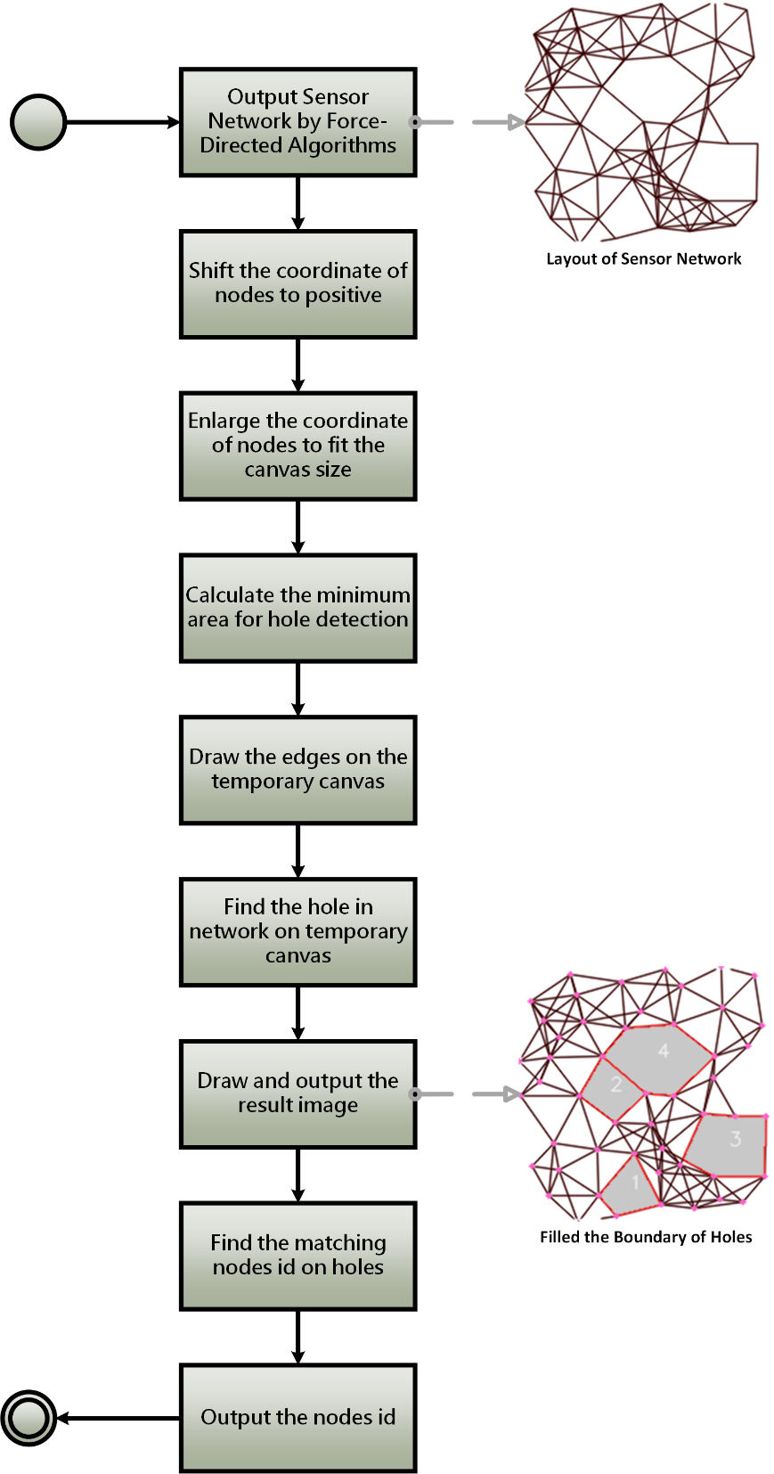

Figure 4: The workflow of one layout in the system of Hole Detection by CTA

There are three major steps in the design of hole detection in sensor network by CTA.

**Step 1: Pre-processing of hole detection in sensor network**

The first step of CTA is to extract information of sensor networks by parsing the text file, which including obtaining the number of nodes, nodes coordinates and edges. Then calculate the canvas size according to number of nodes, shift and ensure the coordinates are positive. Moreover, calculate the ratio for enlarge the coordinate of node that fitting the canvas size. Finally, calculate the minimum hole area.

###### Step 2: Perform hole detection in Sensor Network

This is the core part of the CTA that using image processing method to detect hole. According to the definition of hole, finding a closed and contoured area is above all. The visual sensor network consists of coordinate of nodes and the connection, so drawing the image of whole sensor network can be achieved by drawing the line. After that, convert picture to binary then detecting a closed and contoured area is relatively effective. Filter out the inappropriate size area via calculation, next is sort the area from ascending order. Afterward, it is a significant step that finding the matching node on the contour, determine whether the node is on the contour, it can be achieved by calculating the distance between node coordinate and contour position. After filtering out the contoured area that consist of only three nodes, the holes in sensor network have found then the nodes identity of holes output to a text file.

###### Step 3: Draw Image

Output the image of sensor network that have been hole detected is the final step of CTA. Drawing the edge by the line of nodes connection is similarly with the step for finding a closed and contoured area. Moreover, draw the colourful contoured area according to the result of the step 2. Next, draw the little circles on the canvas with the nodes coordinate. Finally output the image with PNG format.

The pseudo code of Hole Detection in Sensor Network by CTA is given in Algorithm 1.

Algorithm 1.  Pseudo code of Hole Detection in Sensor Network by CTA

$$Input:A file f containing the layout of sensor network$$

$$Output:a text file of the hole nodes T_{output}$$

$$initialize a list l_{coor} to store the coordinate of nodes of the layout$$

$$initialize a list l_{edge} to store edges of the layout$$

$$initialize a list l_{hole} to store holes detected from the layout$$

$$initialize a list l_{hole node} to store nodes located on the hole$$

$$initialize a list Cx to store the x coordinate of nodes$$

$$initialize a list Cy to store the y coordinate of nodes$$

$$// Read the file containing the layout of sensor network.$$

$$DatasetParser(file)$$

$$// Handle nodes with negative x-axis and y-axis positions.$$

$$shiftCoorPositive(l_{coor})$$

$$// enlarge the coordinate of node that fitting the canvas size$$

$$enlargeCoor(l_{coor})$$

$$// calculate the minimum area for hole detection$$

$$calMinArea(canvas size)$$

$// draw edges on the temporary canvas$.

$$drawAllEdges(l_{coor}, l_{edge})$$

$$//find the hole in network on the temporary canvas$$

$$findHoles(C_{tmp})$$

$$//draw and output the result image$$

$$BitmapOut(l_{edge}, l_{hole})$$

$$//Find the matching node id on hole and output$$

$$holeNodeOut(l_{coor}, l_{hole})$$

$$// output node id$$

$$foreach u ∈l_{hole node}do \{$$

$$write u on T_{output}$$

$$\}$$

**return $T_{output}$** ;

Algorithm 1 Pseudo code of CTA

1. Experiments

To evaluate the proposed algorithms, we implemented a simulation environment using the Python programming language. In a sensor network, a number of parameters can influence experimental results, including the total number of nodes in the sensor network, the number of edges per node and the edge distribution within the sensor network. For instant, the higher the number of nodes in a sensor network, the larger the amount of memory consumed and the longer the execution time. We conducted our experiments on a computer using an Intel Core i7-6700HQ processor, graphics card NVDIA GeForce GTX 1070 with 16 GB of memory for CTA. Moreover, we conducted our experiments to train models of YOLO on a computing using Intel Core i7-6700HQ processor, graph card NVDIA GeForce GTX 960M with 16 GB of memory.



## Experiment Settings

In additional to the ground truth datasets, ten force-directed algorithms are implemented in our experiments. They are Fruchterman Reingold (FR) algorithm [10], Kamada Kawai (KK) algorithm [11], Davidson Harel (DH) algorithm [12], ForceAtlas2 (FA2) algorithm [13], force-directed edge bundling (FDGE) algorithm [14], Fruchterman Reingold with range extension (FRR) algorithm [15], CWBound algorithm [16], JIGGLE algorithm [17], LinLog algorithm [18] and Kamada Kawai with multiple node selection and decaying stiffness (KK-MS-DS) algorithm [19].

In our experiments, the default size of the drawing frame (canvas) of force-directed algorithms was 600 $×$ 600. Moreover, the algorithm was allowed to execute for up to 600 seconds. For each input network topology (ground truth dataset), every node was assigned a random visual position within the drawing frame. Force-directed algorithms then produce a layout per iteration in which is layout is stored and used to evaluate the performance of hole detection. Moreover, attributes and notations used in our experiments are summarized in Table 3.

Table 3: Attributes and notations used in the experiments.

|  |  |
| --- | --- |
| **Notation** | **Description** |
| $$n$$ | Number of nodes in the network |
| $$d$$ | Average degree of the network |
| $${Hole}_{P}$$ | The node which is located on the hole. |
| $${Hole}_{N}$$ | The node which is not located on the hole |
| $${Ground}_{P}$$ | The node which is located on the hole of ground truth dataset. |
| $${Ground}_{N}$$ | The node which is NOT located on the hole of ground truth dataset. |
| $${Ground}_{U}$$ | The layout of a uniform sensor network. |
| $${Ground}_{S}$$ | The layout of a sparse sensor network. |
| $${FD}_{P}$$ | The node which is located on the hole of the layout of force-directed algorithm. |
| $${FD}_{N}$$ | The node which is NOT located on the hole of the layout of force-directed algorithm. |
| $${FD}_{U}$$ | The layout of force-directed algorithms in which the input topology is a uniform sensor network. |
| $${FD}_{S}$$ | The layout of force-directed algorithms in which the input topology is a sparse sensor network. |

We showed an example of result of hole detections of a ground truth data and the layout of a force-directed algorithm in Figure 5 (a) and Figure 5 (b) respectively. Figure 5 (a) illustrated the result of hole detection from the layout of sparse ground truth dataset ${Ground}_{S}$ with $n=1000$ and $d=500$. Figure 5 (b) illustrated the result of layout ${FD}_{S}$ which is captured at 600th second of the KK-MS-DS algorithm with $n=1000$ and $d=500$.

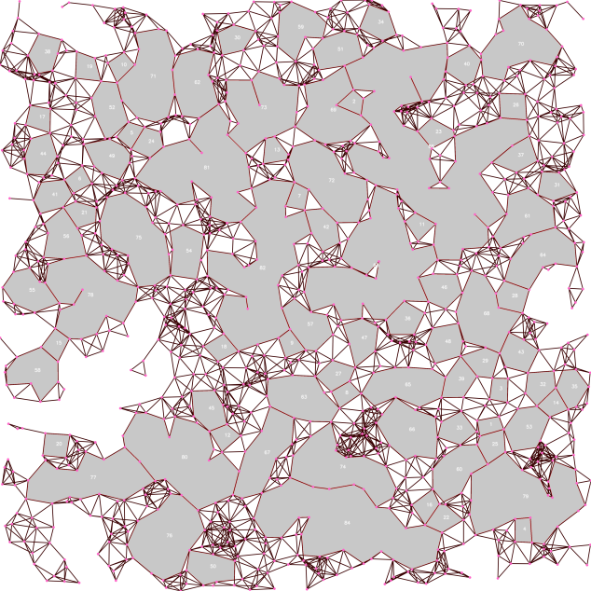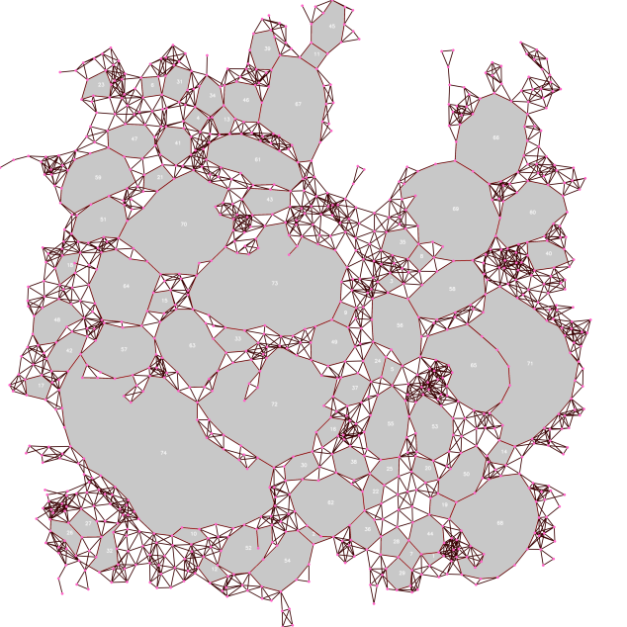

(a) (b)

Figure 5: An example of result of hole detection of (a) ground truth dataset, (b) layout of force-directed algorithm.

## Dataset Preparation

We considered various sensor networks in evaluating the performance and execution time for hole detection. These sensor networks are called ground truth dataset. For our experiments, we focused on sensor networks with sparse and uniform distributions. Figure 6 (a) and (b) illustrate examples of a sparse sensor network and a uniform sensor network which were captured from the ground truth datasets, respectively, with the same total number of nodes $\left(n\right)$ and average degree $\left(d\right)$. In addition, uniform and sparse ground truth datasets are donated as $D_{U}$ and $D_{S}$ respectively. In both ground truth datasets, we set the total number of nodes $n$ to 500, 1,000, 2,000 and 3,000. We also set the average degrees of ground truth datasets $d$ to 6, 8, 10, 12 and 15 for the generation of sensor network. Overall, 40 topologies of (uniform and sparse) sensor network were generated for the experiments based on all of the possible combinations of $n$ and $d$. Moreover, the generation of uniform and sparse ground truth datasets are adopted from [19] and generated by a toolkit CNCAH Network Generator [20].

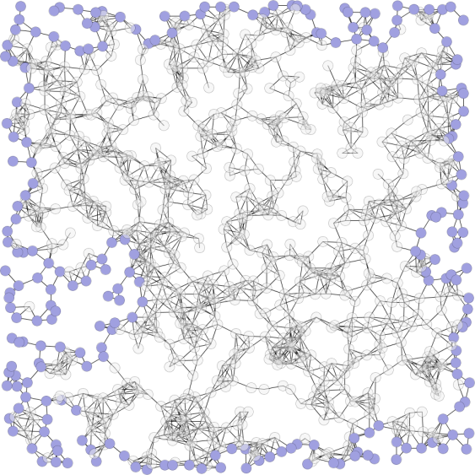 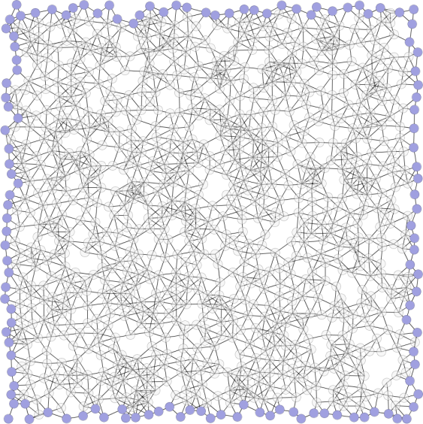

(a) (b)

Figure 6: Example of (a) sparse sensor network, (b) uniform sensor network.

## Image Size Scaling

The size of canvas of force-directed algorithms was set to 600 $×$ 600. That mean, the position of nodes in the layout of force-directed algorithms was placed in a surface with width 600 and height 600. However, such canvas size is hard for hole detection because the size of canvas is too small especially when the number of nodes and average degree are high. That is because too many edges crossing is in the layout and the resolution of layout is not enough for the hole detection. For instant, a layout with high number of nodes and average degree is illustrated in Figure 7. Therefore, we used a scaling technique to enlarge the size of canvas of layout in order to enable the capability for hole detection. The scaling equation used in our experiments is shown in

$$L_{width}\left(n\right)=4×n; L_{height}\left(n\right)=4×n$$

where $L_{width}\left(n\right)$ and $L_{height}\left(n\right)$ are the scaled resolution of canvas for the width and height of layout respectively. $n$ is the number of nodes in the layout.

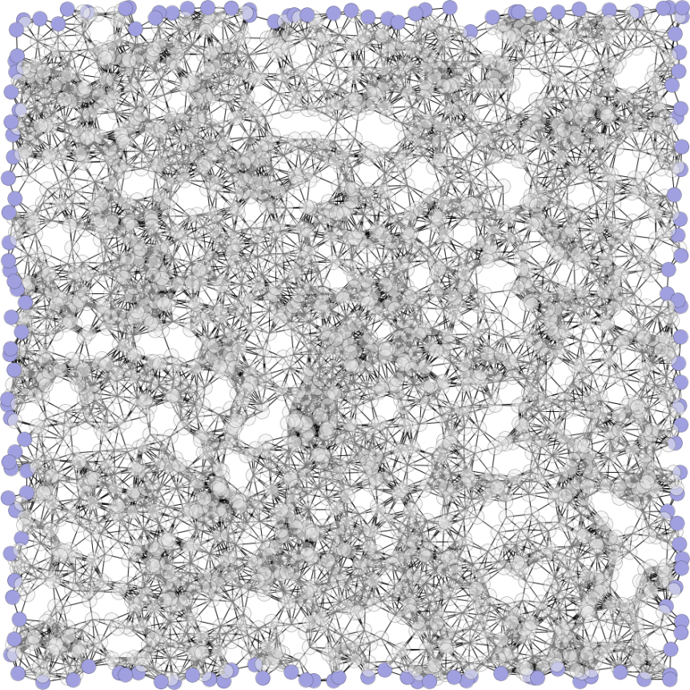

Figure 7: An example of layout with high number of nodes and average degree.

## Criteria

The performance evaluation of hole detection in sensor network by CTA is based on layout of ground truth datasets and the layout of force-directed algorithms. The workflow of performance evaluation of hole detection in sensor network by CTA is illustrated in Figure 8. In the paper, Node Identifier Matching and Hole Count Statistics are used in the performance evaluation. We described the details and the result of Node Identifier Matching in Chapter 6. We described the details and the result of Hole Count Statistics in Chapter 6.2 respectively.

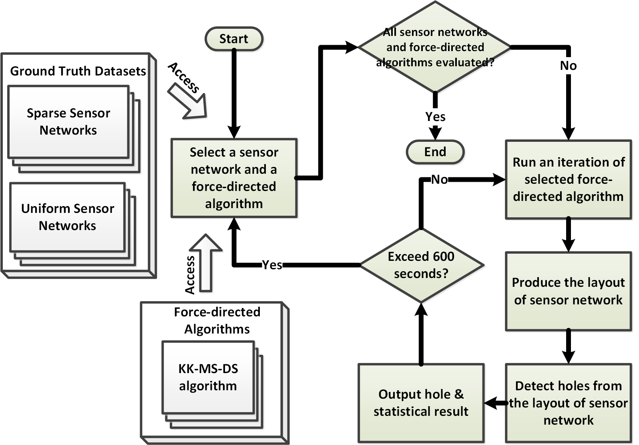

Figure 8: Workflow of performance evaluation of hole detection in sensor network by CTA.

### Accuracy and Recall

In this experiment, we evaluated the performance of node matching between ground truth datasets and the layout of force-directed algorithms using two criteria: accuracy and recall. The description of performance evaluation criteria is shown in Table 4. In this experiment, a time limit was assigned to force-directed algorithms as their stopping criteria. That is, force-directed algorithms produce the layout of sensor network until the time limit reached that does not stop by a maximum iteration or achieve to a lower energy.

|  |  |  |
| --- | --- | --- |
| **Criteria** | **Description** |  |
| Accuracy | Degree of the closeness (i.e., true positives and true negative) between ground truth datasets and the layout of force-directed algorithms. | The higher the better |
| Recall | ${Ground}_{P}$ correctly identified as ${FD}_{P}$ | The higher the better |
| Execution time | Total amount of execution time that the algorithm ran in seconds | 600 seconds in our experiments |

Table 4: Performance evaluation criteria of Node Identifier Matching.

The definition of accuracy is defined as follows:

|  |  |  |
| --- | --- | --- |
|  | $$Accuracy= \frac{TP+TN}{TP+TN+FP+FN}$$ | (1) |

where $TP$ indicates the node is ${Hole}_{P}$ in both ground truth dataset and the layout of force-directed algorithm. $TN$ indicates the node is ${Hole}_{N}$ in both ground truth dataset and the layout of force-directed algorithm. $FP$ indicates the node is ${Hole}_{P}$ in the layout of force-directed algorithm. However, the node is ${Hole}_{N}$ in the ground truth dataset. $FN$ indicates the node is ${Hole}_{N}$ in the layout of force-directed algorithm. However, the node is ${Hole}_{P}$ in the ground truth dataset. However, there are problems with accuracy. When a large network is used for hole detection, the number of ${Hole}_{N}$ nodes can significantly influence the accuracy. In our application, only few numbers of nodes are ${Hole}_{P}$. This means that accuracy depends on the sum of the true positive number ($TP$) and the true negative number ($TN$) divided by the total number of nodes examined. If the true negative number ($TN$) is high, then the accuracy is high. After we got TP, TN, FP and FN, through the equation (1), it can calculate the accuracy between ground truth datasets and the layout of force-directed algorithms

Accuracy will yield misleading our experimental results if the number of ${Hole}_{N}$ and ${Hole}_{P}$ is unbalanced. Precisely, this case occurs when the numbers of ${Hole}_{N}$ and ${Hole}_{P}$ vary greatly. It cannot reflect the real performance of algorithms as applied to hole detection.

Therefore, we verified the sensitivity of the ${Hole}_{P}$ by using the recall in which high recall indicates the ${Ground}_{P}$ correctly identified as ${FD}_{P}$ which is defined as the total number of correctly identified positive examples divide to the total number of positive examples. The definition of recall is defined as follows:

|  |  |  |
| --- | --- | --- |
|  | $$Recall=\frac{TP}{TP+FN}$$ | (2) |

It can calculate the recall between ground truth datasets and the layout of force-directed algorithms by equation (2)

### Number of identified Holes

In this experiment, we are interested in finding the hole count with force-directed algorithms in terms of variant number of nodes and average degree for sparse and uniform sensor network by using statistical methods. The objective for this experiment is to observe the change of the hole count in different force-directed algorithms with respective to time unit and sensor networks. Because of this, we used descriptive statistics in our experiments which are useful for showing and summarizing our experimental results. Figure 9 is the workflow of performance evaluation of Hole Count Statistics. Figure 10 is the workflow of processing result of force-directed algorithms.

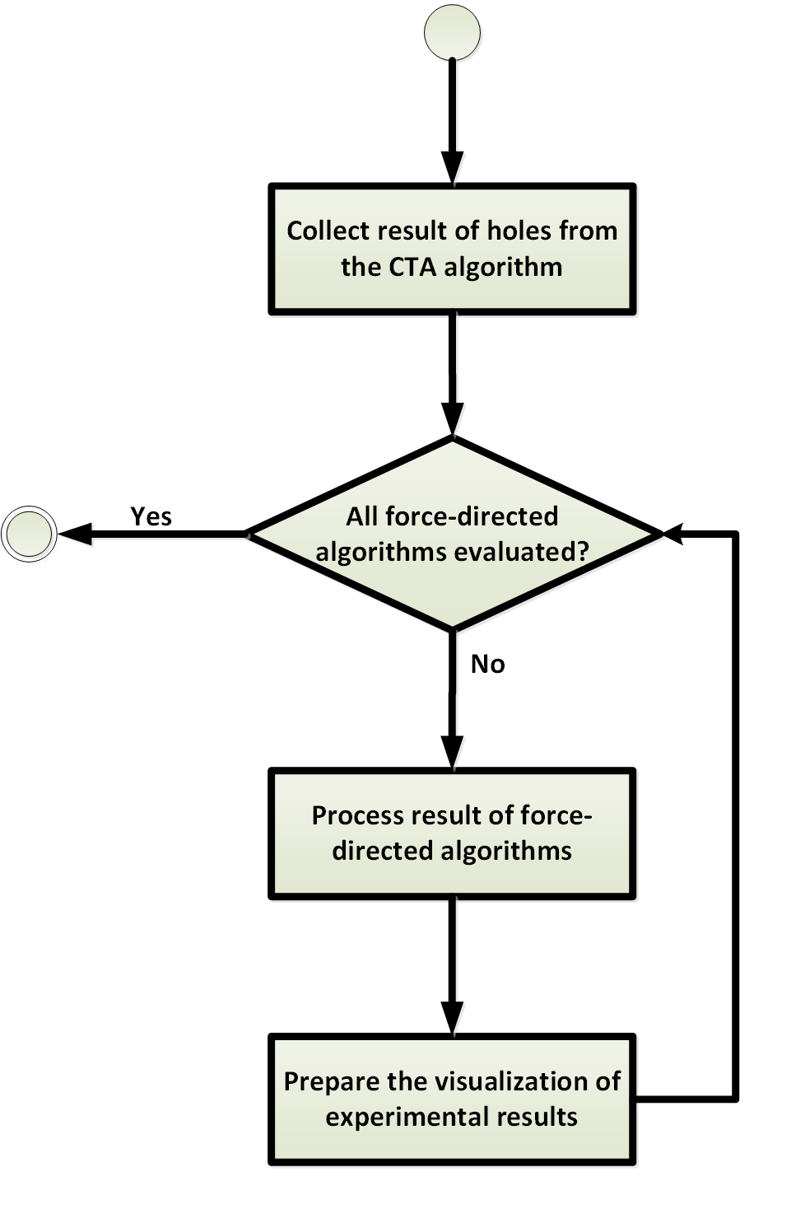

Figure 9: Workflow of performance evaluation of Hole Count Statistics.

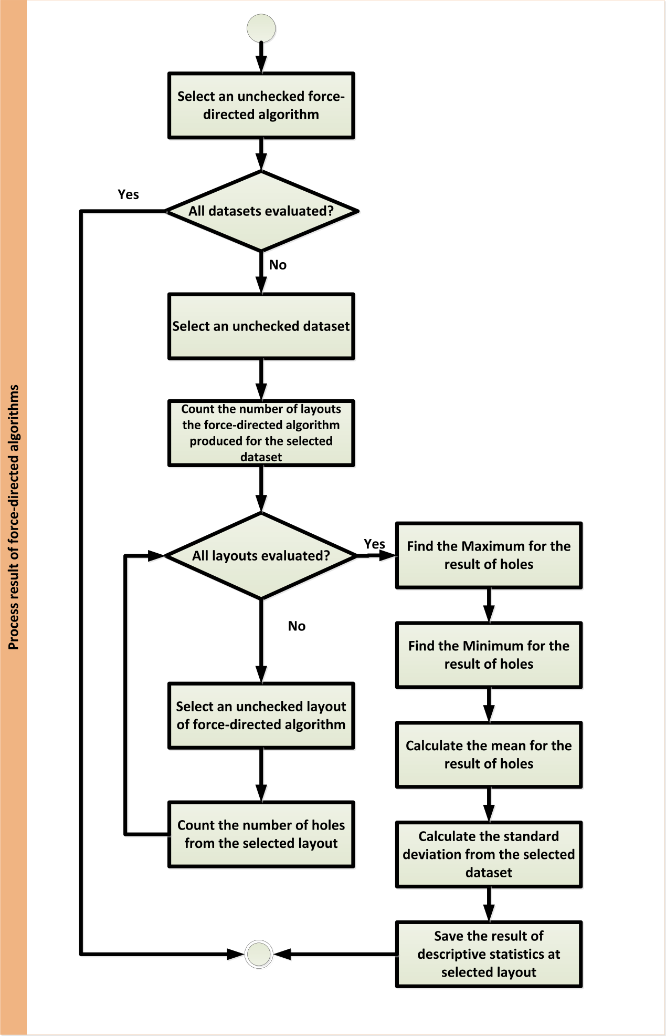

Figure 10: Workflow of processing result of force-directed algorithms

Maximum and minimum are used for comparing the count of holes from the layout of force-directed algorithms. Mean is the measurement of central tendency of count of holes from the layout of force-directed algorithm and defined as follows:

|  |  |  |
| --- | --- | --- |
|  | $$\overline{X}= \frac{\sum_{i=1}^{n}{X_{i}}}{n}$$ | (3) |

where $n$ is the number of iteration of force-directed algorithm executed in 600 seconds, $X_{i}$ is the count of hole of the layout of force-directed algorithm at $i^{th}$ iteration.Standard deviation can be used to evaluate the dispersion of the number of holes and defined as follows:

|  |  |  |
| --- | --- | --- |
|  | $$S=\sqrt{\frac{\sum_{i=1}^{n}{{\left(X_{i}-\overline{X}\right)}^{2}}}{n-1}}$$ | (4) |

where $n$ is the number of iterations of force-directed algorithm executed in 600 seconds, $X_{i}$ is the count of hole of the layout of force-directed algorithm at $i^{th}$ iteration. $\overline{X}$ is the mean of count of holes from the layout of force-directed algorithm which is defined in equation 3.

1. Experiment results

## Result of Node Identifier Matching and Force-directed Algorithms

We concluded the experimental result of accuracy and recall of node identifier matching in this chapter. We discussed the accuracy of node identifier matching in sparse and uniform sensor networks in Chapter 6.1.1 and 6.1.2 respectively. Moreover, we also summarized the experimental result of recall of the node identifier matching in sparse and uniform sensor networks in Chapter 6.1.3 and 6.1.4 respectively.

### Accuracy of Node Identifier Matching of Sparse Sensor Networks

Figure 11 illustrated the experimental results of force-directed algorithms in terms of variant number of nodes and a specific average degree. The experimental result of force-directed algorithms was plotted against the average degree 6 and with number of nodes 500, 1000, 2000 and 3000 in sparse sensor network.

The experimental results revealed that KK-MS-DS algorithm achieved the highest accuracy regardless of the average degree and number of nodes in sparse sensor networks. The accuracy of FA2 algorithm becomes stable since 70th, 300th, 400th and 300th time unit with respect to the number of nodes 500, 1000, 2000 and 3000 respectively. The KK algorithm has a poor accuracy when the number of nodes is larger than 1000. The accuracy of FRU algorithm does not have significant improvement when the number of nodes is 500. However, the accuracy of JIGGLE and FRU algorithms are undulated when the number of nodes is larger than 500. The accuracy of FR, FRR, LinLog, FDGE and DH algorithms do not have significant improvement regardless of the average degree and number of nodes in sparse sensor networks. Moreover, the accuracy of all force-directed algorithms decreased when the number of nodes increased.

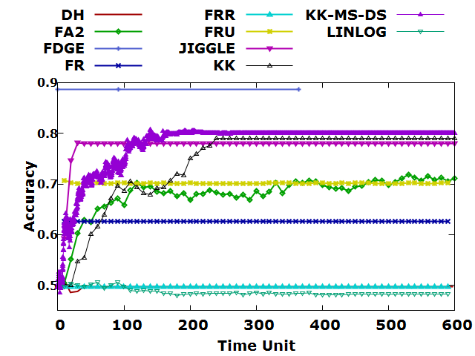

(a)

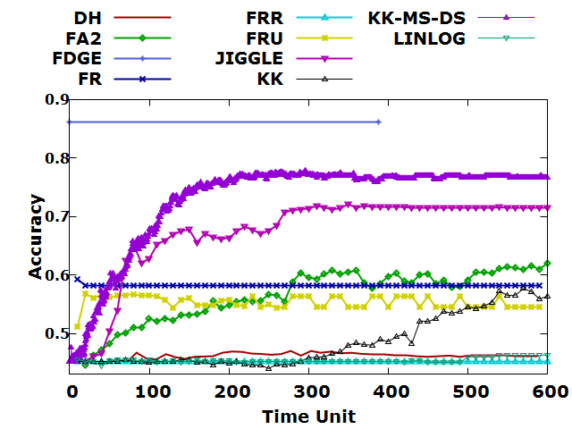

(b)

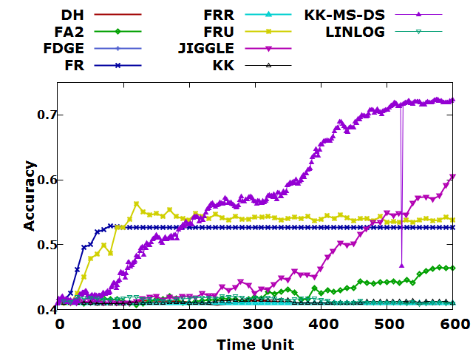

(c)

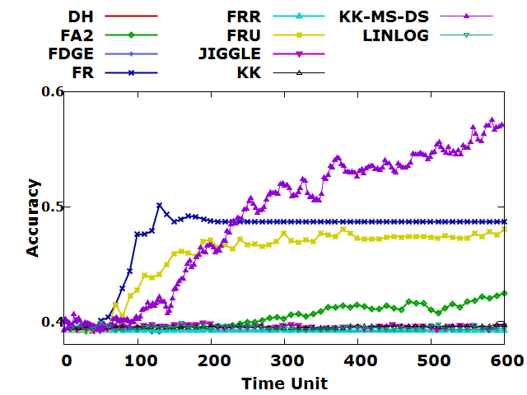

(d)

Figure 11: Accuracy of Node Identifier Matching of (a) 500, (b) 1000, (c) 2000, (d) 3000 nodes and average degree 6 in sparse sensor networks.

Figure 12 illustrated the experimental results of force-directed algorithms in terms of variant number of nodes and a specific average degree. The experimental result of force-directed algorithms was plotted against the average degree 8 and with number of nodes 500, 1000, 2000 and 3000 in sparse sensor network.

The experimental results revealed that KK-MS-DS algorithm achieved the highest accuracy except at 500 nodes, even far higher than other algorithms at 2000 nodes. The accuracy of FA2 has a continuous upward trend except 3000 nodes. The KK algorithm is stable and low accuracy overall except at 500 nodes. However, the accuracy of FRU, FR, FDGE, DH, LinLog algorithms do not have significant improvement regardless of the number of nodes in sparse sensor networks. The accuracy of JIGGLE algorithms is undulated when the number of nodes is 1000 and 2000. Moreover, the accuracy of all force-directed algorithms decreased when the number of nodes increased; the overall accuracy is greater than average degree is 6.

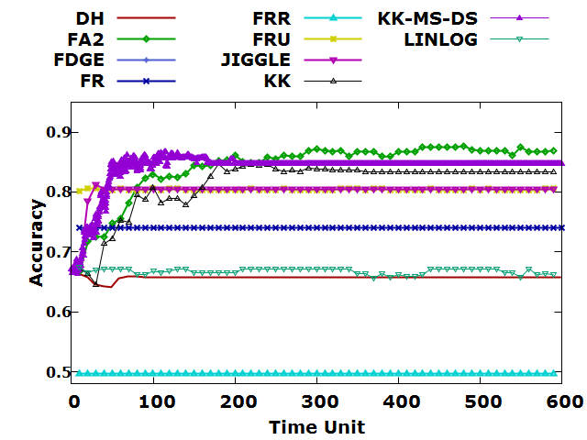

(a)

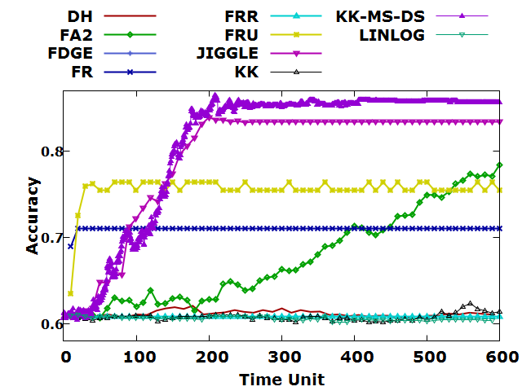

(b)

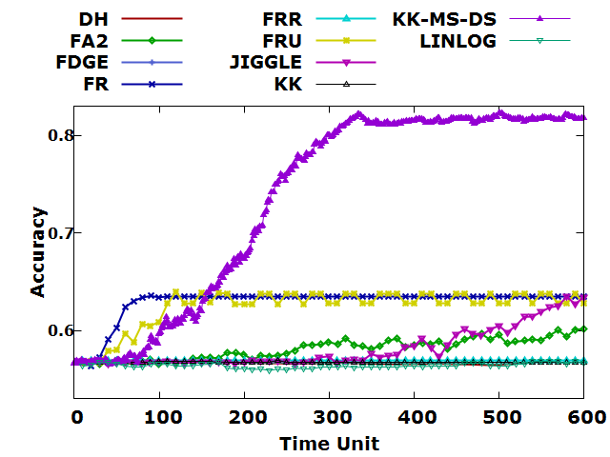

(c)

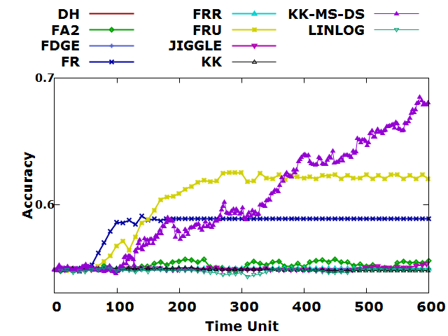

(d)

Figure 12: Accuracy of Node Identifier Matching of (a) 500, (b) 1000, (c) 2000, (d) 3000 nodes and average degree 8 in sparse sensor networks.

Figure 13 illustrated the experimental results of force-directed algorithms in terms of variant number of nodes and a specific average degree. The experimental result of force-directed algorithms was plotted against the average degree 10 and with number of nodes 500, 1000, 2000 and 3000 in sparse sensor network.

The experimental results revealed that KK-MS-DS algorithm has high performance regardless of the average degree, and highest accuracy except at 500 nodes, FA2 and KK algorithm becomes stable since 200th time unit with respect to the number of nodes 500. Moreover, the accuracy of FRU, JIGGLE, FR, FRR, LinLog, FDGE and DH algorithms do not have significant improvement regardless of the number of nodes 500, 1000, 2000 and 3000 respectively. However, the accuracy of JIGGLE algorithm reached over 90%. Moreover, the accuracy of all force-directed algorithms decreased when the number of nodes increased. The overall accuracy is higher than the average degree of 8 and reached more than 70%.

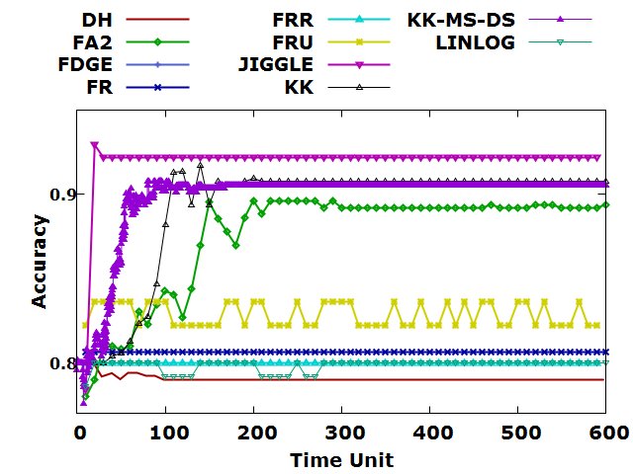

(a)

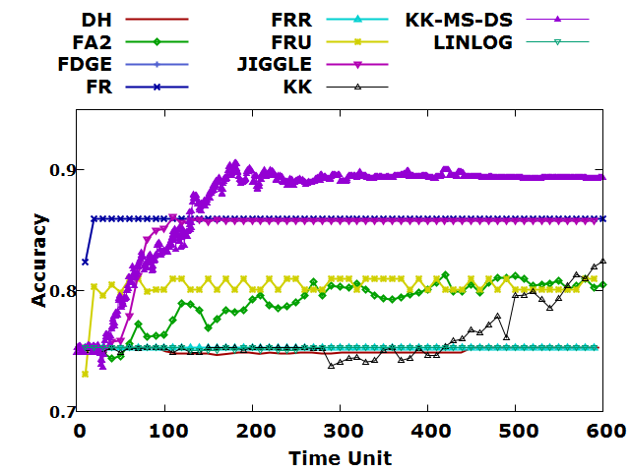

(b)

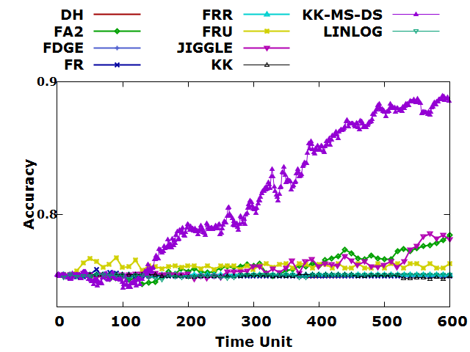

(c)

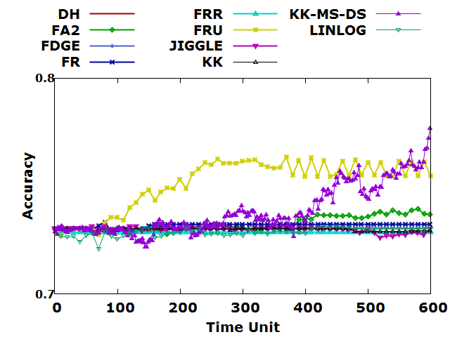

(d)

Figure 13: Accuracy of Node Identifier Matching of (a) 500, (b) 1000, (c) 2000, (d) 3000 nodes and average degree 10 in sparse sensor networks.

Figure 14 illustrated the experimental results of force-directed algorithms in terms of variant number of nodes and a specific average degree. The experimental result of force-directed algorithms was plotted against the average degree 12 and with number of nodes 500, 1000, 2000 and 3000 in sparse sensor network.

The experimental results revealed that the accuracy of each algorithm is close to stable; the overall accuracy has reached more than 80%. Moreover, the accuracy of all force-directed algorithms decreased and became closer when the number of nodes increased. The overall accuracy is higher than the average degree of 10.

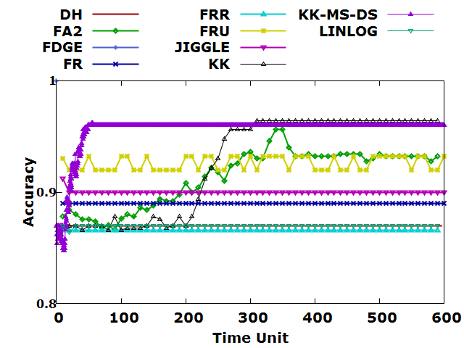

(a)

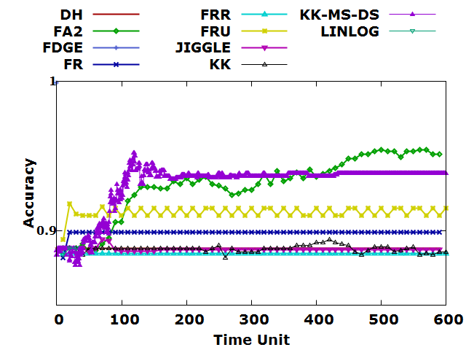

(b)

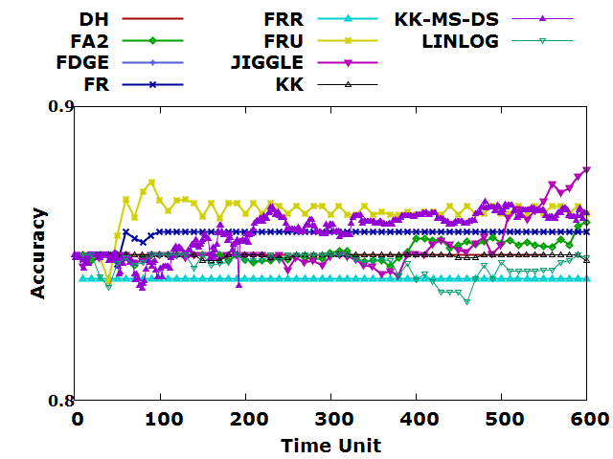

(c)

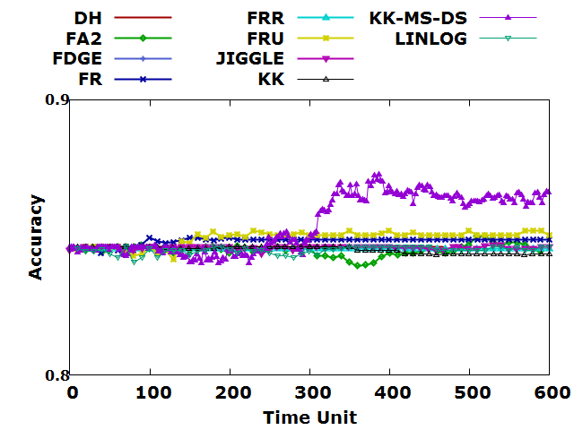

(d)

Figure 14 Accuracy of Node Identifier Matching of (a) 500, (b) 1000, (c) 2000, (d) 3000 nodes and average degree 12 in sparse sensor networks.

Figure 15 illustrated the experimental results of force-directed algorithms in terms of variant number of nodes and a specific average degree. The experimental result of force-directed algorithms was plotted against the average degree 15 and with number of nodes 500, 1000, 2000 and 3000 in sparse sensor network.

The experimental results revealed that the accuracy of each algorithm is close to stable; the overall accuracy has reached more than 90%. Moreover, all algorithm does not have significant improvement regardless of the number of nodes 500, 1000, 2000 and 3000 respectively. However, the accuracy of all force-directed algorithms decreased and became closer when the number of nodes increased. The overall accuracy is higher than the average degree of 12.

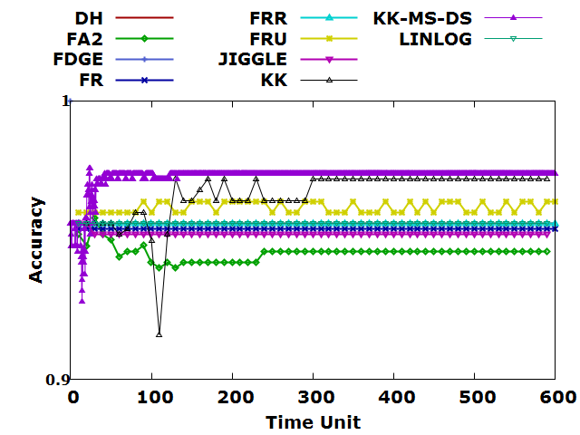

(a)

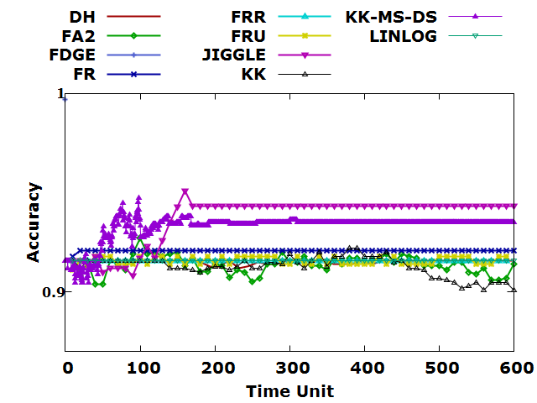

(b)

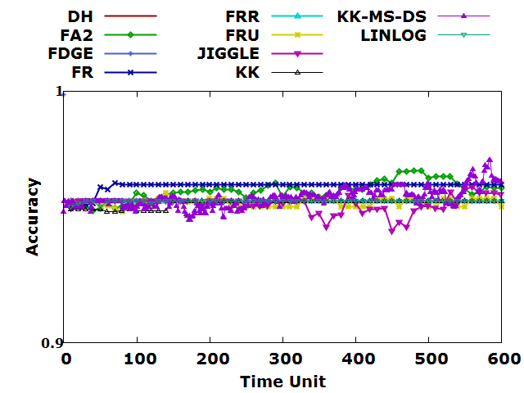

(c)

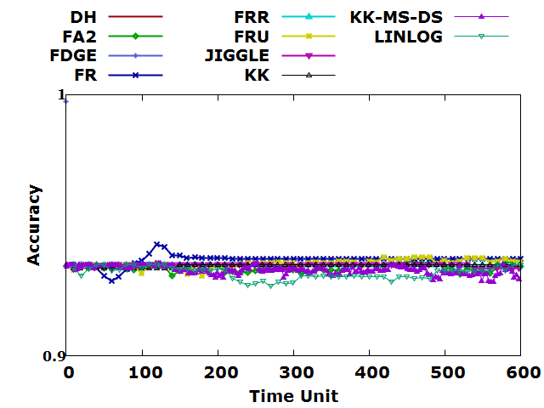

(d)

Figure 15: Accuracy of Node Identifier Matching of (a) 500, (b) 1000, (c) 2000, (d) 3000 nodes and average degree 15 in sparse sensor networks.

### Accuracy of Node Identifier Matching of Uniform Sensor Networks

Figure 16 illustrated the experimental results of force-directed algorithms in terms of variant number of nodes and a specific average degree. The experimental result of force-directed algorithms was plotted against the average degree 6 and with number of nodes 500, 1000, 2000 and 3000 in uniform sensor network.

The experimental results revealed that KK-MS-DS algorithm has high performance regardless of the number of nodes 500, 1000, 2000 and 3000 respectively. The accuracy of JIGGLE KK and FA2 achieves high performance at the number of nodes 500, 1000. Moreover, FDGE algorithm has the high accuracy at the number of nodes 500, more than 95%. However, the accuracy of FR, FRU, FRR, DH and LINLOG do not have significant improvement regardless of the number of nodes 500, 1000, 2000 and 3000 respectively. The accuracy of all force-directed algorithms decreased when the number of nodes increased.

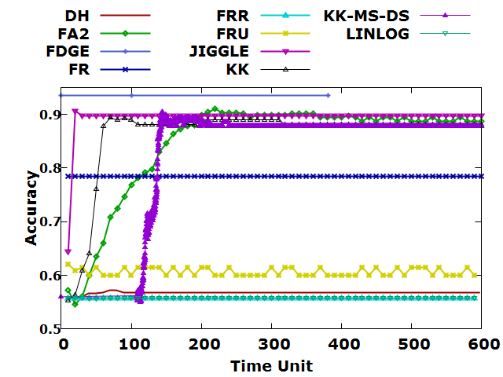

(a)

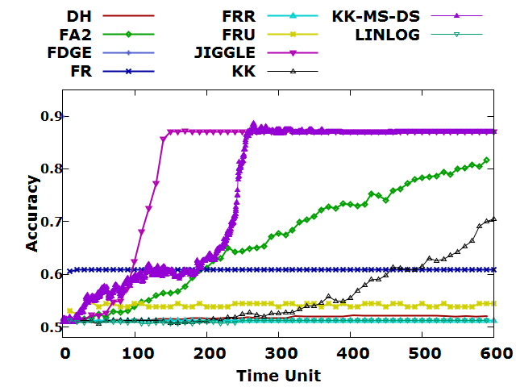

(b)

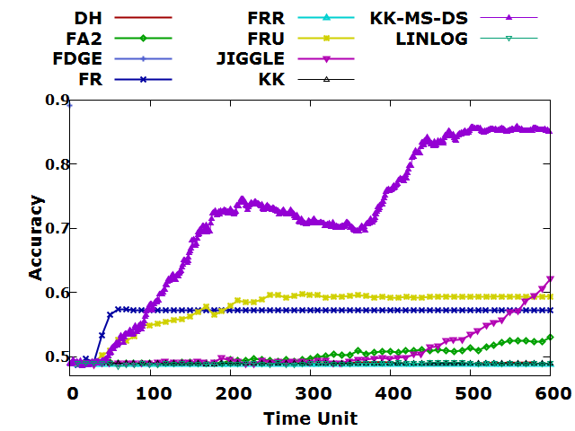

(c)

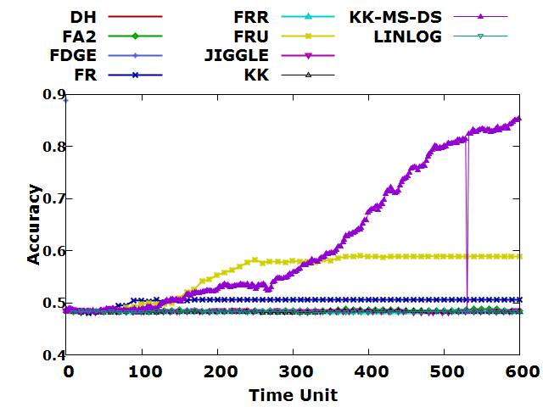

(d)

Figure 16: Accuracy of Node Identifier Matching of (a) 500, (b) 1000, (c) 2000, (d) 3000 nodes and average degree 6 in uniform sensor networks.

Figure 17 illustrated the experimental results of force-directed algorithms in terms of variant number of nodes and a specific average degree. The experimental result of force-directed algorithms was plotted against the average degree 8 and with number of nodes 500, 1000, 2000 and 3000 in uniform sensor network.

The experimental results revealed that the accuracy of each algorithm is close to stable; the overall accuracy has reached more than 80%. Moreover, all algorithms do not have significant improvement regardless of the number of nodes 500, 1000, 2000 and 3000 respectively. However, the accuracy of all force-directed algorithms decreased and became closer when the number of nodes increased. The overall accuracy is higher than the average degree of 6.

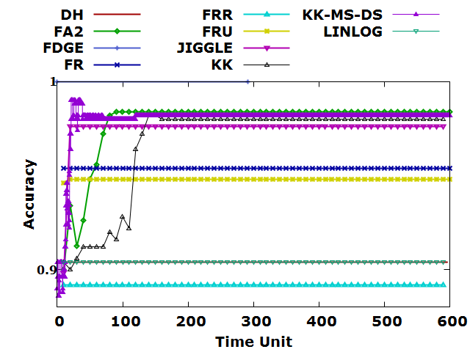

(a)

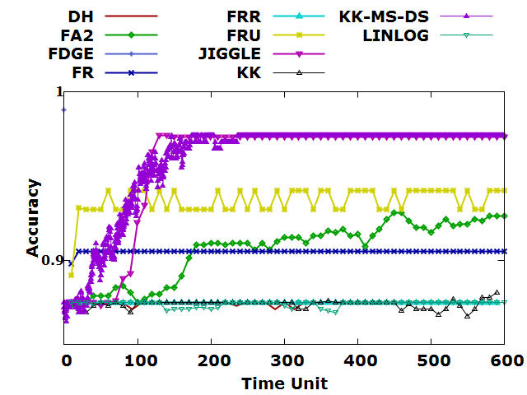

(b)

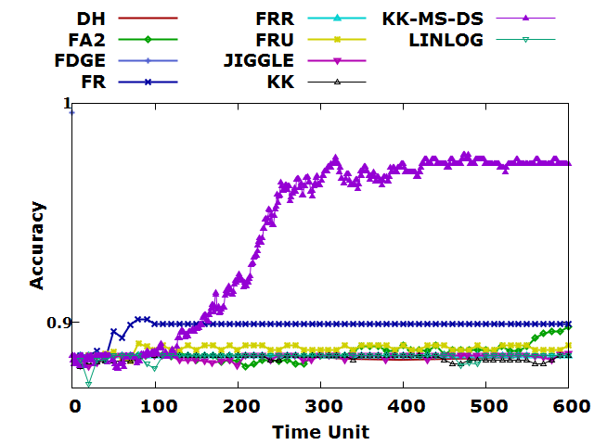

(c)

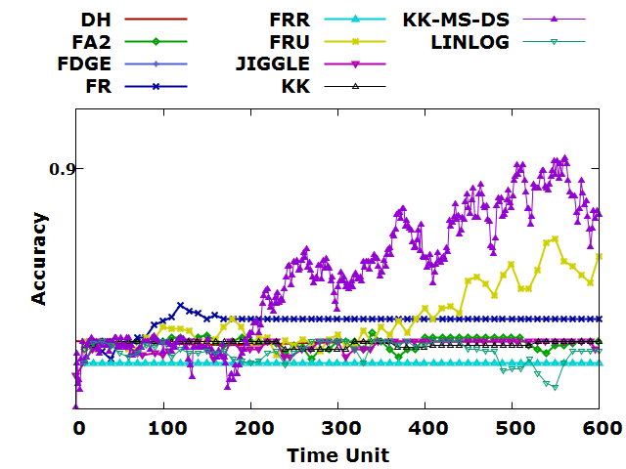

(d)

Figure 17: Accuracy of Node Identifier Matching of (a) 500, (b) 1000, (c) 2000, (d) 3000 nodes and average degree 8 in uniform sensor networks.

Figure 18 illustrated the experimental results of force-directed algorithms in terms of variant number of nodes and a specific average degree. The experimental result of force-directed algorithms was plotted against the average degree 10 and with number of nodes 500, 1000, 2000 and 3000 in uniform sensor network.

The experimental results revealed that the accuracy of each algorithm is stable from the beginning and very close to 100%. Moreover, all algorithm does not have significant improvement regardless of the number of nodes 500, 1000, 2000 and 3000 respectively.

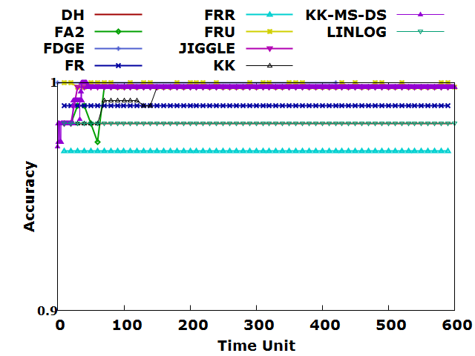

(a)

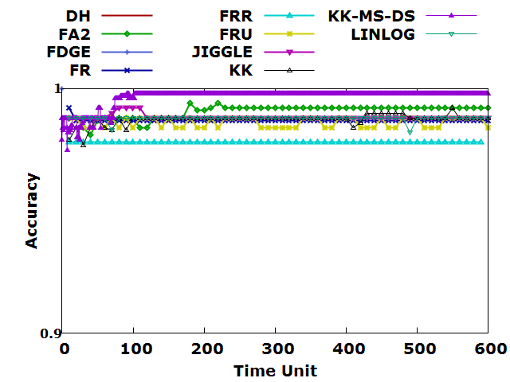

(b)

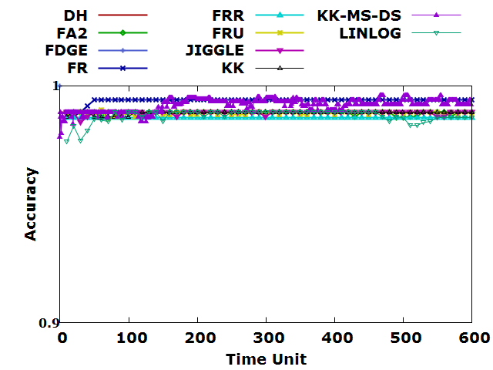

(c)

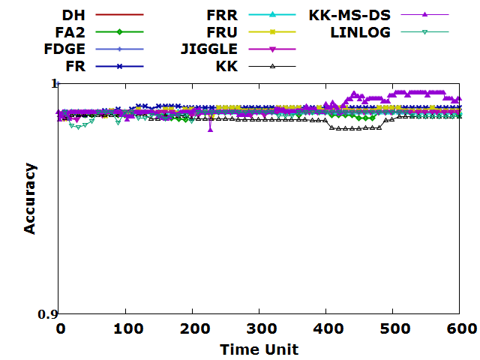

(d)

Figure 18: Accuracy of Node Identifier Matching of (a) 500, (b) 1000, (c) 2000, (d) 3000 nodes and average degree 10 in uniform sensor networks.

Figure 19 illustrated the experimental results of force-directed algorithms in terms of variant number of nodes and a specific average degree. The experimental result of force-directed algorithms was plotted against the average degree 12 and with number of nodes 500, 1000, 2000 and 3000 in uniform sensor network.

The experimental results revealed that the accuracy of each algorithm is stable from the beginning and very close to 100%. Moreover, all algorithms do not have significant improvement regardless of the number of nodes 500, 1000, 2000 and 3000 respectively.

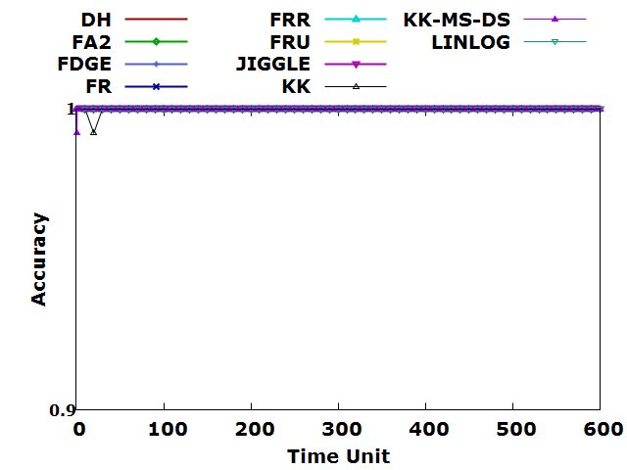

(a)

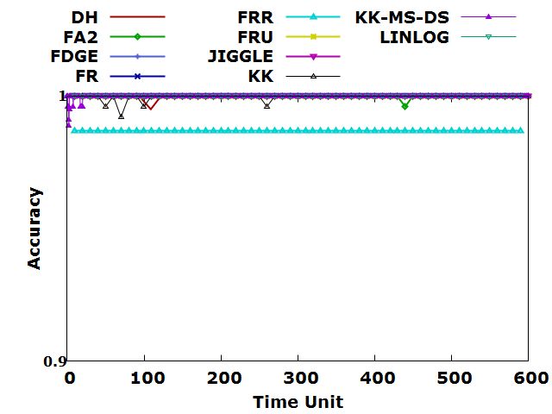

(b)

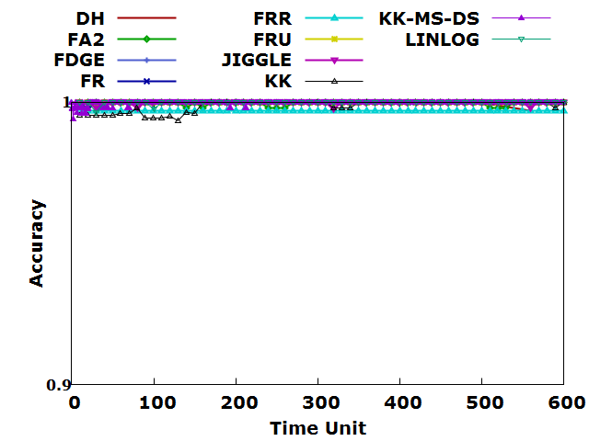

(c)

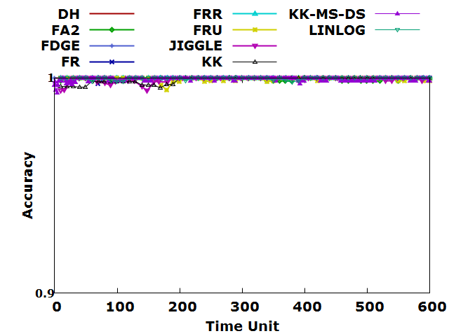

(d)

Figure 19: Accuracy of Node Identifier Matching of (a) 500, (b) 1000, (c) 2000, (d) 3000 nodes and average degree 12 in uniform sensor networks.

Figure 20 illustrated the experimental results of force-directed algorithms in terms of variant number of nodes and a specific average degree. The experimental result of force-directed algorithms was plotted against the average degree 15 and with number of nodes 500, 1000, 2000 and 3000 in uniform sensor network.

The experimental results revealed that the accuracy of each algorithm is stable from the beginning and very close to 1 except FR algorithm at the number of nodes 3000. Moreover, all algorithm does not have significant improvement regardless of the number of nodes 500, 1000, 2000 and 3000 respectively.

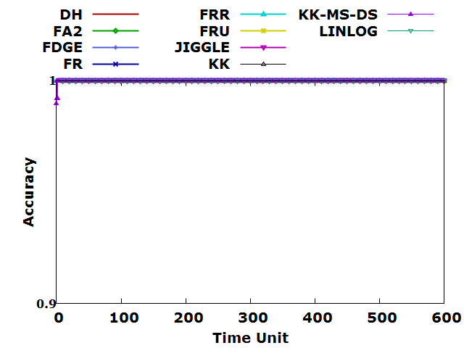

(a)

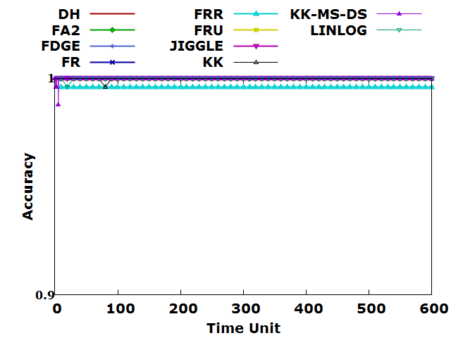

(b)

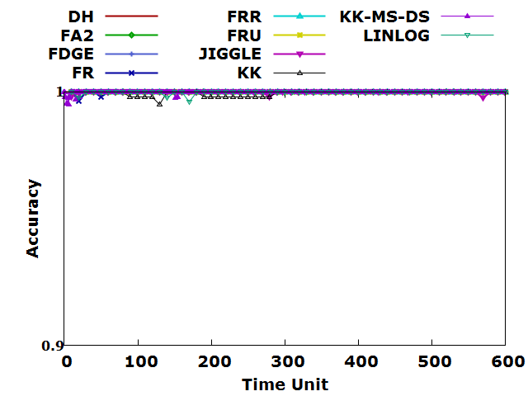

(c)

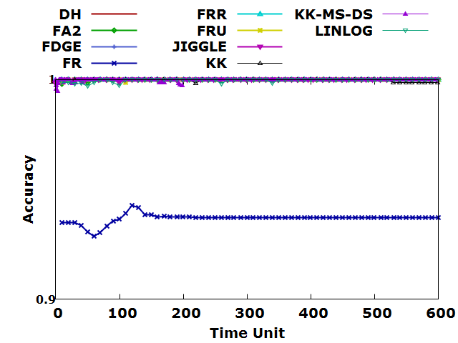

(d)

Figure 20: Accuracy of Node Identifier Matching of (a) 500, (b) 1000, (c) 2000, (d) 3000 nodes and average degree 15 in uniform sensor networks.

### Recall of Node Identifier Matching of Sparse Sensor Networks

Figure 21 illustrated the experimental results of force-directed algorithms in terms of variant number of nodes and a specific average degree. The experimental result of force-directed algorithms was plotted against the average degree 6 and with number of nodes 500, 1000, 2000 and 3000 in sparse sensor network.

The recall of all force-directed algorithms decreased when the number of nodes increased. The experimental results also revealed that KK-MS-DS algorithm achieved the highest recall regardless of the average degree and number of nodes in sparse sensor networks. KK and JIGGLE algorithms have poor performance of recall when the number of nodes is larger than 2000. The recall of FA2 algorithm is undulated in sparse sensor networks with the number of nodes 500, 1000, 2000 and 3000. The recall of FR and FRU algorithms almost unchanged since 100th execution time. Moreover, the recall of algorithms LinLog, DH, FRR and FDGE algorithms are low regardless of the number of nodes in sparse sensor networks.

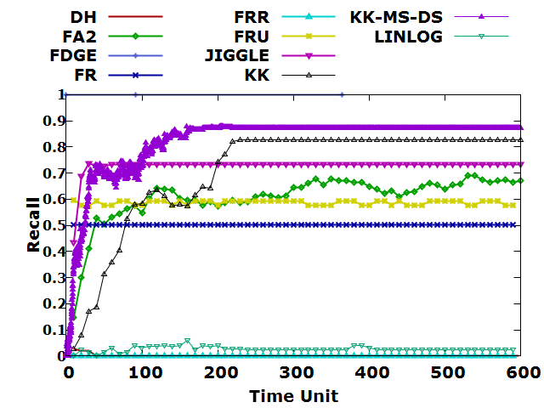

(a)

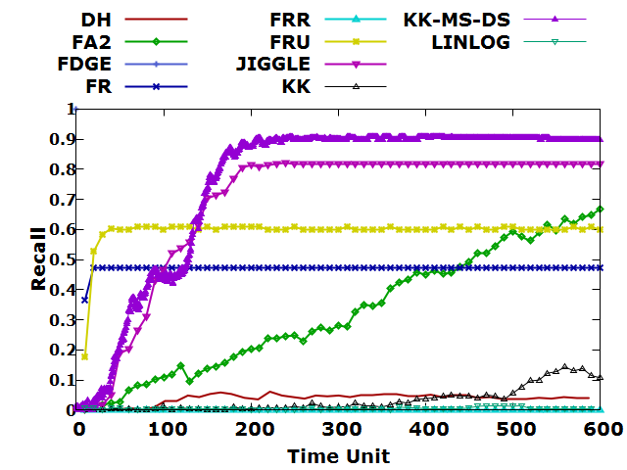

(b)

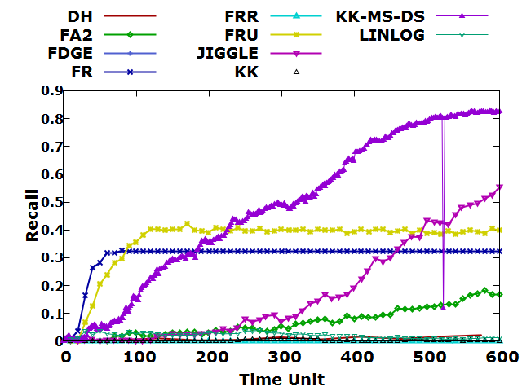

(c)

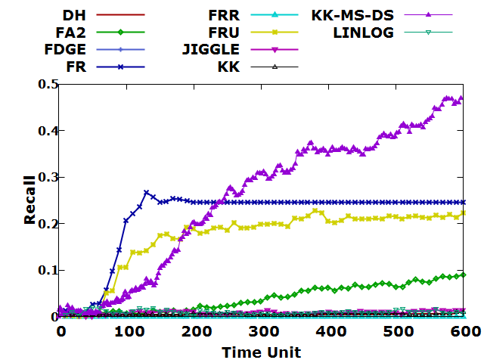

(d)

Figure 21: Recall of Node Identifier Matching of (a) 500, (b) 1000, (c) 2000, (d) 3000 nodes and average degree 6 in sparse sensor networks.

Figure 22 illustrated the experimental results of force-directed algorithms in terms of variant number of nodes and a specific average degree. The experimental result of force-directed algorithms was plotted against the average degree 8 and with number of nodes 500, 1000, 2000 and 3000 in sparse sensor network.

The experimental results also revealed that KK-MS-DS algorithm achieved the high recall regardless of the number of nodes. The recall of FA2 algorithm is undulated at the number of nodes 500, 1000, 2000. Moreover, the KK algorithm does not have significant improvement except the number of nodes 500. JIGGLE algorithms have poor performance of recall when the number of nodes is larger than 1000. The recall of FR and FRU algorithms almost unchanged since 100th execution time.

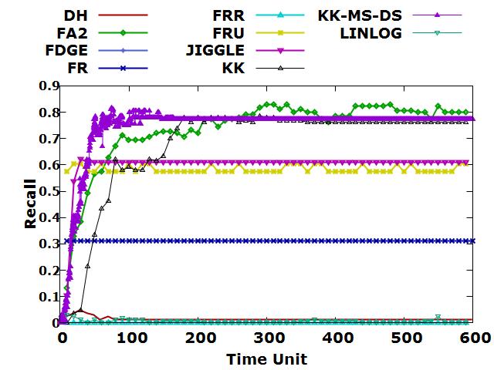

(a)



(b)

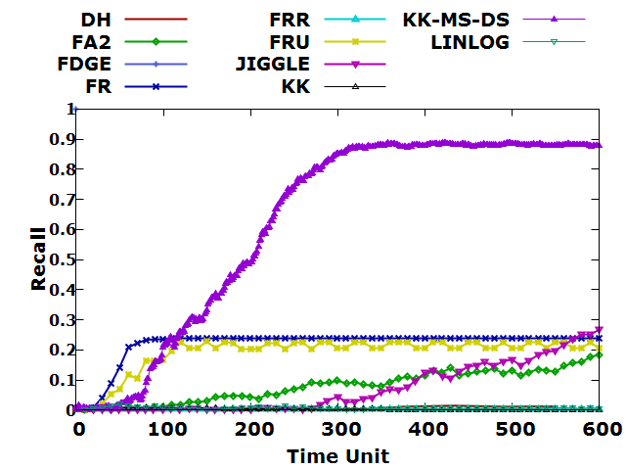

(c)

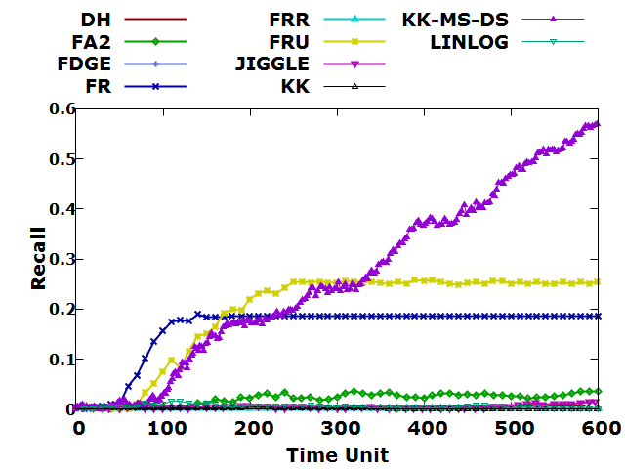

(d)

Figure 22: Recall of Node Identifier Matching of (a) 500, (b) 1000, (c) 2000, (d) 3000 nodes and average degree 8 in sparse sensor networks.

Figure 23 illustrated the experimental results of force-directed algorithms in terms of variant number of nodes and a specific average degree. The experimental result of force-directed algorithms was plotted against the average degree 10 and with number of nodes 500, 1000, 2000 and 3000 in sparse sensor network.

The experimental results also revealed that KK-MS-DS algorithm achieved the high recall with respect to the number of nodes 1000, 2000, 3000. The accuracy of JIGGLE, KK and FA2 algorithm have high performance at the number of nodes 500. However, FRU, FR, FRR, FDGE, DH and LinLog algorithm do not have significant improvement regardless of the number of nodes.

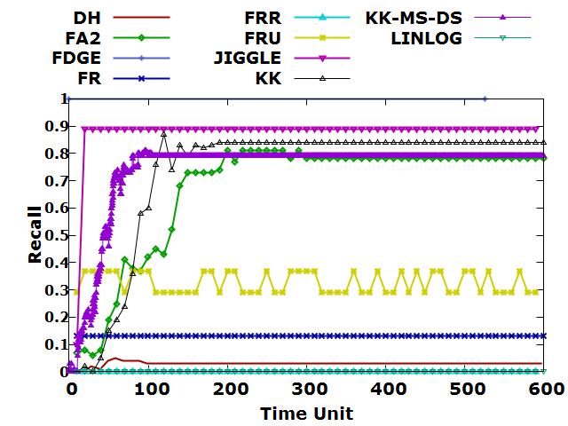

(a)

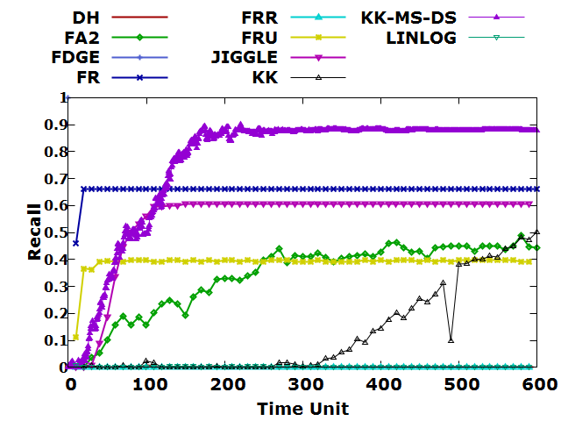

(b)

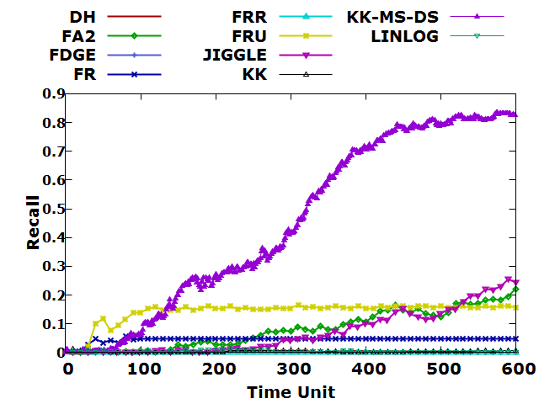

(c)

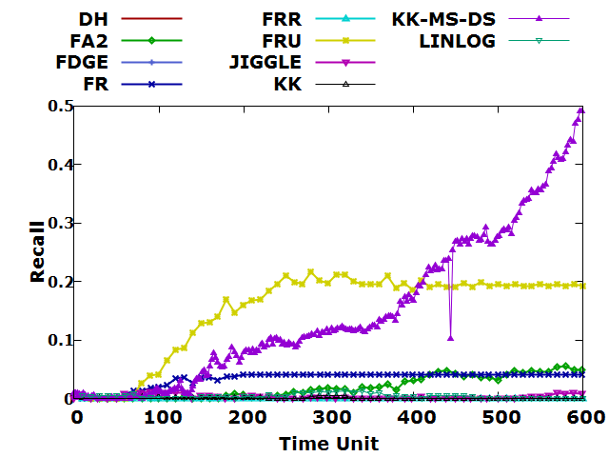

(d)

Figure 23: Recall of Node Identifier Matching of (a) 500, (b) 1000, (c) 2000, (d) 3000 nodes and average degree 10 in sparse sensor networks.

Figure 24 illustrated the experimental results of force-directed algorithms in terms of variant number of nodes and a specific average degree. The experimental result of force-directed algorithms was plotted against the average degree 12 and with number of nodes 500, 1000, 2000 and 3000 in sparse sensor network.

The experimental results also revealed that KK-MS-DS algorithm achieved the high recall with respect to the number of nodes 500, 1000. KK algorithm has the best recall with respect to the number of nodes 500. Moreover, the recall of the FA2 algorithm has the highest performance at the number of nodes 1000. FRU, FR, JIGGLE, FRR, DH, FDGE, LinLog algorithm do not have significant improvement and be stable regardless of the number of nodes.

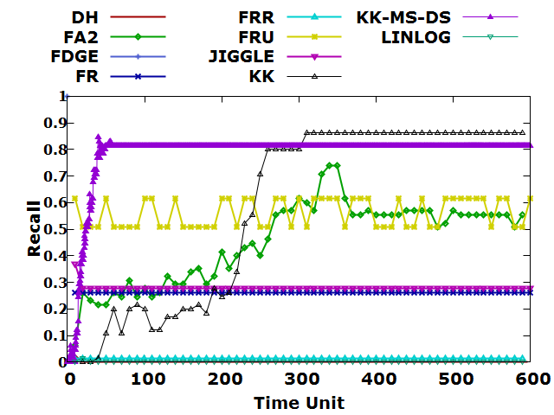

(a)

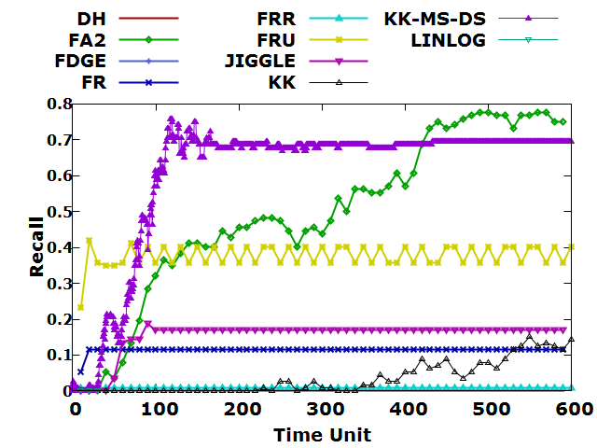

(b)

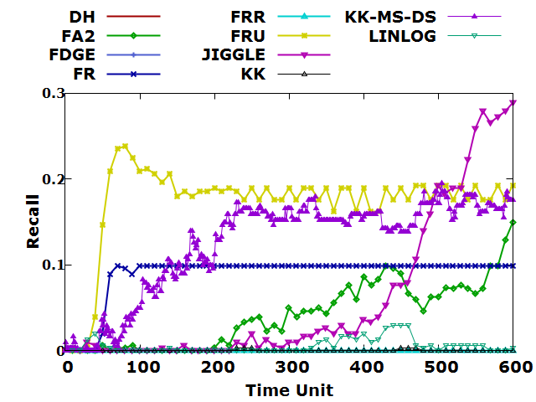

(c)

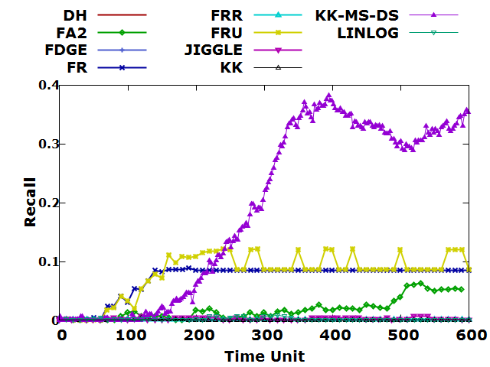

(d)

Figure 24: Recall of Node Identifier Matching of (a) 500, (b) 1000, (c) 2000, (d) 3000 nodes and average degree 12 in sparse sensor networks.

Figure 25 illustrated the experimental results of force-directed algorithms in terms of variant number of nodes and a specific average degree. The experimental result of force-directed algorithms was plotted against the average degree 15 and with number of nodes 500, 1000, 2000 and 3000 in sparse sensor network.

The experimental results also revealed that KK-MS-DS algorithm achieved the high recall with respect to the number of nodes 500, 1000. KK algorithm has the high recall with respect to the number of nodes 500. Moreover, the recall of JIGGLE has a high performance at the number of nodes 1000. FA2 and DH algorithm have slight fluctuations with respect to the number of nodes 2000. However, FRU, FR, DH algorithms do not have significant improvement regardless of the number of nodes. The recall of FRR, FDGE, LinLog algorithm are stable and poor recall since beginning.

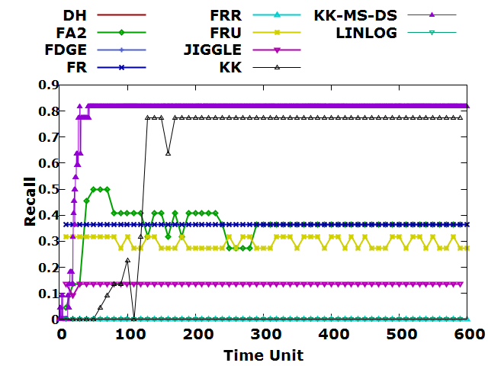

(a)

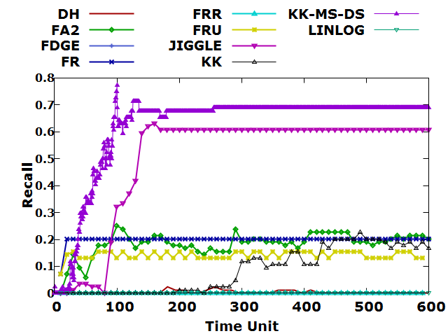

(b)

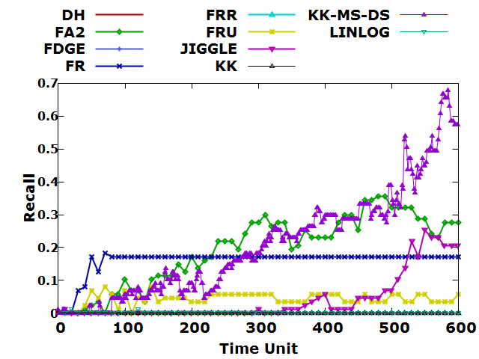

(c)

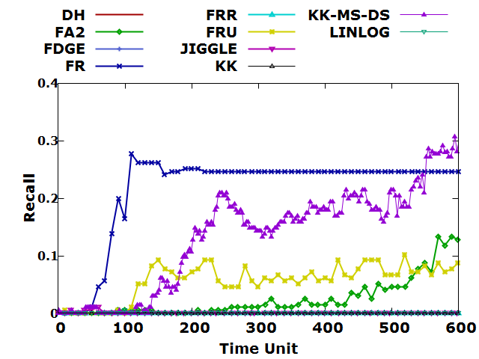

(d)

Figure 25: Recall of Node Identifier Matching of (a) 500, (b) 1000, (c) 2000, (d) 3000 nodes and average degree 15 in sparse sensor networks.

### Recall of Node Identifier Matching of Uniform Sensor Networks

Figure 26 illustrated the experimental results of force-directed algorithms in terms of variant number of nodes and a specific average degree. The experimental result of force-directed algorithms was plotted against the average degree 6 and with number of nodes 500, 1000, 2000 and 3000 in uniform sensor network.

The experimental results also revealed that KK-MS-DS algorithm has the highest recall with respect to the number of nodes 1000, 2000, 3000 and almost reached 90%. KK, JIGGLE, FA2 algorithm achieved the high recall with respect to the number of nodes 500 and also reached 90%. However, the recall of FRU algorithm do not have significant improvement regardless of the number of nodes. The recall of FRR, FR, DH, FDGE, LinLog algorithm are stable since beginning.

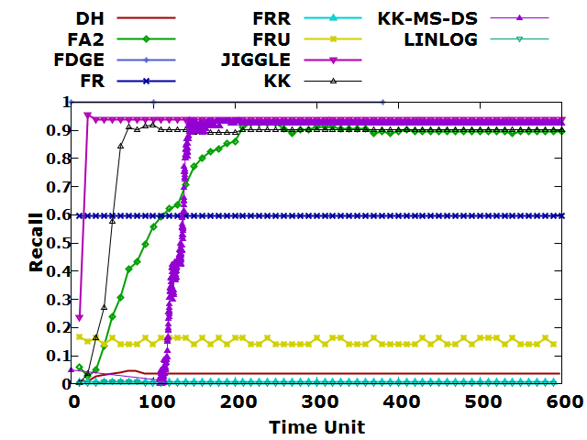

(a)

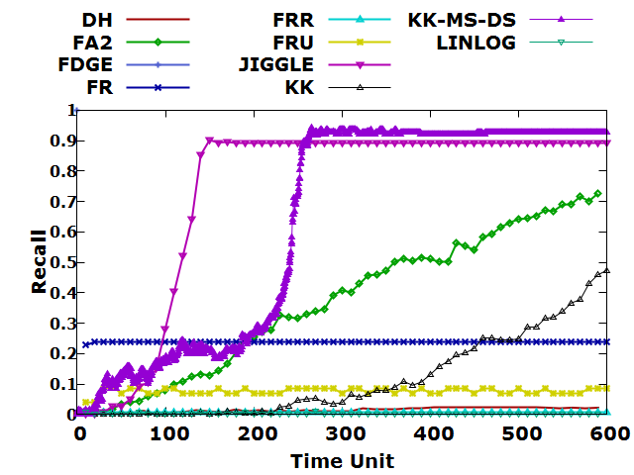

(b)

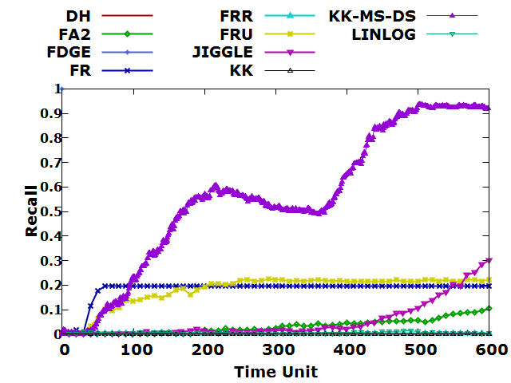

(c)

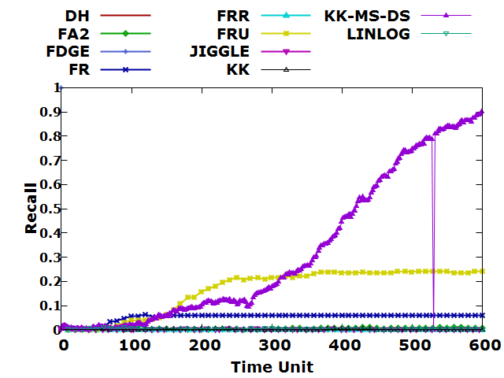

(d)

Figure 26: Recall of Node Identifier Matching of (a) 500, (b) 1000, (c) 2000, (d) 3000 nodes and average degree 6 in uniform sensor networks.

Figure 27 illustrated the experimental results of force-directed algorithms in terms of variant number of nodes and a specific average degree. The experimental result of force-directed algorithms was plotted against the average degree 8 and with number of nodes 500, 1000, 2000 and 3000 in uniform sensor network.

The experimental results also revealed that KK-MS-DS algorithm achieved the highest recall regardless of the number of nodes. KK, FA2 have high recall with respect to the number of nodes 500 and also reached 90%. Moreover, the accuracy of JIGGLE has high performance with respect to the number of nodes 500 and 1000. However, the recall of FRU, FR, FDGE, FRR, DH and LinLog algorithms do not have significant improvement regardless of the number of nodes.

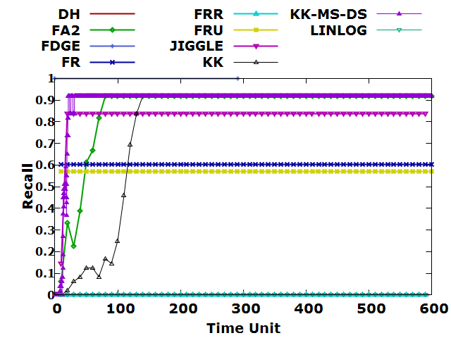

(a)

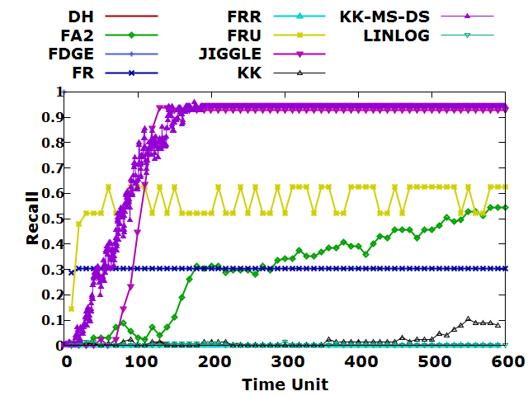

(b)

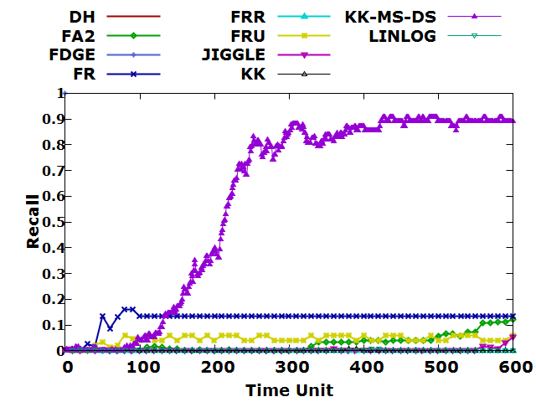

(c)

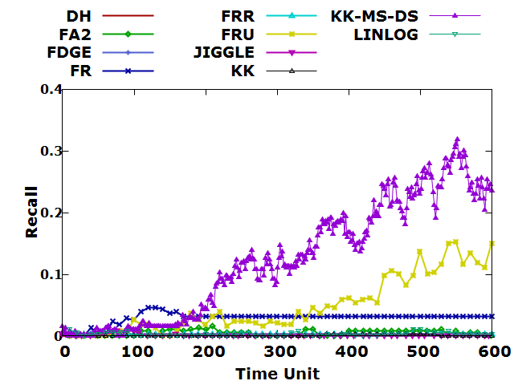

(d)

Figure 27: Recall of Node Identifier Matching of (a) 500, (b) 1000, (c) 2000, (d) 3000 nodes and average degree 8 in uniform sensor networks.

Figure 28 illustrated the experimental results of force-directed algorithms in terms of variant number of nodes and a specific average degree. The experimental result of force-directed algorithms was plotted against the average degree 10 and with number of nodes 500, 1000, 2000 and 3000 in uniform sensor network.

The experimental results also revealed that FRU algorithm achieved the highest recall with respect to the number of nodes 500, that almost reached over 90%. The recall of KK-MS-DS has the high performance at the number of nodes 500 and 1000. KK, FA2 algorithm achieved high recall and became stable since 200th time unit with respect to the number of nodes 500. However, the recall of FRU, FR, FDGE, FRR, DH and LinLog algorithms do not have significant improvement and became stable at the beginning regardless of the number of nodes.

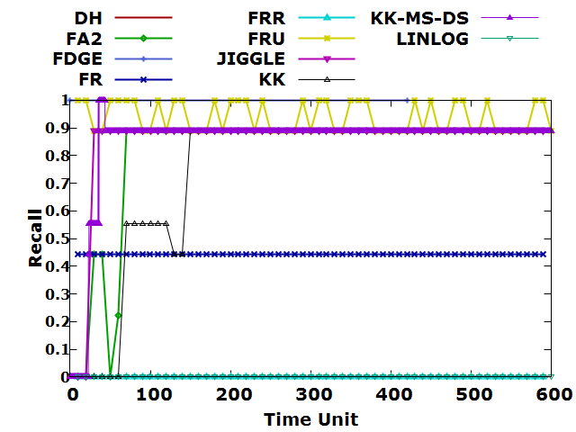

(a)

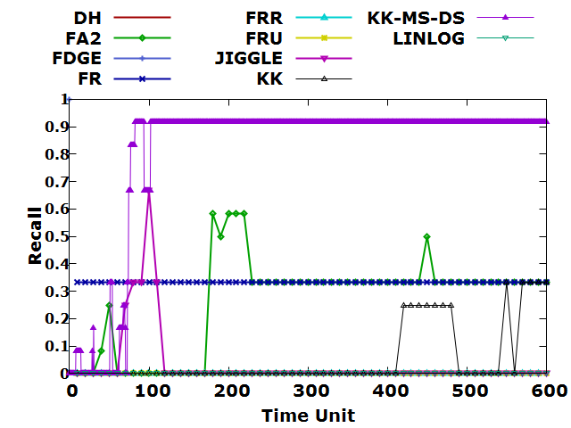

(b)

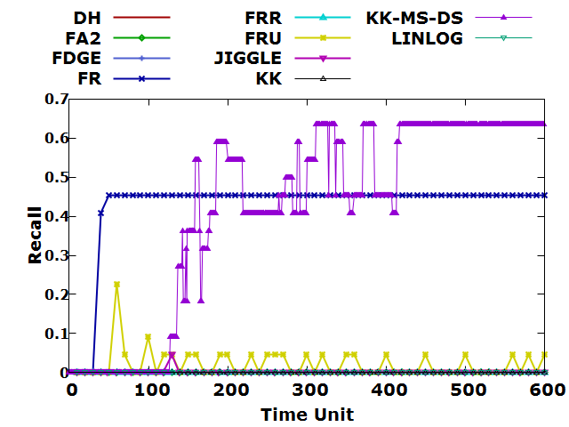

(a)

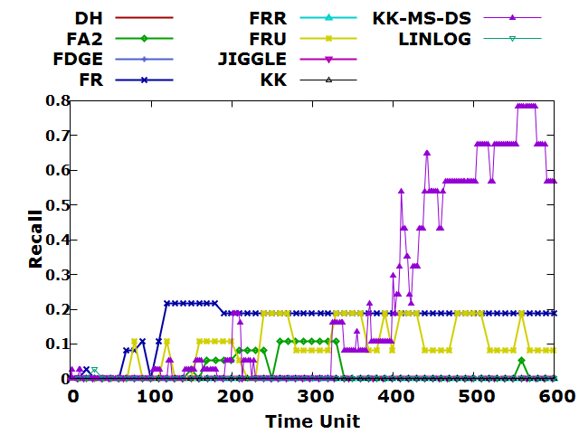

(d)

Figure 28: Recall of Node Identifier Matching of (a) 500, (b) 1000, (c) 2000, (d) 3000 nodes and average degree 10 in uniform sensor networks.

Figure 29 illustrated the experimental results of force-directed algorithms in terms of variant number of nodes and a specific average degree. The experimental result of force-directed algorithms was plotted against the average degree 12 and with number of nodes 500, 1000, 2000 and 3000 in uniform sensor network.

All of the recall does not have significant improvement, reached 0% and became stable at the beginning regardless of the number of nodes

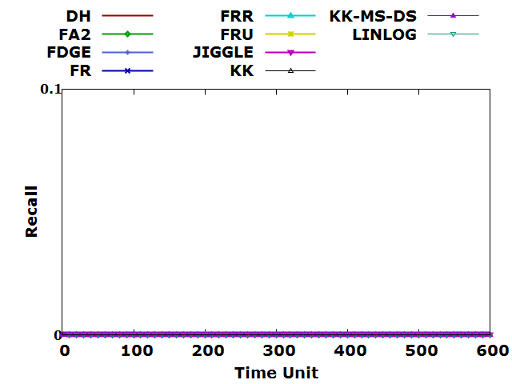

(a)

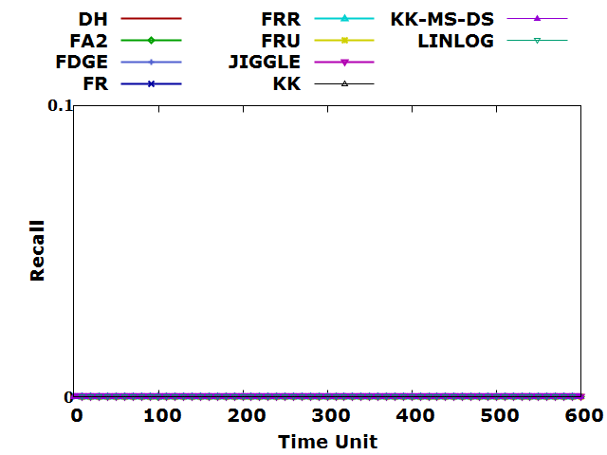

(b)

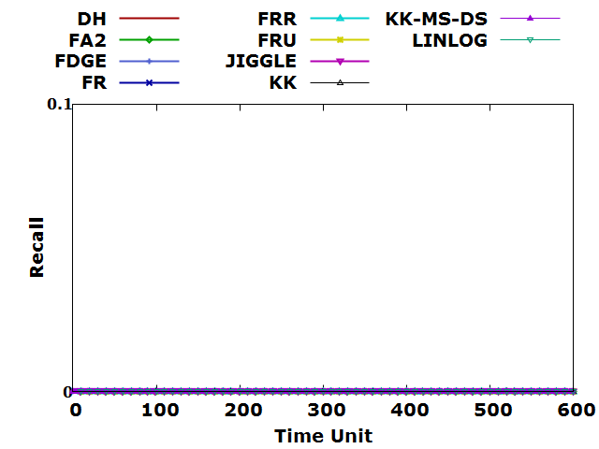

(c)

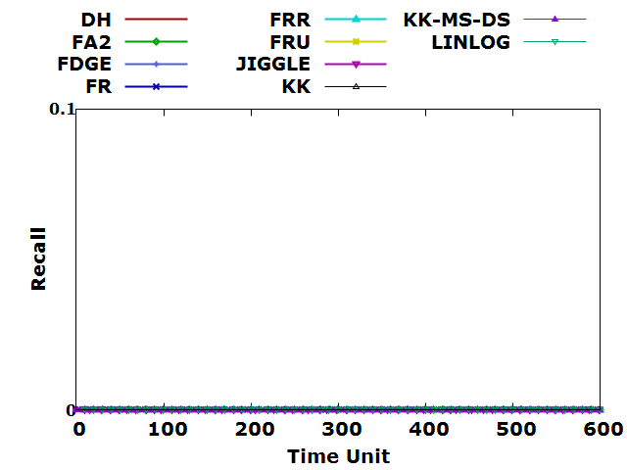

(d)

Figure 29: Recall of Node Identifier Matching of (a) 500, (b) 1000, (c) 2000, (d) 3000 nodes and average degree 12 in uniform sensor networks.

Figure 30 illustrated the experimental results of force-directed algorithms in terms of variant number of nodes and a specific average degree. The experimental result of force-directed algorithms was plotted against the average degree 15 and with number of nodes 500, 1000, 2000 and 3000 in uniform sensor network.

All of the recall does not have significant improvement, reached 0% and became stable at the beginning regardless of the number of nodes except FR algorithm has fluctuation with respect to the number of nodes 3000 and reached over 20%.

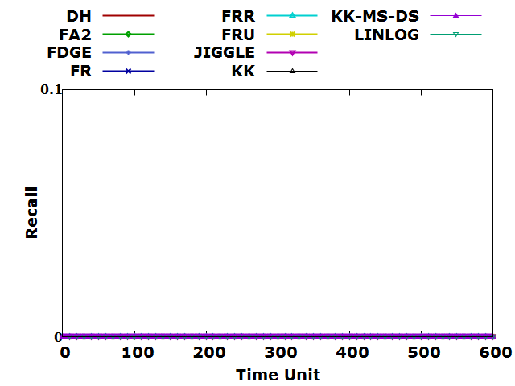

(a)

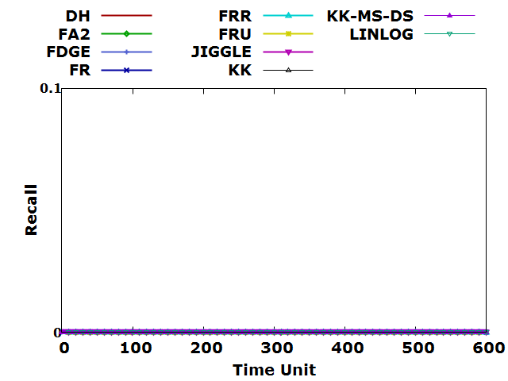

(b)

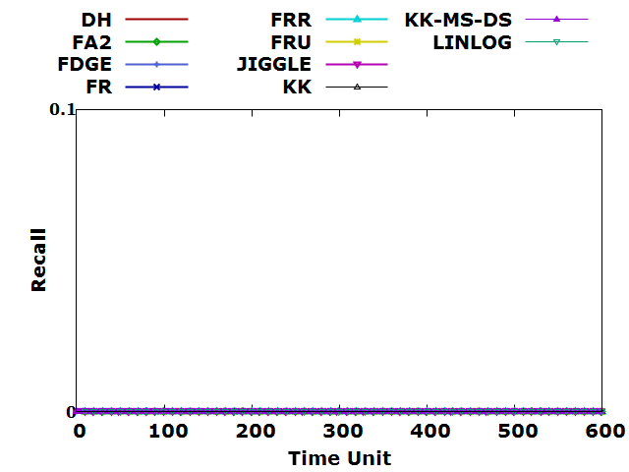

(c)

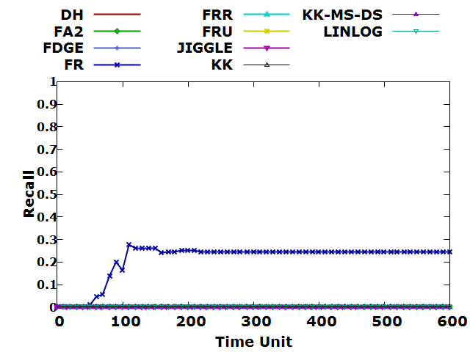

(d)

Figure 30: Recall of Node Identifier Matching of (a) 500, (b) 1000, (c) 2000, (d) 3000 nodes and average degree 15 in uniform sensor networks.

## Result of Hole Count Statistics and Force-directed Algorithms

We concluded the experimental result of count of holes with respect to force-directed algorithms, the number of nodes and the average degree of sparse and uniform sensor networks in Chapter 6.2.1 and 6.2.2 respectively.

### Hole Count Statistics of Sparse Sensor Networks

Figure 31 illustrated the experimental results of force-directed algorithms in terms of variant number of nodes and a specific average degree. The experimental result of force-directed algorithms was plotted against the average degree 6 and with number of nodes 500, 1000, 2000 and 3000 in sparse sensor network. The experimental result showed that high number of hole has been captured by KK-MS-DS, FDGE, FR, FA2, FRU, KK, JIGGLE algorithms especially when the number of nodes is less than 3000. However, DH, FRR and LinLog algorithms captured the smallest number of holes regardless of the average degree and number of nodes in sparse sensor networks. Moreover, we summarized the mean, minimum and maximum count of holes in Table 5.

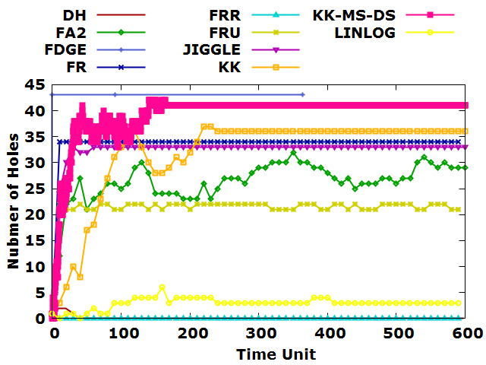

(a)

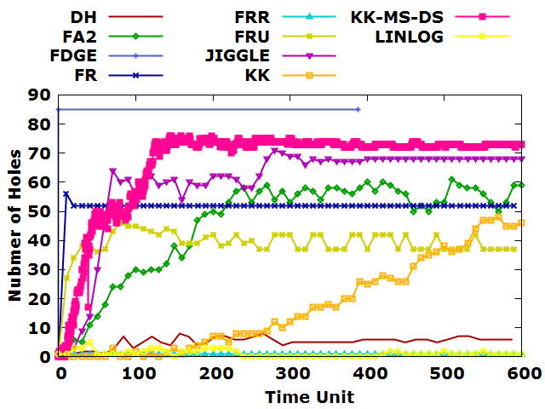

(b)

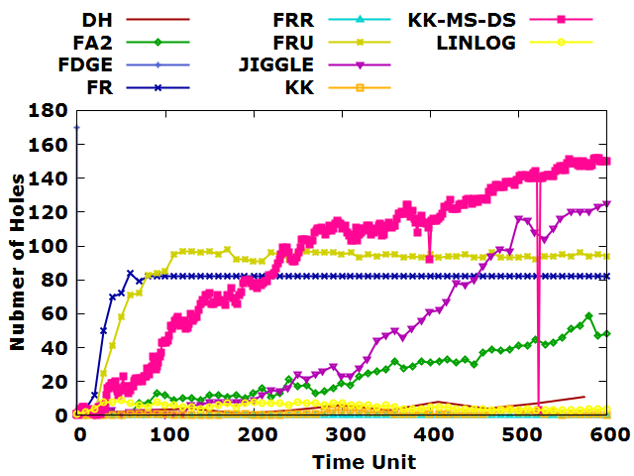

(c)

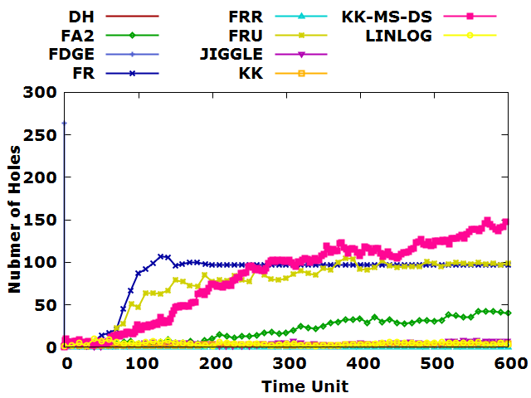

(d)

Figure 31: Hole Count Statistics of (a) 500, (b) 1000, (c) 2000, (d) 3000 nodes and average degree 6 in sparse sensor networks.

Table 5: Mean, standard deviation, maximum and minimum hole count of average degree 6 in sparse sensor network.

|  |  |  |  |  |  |  |
| --- | --- | --- | --- | --- | --- | --- |
| **Average Degree** | **Number of Nodes** | **Force-directed algorithm** | **Standard Deviation of Hole Count** | **Mean of Hole Count** | **Maximum Hole Count** | **Minimum Hole Count** |
| 6 | 500 | DH | 0.381419 | 0.083333 | 2 | 0 |
| FA2 | 3.190027 | 26.6 | 32 | 12 |
| FDGE | 0 | 43 | 43 | 43 |
| FR | 0 | 34 | 34 | 34 |
| FRR | 0 | 0 | 0 | 0 |
| FRU | 0.491898 | 21.61017 | 22 | 21 |
| JIGGLE | 1.226358 | 32.76667 | 33 | 24 |
| KK | 6.671017 | 38.61164 | 42 | 0 |
| KK-MS-DS | 8.048774 | 32.11667 | 37 | 3 |
| LINLOG | 1.025394 | 2.983051 | 6 | 0 |
| 1000 | DH | 1.753533 | 5.23913 | 8 | 1 |
| FA2 | 16.14066 | 46.23333 | 61 | 2 |
| FDGE | 0 | 85 | 85 | 85 |
| FR | 0.520756 | 52.0678 | 56 | 52 |
| FRR | 0 | 1 | 1 | 1 |
| FRU | 3.286353 | 39.42373 | 46 | 27 |
| JIGGLE | 15.78764 | 60.26667 | 71 | 2 |
| KK | 18.69685 | 64.64012 | 76 | 0 |
| KK-MS-DS | 15.94734 | 17.43333 | 48 | 0 |
| LINLOG | 1.13197 | 1.2 | 5 | 0 |
| 2000 | DH | 3.20511 | 4.545455 | 11 | 0 |
| FA2 | 15.3606 | 23.53333 | 59 | 0 |
| FDGE | 0 | 170 | 170 | 170 |
| FR | 14.00858 | 78.61667 | 84 | 4 |
| FRR | 0 | 0 | 0 | 0 |
| FRU | 20.71818 | 87.33333 | 98 | 0 |
| JIGGLE | 43.46698 | 45.66667 | 125 | 0 |
| KK | 49.32848 | 85.46176 | 152 | 0 |
| KK-MS-DS | 0.969011 | 1.1 | 4 | 0 |
| LINLOG | 1.698371 | 5.216667 | 9 | 2 |
| 3000 | DH | 1.581139 | 3 | 5 | 1 |
| FA2 | 13.34911 | 20.26667 | 42 | 1 |
| FDGE | 0 | 264 | 264 | 264 |
| FR | 28.74911 | 85.78333 | 107 | 4 |
| FRR | 0 | 0 | 0 | 0 |
| FRU | 30.2413 | 76.15 | 105 | 0 |
| JIGGLE | 2.070167 | 3.95 | 8 | 0 |
| KK | 48.16382 | 72.22807 | 151 | 0 |
| KK-MS-DS | 0.563484 | 2.566667 | 4 | 2 |
| LINLOG | 1.851172 | 4.283333 | 10 | 1 |

Figure 32 illustrated the experimental results of force-directed algorithms in terms of variant number of nodes and a specific average degree. The experimental result of force-directed algorithms was plotted against the average degree 8 and with number of nodes 500, 1000, 2000 and 3000 in sparse sensor network. The experimental result showed that the count of holes with average degree 8 is similar to the count of holes with average degree 6. All force-directed algorithms produce similar trend of number of holes. Moreover, we summarized the mean, minimum and maximum count of holes in Table 6.

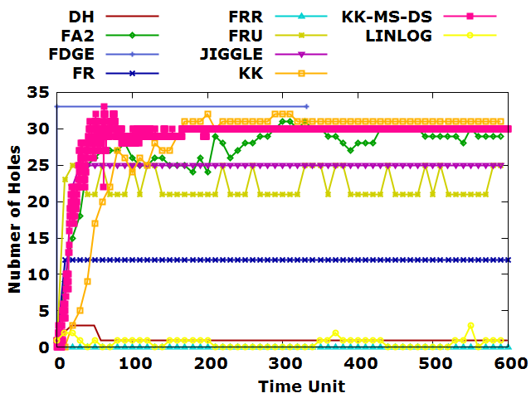

(a)

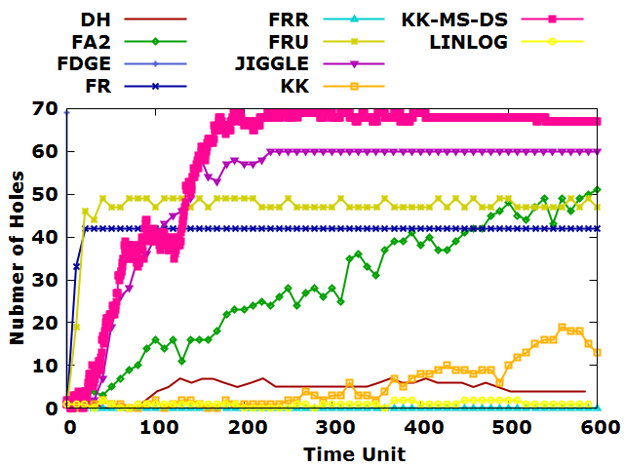

(b)

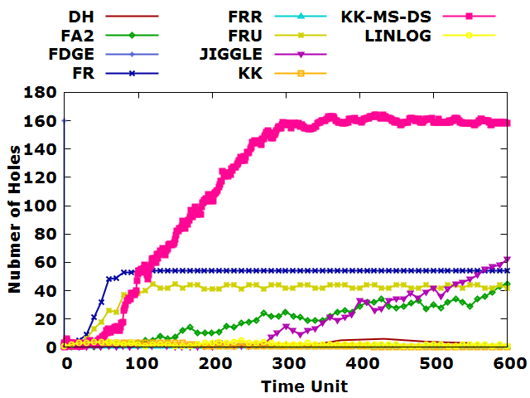

(c)

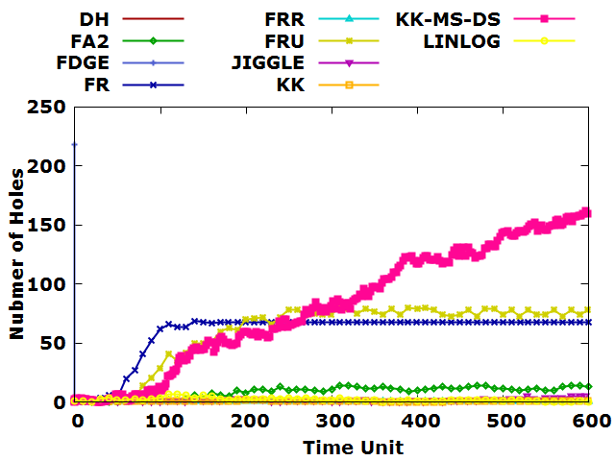

(d)

Figure 32: Hole Count Statistics of (a) 500, (b) 1000, (c) 2000, (d) 3000 nodes and average degree 8 in sparse sensor networks.

Table 6: Mean, standard deviation, maximum and minimum hole count of average degree 8 in sparse sensor network.

|  |  |  |  |  |  |  |
| --- | --- | --- | --- | --- | --- | --- |
| **Average Degree** | **Number of Nodes** | **Force-directed algorithm** | **Standard Deviation of Hole Count** | **Mean of Hole Count** | **Maximum Hole Count** | **Minimum Hole Count** |
| 8 | 500 | DH | 0.515028 | 1.15 | 3 | 1 |
| FA2 | 3.720589 | 27.32203 | 31 | 9 |
| FDGE | 0 | 33 | 33 | 33 |
| FR | 0 | 12 | 12 | 12 |
| FRR | 0 | 0 | 0 | 0 |
| FRU | 1.853173 | 22.25424 | 25 | 21 |
| JIGGLE | 2.369073 | 24.64407 | 25 | 7 |
| KK | 4.701353 | 28.79912 | 33 | 0 |
| KK-MS-DS | 7.152264 | 27.98305 | 32 | 0 |
| LINLOG | 0.672582 | 0.59322 | 3 | 0 |
| 1000 | DH | 2.025603 | 4.613636 | 7 | 0 |
| FA2 | 14.48338 | 29.16667 | 51 | 0 |
| FDGE | 0 | 69 | 69 | 69 |
| FR | 1.161895 | 41.85 | 42 | 33 |
| FRR | 0 | 0 | 0 | 0 |
| FRU | 3.86802 | 47.23333 | 49 | 19 |
| JIGGLE | 16.189 | 51.86667 | 60 | 1 |
| KK | 19.71108 | 57.46754 | 69 | 0 |
| KK-MS-DS | 5.472556 | 5.483333 | 19 | 0 |
| LINLOG | 0.615882 | 1 | 2 | 0 |
| 2000 | DH | 2.20101 | 2.2 | 6 | 0 |
| FA2 | 12.17105 | 19.63333 | 45 | 0 |
| FDGE | 0 | 160 | 160 | 160 |
| FR | 11.78939 | 50.4 | 54 | 0 |
| FRR | 0 | 1 | 1 | 1 |
| FRU | 10.4016 | 39.1 | 45 | 0 |
| JIGGLE | 19.36736 | 17.91667 | 62 | 0 |
| KK | 60.01836 | 108.7578 | 164 | 0 |
| KK-MS-DS | 1.140423 | 1.233333 | 3 | 0 |
| LINLOG | 0.932011 | 2.25 | 5 | 1 |
| 3000 | DH | 1.341641 | 1.4 | 3 | 0 |
| FA2 | 4.482987 | 8.933333 | 14 | 0 |
| FDGE | 0 | 218 | 218 | 218 |
| FR | 19.4618 | 60.13333 | 69 | 0 |
| FRR | 0 | 1 | 1 | 1 |
| FRU | 26.23907 | 60.45 | 80 | 0 |
| JIGGLE | 1.455459 | 1.516667 | 5 | 0 |
| KK | 53.51741 | 73.66045 | 165 | 0 |
| KK-MS-DS | 0.423531 | 0.916667 | 2 | 0 |
| LINLOG | 1.663839 | 2.333333 | 7 | 0 |

Figure 33 illustrated the experimental results of force-directed algorithms in terms of variant number of nodes and a specific average degree. The experimental result of force-directed algorithms was plotted against the average degree 10 and with number of nodes 500, 1000, 2000 and 3000 in sparse sensor network. The experimental result showed that the count of holes with average degree 10 is similar to the count of holes with average degree 6 and 8. All force-directed algorithms produce similar trend of number of holes. Moreover, we summarized the mean, minimum and maximum count of holes in Table 7.

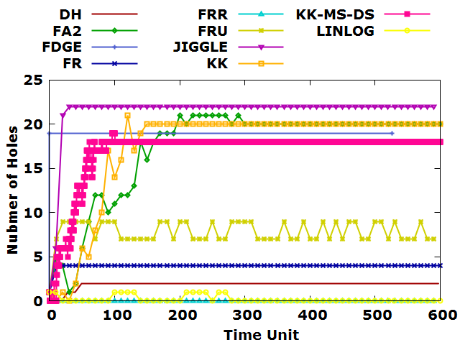

(a)

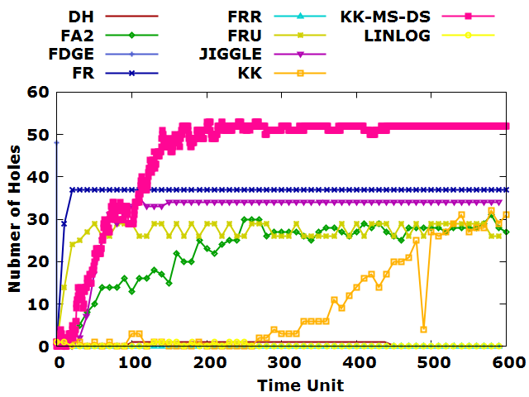

(b)

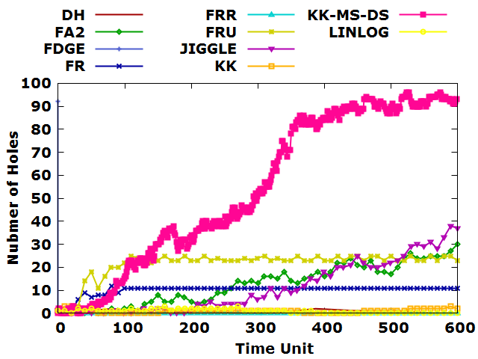

(c)

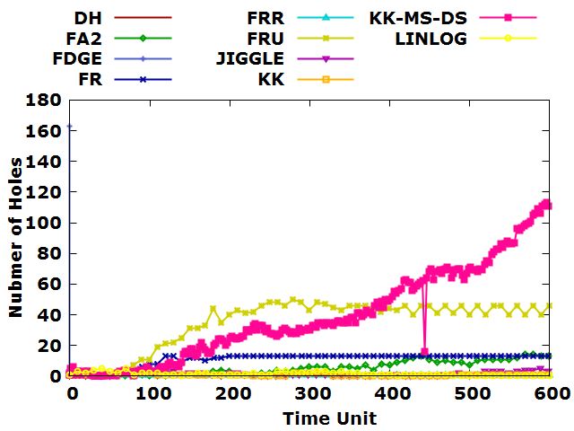

(d)

Figure 33: Hole Count Statistics of (a) 500, (b) 1000, (c) 2000, (d) 3000 nodes and average degree 10 in sparse sensor networks.

Table 7: Mean, standard deviation, maximum and minimum hole count of average degree 10 in sparse sensor network.

|  |  |  |  |  |  |  |
| --- | --- | --- | --- | --- | --- | --- |
| **Average Degree** | **Number of Nodes** | **Force-directed algorithm** | **Standard Deviation of Hole Count** | **Mean of Hole Count** | **Maximum Hole Count** | **Minimum Hole Count** |
| 10 | 500 | DH | 0.399152 | 1.9 | 2 | 0 |
| FA2 | 5.221749 | 17.43333 | 21 | 1 |
| FDGE | 0 | 19 | 19 | 19 |
| FR | 0 | 4 | 4 | 4 |
| FRR | 0 | 0 | 0 | 0 |
| FRU | 1.004956 | 7.915254 | 9 | 7 |
| JIGGLE | 2.084846 | 21.71186 | 22 | 6 |
| KK | 3.247112 | 17.10695 | 19 | 0 |
| KK-MS-DS | 5.639449 | 17.6 | 21 | 0 |
| LINLOG | 0.390205 | 0.183333 | 1 | 0 |
| 1000 | DH | 0.496587 | 0.591837 | 1 | 0 |
| FA2 | 7.446912 | 22.96667 | 31 | 0 |
| FDGE | 0 | 48 | 48 | 48 |
| FR | 1.032796 | 36.86667 | 37 | 29 |
| FRR | 0 | 0 | 0 | 0 |
| FRU | 2.356582 | 27.28814 | 29 | 14 |
| JIGGLE | 8.315238 | 31.16949 | 35 | 0 |
| KK | 14.03647 | 44.66575 | 53 | 0 |
| KK-MS-DS | 11.13781 | 9.5 | 32 | 0 |
| LINLOG | 0.378406 | 0.169492 | 1 | 0 |
| 2000 | DH | 0.823273 | 0.7 | 2 | 0 |
| FA2 | 8.848298 | 12.75 | 30 | 0 |
| FDGE | 0 | 92 | 92 | 92 |
| FR | 2.113917 | 10.35 | 12 | 0 |
| FRR | 0 | 0 | 0 | 0 |
| FRU | 5.481762 | 21.86667 | 25 | 0 |
| JIGGLE | 11.32898 | 11.4 | 38 | 0 |
| KK | 33.84532 | 52.43294 | 96 | 0 |
| KK-MS-DS | 0.808675 | 0.916667 | 3 | 0 |
| LINLOG | 0.884742 | 0.883333 | 3 | 0 |
| 3000 | DH | 0.447214 | 0.2 | 1 | 0 |
| FA2 | 4.54839 | 5.416667 | 14 | 0 |
| FDGE | 0 | 163 | 163 | 163 |
| FR | 4.163705 | 10.95 | 13 | 0 |
| FRR | 0 | 1 | 1 | 1 |
| FRU | 15.81714 | 35.23333 | 50 | 0 |
| JIGGLE | 1.408108 | 1.316667 | 5 | 0 |
| KK | 31.1553 | 35.768 | 115 | 0 |
| KK-MS-DS | 0.692983 | 0.833333 | 2 | 0 |
| LINLOG | 1.224053 | 1.4 | 5 | 0 |

Figure 34 illustrated the experimental results of force-directed algorithms in terms of variant number of nodes and a specific average degree. The experimental result of force-directed algorithms was plotted against the average degree 12 and with number of nodes 500, 1000, 2000 and 3000 in sparse sensor network. The experimental result showed that the count of holes with average degree 12 is similar to the count of holes with average degree 6, 8 and 10 except for the KK-MS-DS algorithm. The number of holes detected decreased when the number of nodes larger than 1000. Moreover, we summarized the mean, minimum and maximum count of holes in Table 8.

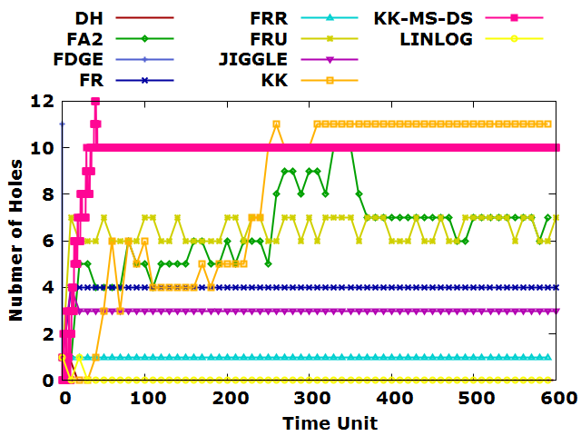

(a)

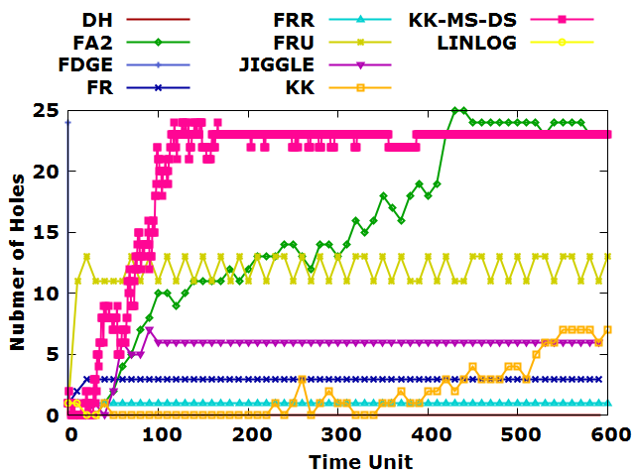

(b)

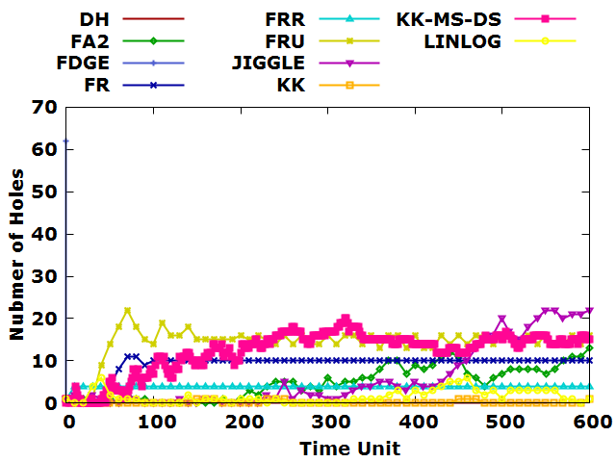

(c)

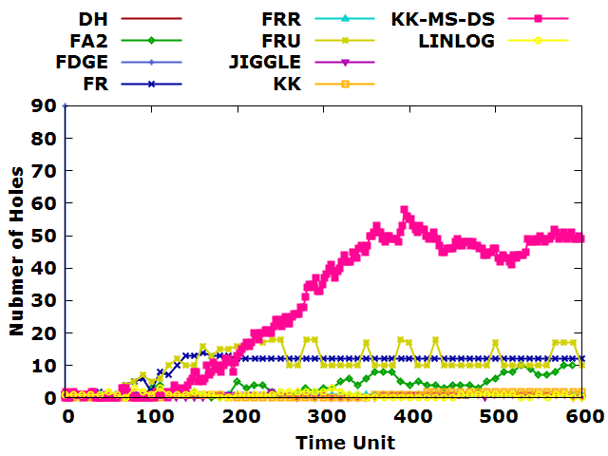

(d)

Figure 34: Hole Count Statistics of (a) 500, (b) 1000, (c) 2000, (d) 3000 nodes and average degree 12 in sparse sensor networks.

Table 8: Mean, standard deviation, maximum and minimum hole count of average degree 12 in sparse sensor network.

|  |  |  |  |  |  |  |
| --- | --- | --- | --- | --- | --- | --- |
| **Average Degree** | **Number of Nodes** | **Force-directed algorithm** | **Standard Deviation of Hole Count** | **Mean of Hole Count** | **Maximum Hole Count** | **Minimum Hole Count** |
| 12 | 500 | DH | 0.129099 | 0.016667 | 1 | 0 |
| FA2 | 1.693837 | 6.423729 | 10 | 1 |
| FDGE | 0 | 11 | 11 | 11 |
| FR | 0 | 4 | 4 | 4 |
| FRR | 0 | 1 | 1 | 1 |
| FRU | 0.504219 | 6.5 | 7 | 6 |
| JIGGLE | 0.129099 | 3.016667 | 4 | 3 |
| KK | 1.459026 | 9.692911 | 12 | 0 |
| KK-MS-DS | 3.621241 | 8.084746 | 11 | 0 |
| LINLOG | 0.130189 | 0.016949 | 1 | 0 |
| 1000 | DH | 0 | 0 | 0 | 0 |
| FA2 | 7.322176 | 15.15254 | 25 | 0 |
| FDGE | 0 | 24 | 24 | 24 |
| FR | 0.130189 | 2.983051 | 3 | 2 |
| FRR | 0 | 1 | 1 | 1 |
| FRU | 1.008439 | 12 | 13 | 11 |
| JIGGLE | 1.546475 | 5.525424 | 7 | 0 |
| KK | 6.593141 | 19.99411 | 24 | 0 |
| KK-MS-DS | 2.305667 | 1.85 | 7 | 0 |
| LINLOG | 0.57735 | 0.333333 | 1 | 0 |
| 2000 | DH | 0 | 0 | 0 | 0 |
| FA2 | 3.909246 | 4.85 | 13 | 0 |
| FDGE | 0 | 62 | 62 | 62 |
| FR | 2.566846 | 9.233333 | 11 | 0 |
| FRR | 0 | 4 | 4 | 4 |
| FRU | 3.712059 | 14.48333 | 22 | 0 |
| JIGGLE | 7.489805 | 6.066667 | 22 | 0 |
| KK | 5.391428 | 11.58869 | 20 | 0 |
| KK-MS-DS | 0.375823 | 0.166667 | 1 | 0 |
| LINLOG | 1.599435 | 1.533333 | 6 | 0 |
| 3000 | DH | 0 | 0 | 0 | 0 |
| FA2 | 2.847169 | 3.881356 | 10 | 0 |
| FDGE | 0 | 90 | 90 | 90 |
| FR | 3.863344 | 10.3 | 14 | 0 |
| FRR | 0 | 1 | 1 | 1 |
| FRU | 5.228426 | 10.95 | 18 | 0 |
| JIGGLE | 0.555151 | 0.716667 | 2 | 0 |
| KK | 20.7263 | 27.28745 | 58 | 0 |
| KK-MS-DS | 0.879619 | 0.85 | 2 | 0 |
| LINLOG | 0.832089 | 0.95 | 3 | 0 |

Figure 35 illustrated the experimental results of force-directed algorithms in terms of variant number of nodes and a specific average degree. The experimental result of force-directed algorithms was plotted against the average degree 15 and with number of nodes 500, 1000, 2000 and 3000 in sparse sensor network. The experimental result showed that there are few number of holes existed in datasets when the average degree is high. KK and KK-MS-DS algorithms detected about 7 holes when the number of nodes is 500. For the number of node in 1000, 2000 and 3000, KK-MS-DS algorithm captured the highest number of holes. Moreover, we summarized the mean, minimum and maximum count of holes in Table 9.

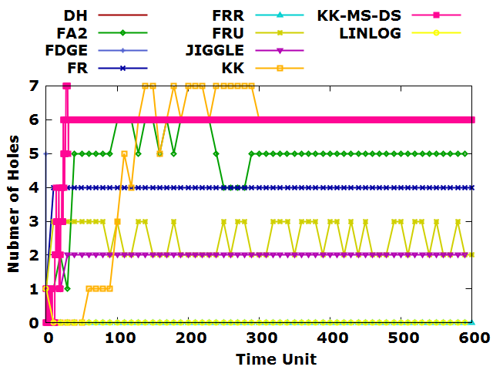

(a)

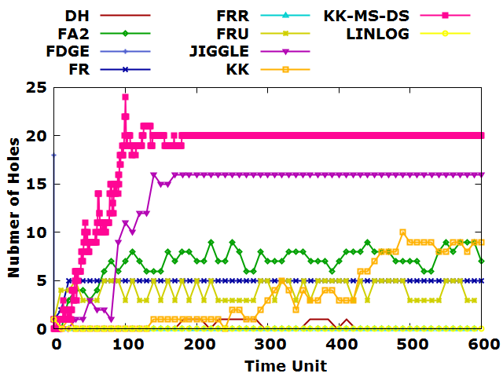

(b)

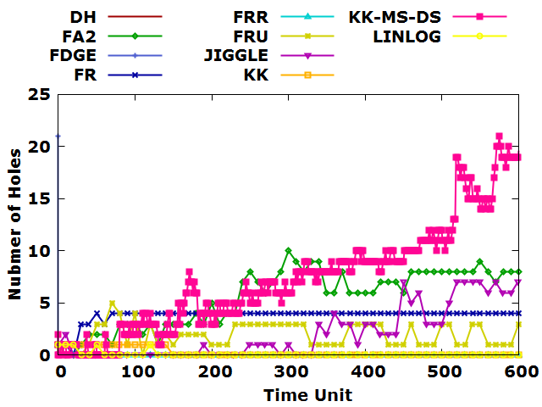

(c)

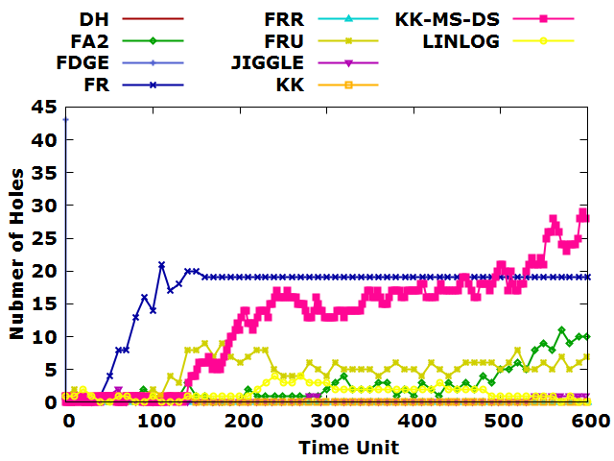

(d)

Figure 36: Hole Count Statistics of (a) 500, (b) 1000, (c) 2000, (d) 3000 nodes and average degree 15 in sparse sensor networks.

Table 9: Mean, standard deviation, maximum and minimum hole count of average degree 15 in sparse sensor network.

|  |  |  |  |  |  |  |
| --- | --- | --- | --- | --- | --- | --- |
| **Average Degree** | **Number of Nodes** | **Force-directed algorithm** | **Standard Deviation of Hole Count** | **Mean of Hole Count** | **Maximum Hole Count** | **Minimum Hole Count** |
| 15 | 500 | DH | 0 | 0 | 0 | 0 |
| FA2 | 0.980225 | 4.932203 | 6 | 1 |
| FDGE | 0 | 5 | 5 | 5 |
| FR | 0 | 4 | 4 | 4 |
| FRR | 0 | 0 | 0 | 0 |
| FRU | 0.503939 | 2.516667 | 3 | 2 |
| JIGGLE | 0.182521 | 1.966102 | 2 | 1 |
| KK | 0.950022 | 5.814658 | 7 | 0 |
| KK-MS-DS | 2.168258 | 5.237288 | 7 | 0 |
| LINLOG | 0 | 0 | 0 | 0 |
| 1000 | DH | 0.440755 | 0.255319 | 1 | 0 |
| FA2 | 1.661376 | 6.95 | 9 | 0 |
| FDGE | 0 | 18 | 18 | 18 |
| FR | 0.387298 | 4.95 | 5 | 2 |
| FRR | 0 | 0 | 0 | 0 |
| FRU | 0.991194 | 4.016949 | 5 | 3 |
| JIGGLE | 5.10356 | 13.56667 | 16 | 0 |
| KK | 5.272023 | 17.76504 | 24 | 0 |
| KK-MS-DS | 3.406997 | 3.55 | 10 | 0 |
| LINLOG | 0 | 0 | 0 | 0 |
| 2000 | DH | 0 | 0 | 0 | 0 |
| FA2 | 2.7065 | 5.616667 | 10 | 0 |
| FDGE | 0 | 21 | 21 | 21 |
| FR | 0.668078 | 3.833333 | 4 | 0 |
| FRR | 0 | 0 | 0 | 0 |
| FRU | 1.17158 | 1.983333 | 5 | 0 |
| JIGGLE | 2.534285 | 2.133333 | 7 | 0 |
| KK | 5.363632 | 6.992042 | 21 | 0 |
| KK-MS-DS | 0.426522 | 0.233333 | 1 | 0 |
| LINLOG | 0.251549 | 0.066667 | 1 | 0 |
| 3000 | DH | 0 | 0 | 0 | 0 |
| FA2 | 2.834961 | 2.616667 | 11 | 0 |
| FDGE | 0 | 43 | 43 | 43 |
| FR | 5.359268 | 16.91667 | 21 | 0 |
| FRR | 0 | 0 | 0 | 0 |
| FRU | 2.410195 | 4.766667 | 9 | 0 |
| JIGGLE | 0.473895 | 0.25 | 2 | 0 |
| KK | 8.324792 | 11.25941 | 29 | 0 |
| KK-MS-DS | 0.426522 | 0.233333 | 1 | 0 |
| LINLOG | 1.016669 | 1.483333 | 4 | 0 |

### Hole Count Statistics of Uniform Sensor Networks

Figure 36 illustrated the experimental results of force-directed algorithms in terms of variant number of nodes and a specific average degree. The experimental result of force-directed algorithms was plotted against the average degree 6 and with number of nodes 500, 1000, 2000 and 3000 in uniform sensor network. The experimental result showed that high number of hole has been captured by KK-MS-DS, FDGE, FA2, KK and JIGGLE algorithms especially when the number of nodes is less than 1000. However, FR, FRU, FRR, DH and LinLog algorithms captured the smallest number of holes regardless of the average degree and number of nodes in sparse sensor networks. KK-MS-DS algorithm captured the highest number of hole even when the number of nodes is in 2000 and 3000. Moreover, we summarized the mean, minimum and maximum count of holes in Table 10.

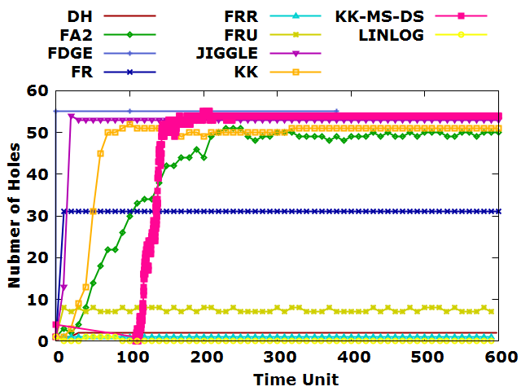

(a)

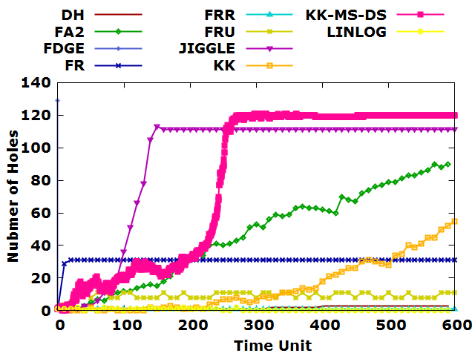

(b)

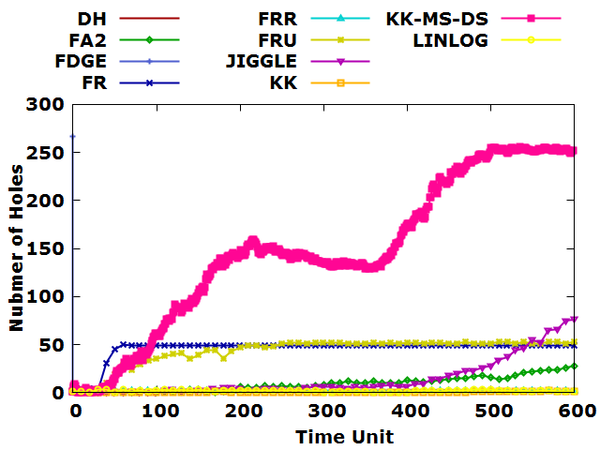

(c)

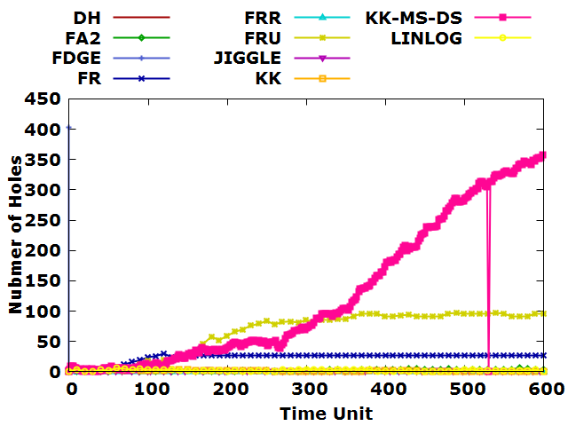

(d)

Figure 37: Hole Count Statistics of (a) 500, (b) 1000, (c) 2000, (d) 3000 nodes and average degree 6 in uniform sensor networks.

Table 10: Mean, standard deviation, maximum and minimum hole count of average degree 6 in uniform sensor network.

|  |  |  |  |  |  |  |
| --- | --- | --- | --- | --- | --- | --- |
| **Average Degree** | **Number of Nodes** | **Force-directed algorithm** | **Standard Deviation of Hole Count** | **Mean of Hole Count** | **Maximum Hole Count** | **Minimum Hole Count** |
| 6 | 500 | DH | 0.180006 | 1.966667 | 2 | 1 |
| FA2 | 13.43821 | 42.13333 | 51 | 2 |
| FDGE | 0 | 55 | 55 | 55 |
| FR | 0 | 31 | 31 | 31 |
| FRR | 0 | 1 | 1 | 1 |
| FRU | 0.49555 | 7.423729 | 8 | 7 |
| JIGGLE | 5.138827 | 52.35 | 54 | 13 |
| KK | 8.464458 | 51.94216 | 55 | 0 |
| KK-MS-DS | 11.314 | 47.26667 | 52 | 1 |
| LINLOG | 0.280894 | 0.084746 | 1 | 0 |
| 1000 | DH | 0.949442 | 1.837209 | 3 | 0 |
| FA2 | 28.24173 | 46.55932 | 90 | 1 |
| FDGE | 0 | 129 | 129 | 129 |
| FR | 0.258199 | 30.96667 | 31 | 29 |
| FRR | 0 | 1 | 1 | 1 |
| FRU | 1.767887 | 9.4 | 12 | 4 |
| JIGGLE | 38.76487 | 91.71667 | 113 | 0 |
| KK | 47.00752 | 83.07603 | 121 | 0 |
| KK-MS-DS | 16.12154 | 14.83333 | 55 | 0 |
| LINLOG | 0.651842 | 0.457627 | 2 | 0 |
| 2000 | DH | 0.875595 | 0.9 | 2 | 0 |
| FA2 | 7.684823 | 9.166667 | 28 | 0 |
| FDGE | 0 | 267 | 267 | 267 |
| FR | 10.23779 | 46.36667 | 50 | 2 |
| FRR | 0 | 2 | 2 | 2 |
| FRU | 13.59249 | 44.08333 | 53 | 0 |
| JIGGLE | 20.28375 | 14.4 | 76 | 0 |
| KK | 80.35794 | 143.0874 | 256 | 0 |
| KK-MS-DS | 0.482461 | 0.266667 | 2 | 0 |
| LINLOG | 0.92425 | 1.6 | 3 | 0 |
| 3000 | DH | 0.5 | 0.25 | 1 | 0 |
| FA2 | 1.519274 | 2.216667 | 6 | 0 |
| FDGE | 0 | 403 | 403 | 403 |
| FR | 7.356518 | 24.01667 | 30 | 1 |
| FRR | 0 | 0 | 0 | 0 |
| FRU | 35.261 | 66.13333 | 97 | 0 |
| JIGGLE | 0.839693 | 0.8 | 3 | 0 |
| KK | 120.4994 | 118.9248 | 359 | 0 |
| KK-MS-DS | 1.016808 | 1.5 | 3 | 0 |
| LINLOG | 1.229924 | 2.25 | 6 | 0 |

Figure 37 illustrated the experimental results of force-directed algorithms in terms of variant number of nodes and a specific average degree. The experimental result of force-directed algorithms was plotted against the average degree 8 and with number of nodes 500, 1000, 2000 and 3000 in uniform sensor network. The experimental result showed that the count of holes with average degree 8 is similar to the count of holes with average degree 6. All force-directed algorithms produce similar trend of number of holes. Moreover, we summarized the mean, minimum and maximum count of holes in Table 11.

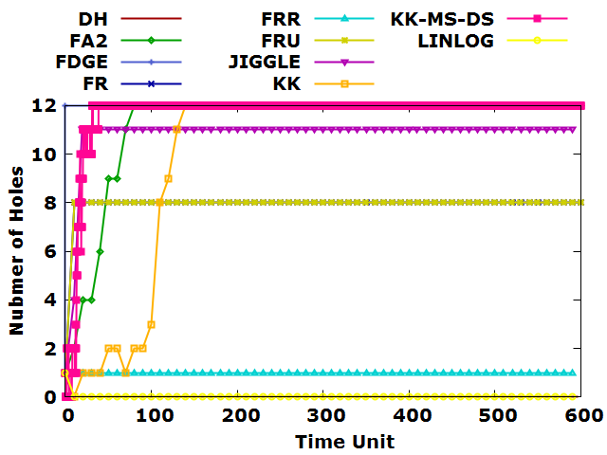

(a)

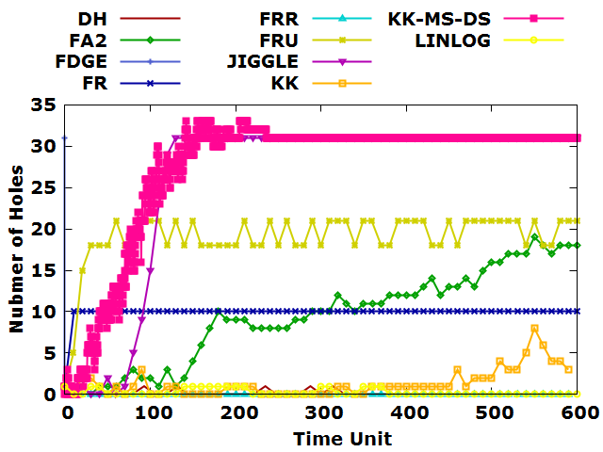

(b)

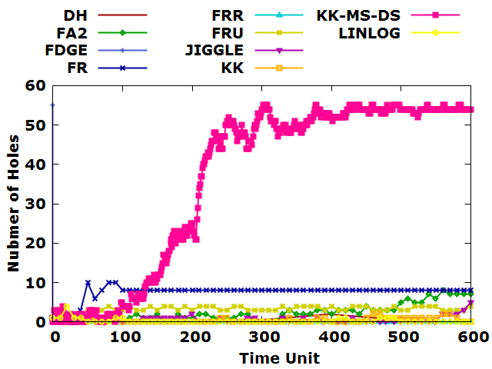

(c)

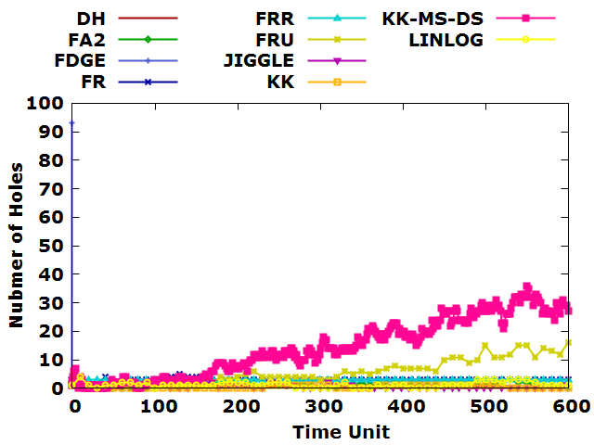

(d)

Figure 38: Hole Count Statistics of (a) 500, (b) 1000, (c) 2000, (d) 3000 nodes and average degree 8 in uniform sensor networks.

Table 11: Mean, standard deviation, maximum and minimum hole count of average degree 8 in uniform sensor network.

|  |  |  |  |  |  |  |
| --- | --- | --- | --- | --- | --- | --- |
| **Average Degree** | **Number of Nodes** | **Force-directed algorithm** | **Standard Deviation of Hole Count** | **Mean of Hole Count** | **Maximum Hole Count** | **Minimum Hole Count** |
| 8 | 500 | DH | 0 | 0 | 0 | 0 |
| FA2 | 2.089725 | 11.35 | 12 | 2 |
| FDGE | 0 | 12 | 12 | 12 |
| FR | 0 | 8 | 8 | 8 |
| FRR | 0 | 1 | 1 | 1 |
| FRU | 0 | 8 | 8 | 8 |
| JIGGLE | 0.911322 | 10.88136 | 11 | 4 |
| KK | 1.684426 | 11.67968 | 12 | 0 |
| KK-MS-DS | 3.979638 | 10.08475 | 12 | 0 |
| LINLOG | 0 | 0 | 0 | 0 |
| 1000 | DH | 0.321038 | 0.113636 | 1 | 0 |
| FA2 | 5.551607 | 9.6 | 19 | 0 |
| FDGE | 0 | 31 | 31 | 31 |
| FR | 0 | 10 | 10 | 10 |
| FRR | 0 | 0 | 0 | 0 |
| FRU | 2.46392 | 19.28333 | 21 | 5 |
| JIGGLE | 10.57354 | 26.21667 | 31 | 0 |
| KK | 8.527255 | 27.13471 | 33 | 0 |
| KK-MS-DS | 1.644643 | 1.322034 | 8 | 0 |
| LINLOG | 0.436667 | 0.25 | 1 | 0 |
| 2000 | DH | 0.726483 | 0.555556 | 2 | 0 |
| FA2 | 2.258631 | 2.316667 | 8 | 0 |
| FDGE | 0 | 55 | 55 | 55 |
| FR | 1.823497 | 7.616667 | 10 | 0 |
| FRR | 0 | 0 | 0 | 0 |
| FRU | 0.880421 | 3.266667 | 4 | 0 |
| JIGGLE | 0.956098 | 0.633333 | 5 | 0 |
| KK | 21.48377 | 36.79087 | 55 | 0 |
| KK-MS-DS | 0.699273 | 0.55 | 3 | 0 |
| LINLOG | 0.620734 | 0.233333 | 4 | 0 |
| 3000 | DH | 0.5 | 0.25 | 1 | 0 |
| FA2 | 0.758381 | 1.033333 | 3 | 0 |
| FDGE | 0 | 93 | 93 | 93 |
| FR | 0.829369 | 2.916667 | 5 | 0 |
| FRR | 0 | 3 | 3 | 3 |
| FRU | 4.529252 | 5.833333 | 16 | 0 |
| JIGGLE | 0.865373 | 0.616667 | 3 | 0 |
| KK | 10.14871 | 14.46132 | 36 | 0 |
| KK-MS-DS | 0.499717 | 0.433333 | 1 | 0 |
| LINLOG | 0.993055 | 1.216667 | 4 | 0 |

Figure 38 illustrated the experimental results of force-directed algorithms in terms of variant number of nodes and a specific average degree. The experimental result of force-directed algorithms was plotted against the average degree 10 and with number of nodes 500, 1000, 2000 and 3000 in uniform sensor network. The experimental result showed that there are few number of holes existed in datasets when the average degree is 10. FR, LinLog and KK-MS-DS algorithms detected about 2 holes when the number of nodes is 500. For the number of node in 1000, 2000 and 3000, KK-MS-DS algorithm captured the highest number of holes. Moreover, we summarized the mean, minimum and maximum count of holes in Table 12.

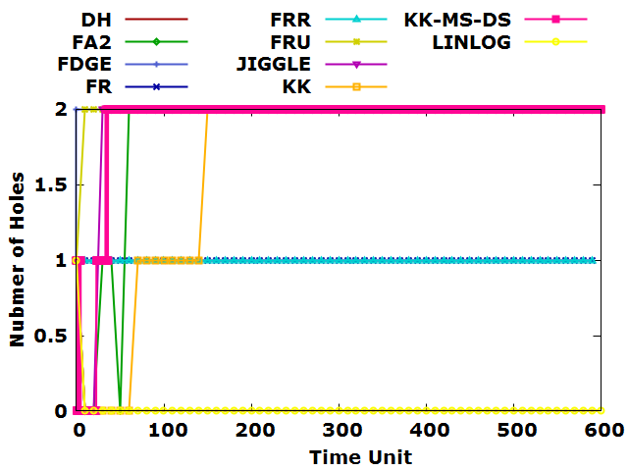

(a)

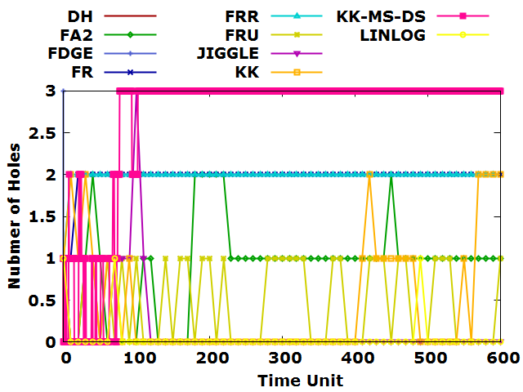

(b)

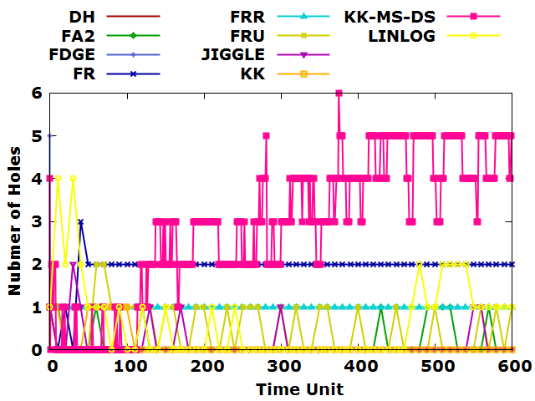

(c)

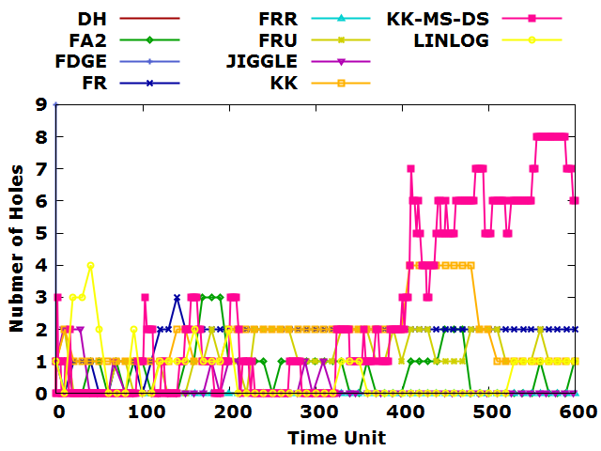

(d)

Figure 39 Hole Count Statistics of (a) 500, (b) 1000, (c) 2000, (d) 3000 nodes and average degree 10 in uniform sensor networks.

Table 12: Mean, standard deviation, maximum and minimum hole count of average degree 10 in uniform sensor network.

|  |  |  |  |  |  |  |
| --- | --- | --- | --- | --- | --- | --- |
| **Average Degree** | **Number of Nodes** | **Force-directed algorithm** | **Standard Deviation of Hole Count** | **Mean of Hole Count** | **Maximum Hole Count** | **Minimum Hole Count** |
| 10 | 500 | DH | 0 | 0 | 0 | 0 |
| FA2 | 0.471886 | 1.864407 | 2 | 0 |
| FDGE | 0 | 2 | 2 | 2 |
| FR | 0 | 1 | 1 | 1 |
| FRR | 0 | 1 | 1 | 1 |
| FRU | 0 | 2 | 2 | 2 |
| JIGGLE | 0.365042 | 1.932203 | 2 | 0 |
| KK | 0.371136 | 1.915152 | 2 | 0 |
| KK-MS-DS | 0.65527 | 1.666667 | 2 | 0 |
| LINLOG | 0 | 0 | 0 | 0 |
| 1000 | DH | 0 | 0 | 0 | 0 |
| FA2 | 0.561223 | 0.916667 | 2 | 0 |
| FDGE | 0 | 3 | 3 | 3 |
| FR | 0.129099 | 1.983333 | 2 | 1 |
| FRR | 0 | 2 | 2 | 2 |
| FRU | 0.503098 | 0.466667 | 1 | 0 |
| JIGGLE | 0.45442 | 0.116667 | 3 | 0 |
| KK | 0.8589 | 2.671264 | 3 | 0 |
| KK-MS-DS | 0.699273 | 0.45 | 2 | 0 |
| LINLOG | 0.18102 | 0.033333 | 1 | 0 |
| 2000 | DH | 0 | 0 | 0 | 0 |
| FA2 | 0.360085 | 0.15 | 1 | 0 |
| FDGE | 0 | 5 | 5 | 5 |
| FR | 0.406167 | 1.933333 | 3 | 0 |
| FRR | 0 | 1 | 1 | 1 |
| FRU | 0.566484 | 0.466667 | 2 | 0 |
| JIGGLE | 0.389118 | 0.133333 | 2 | 0 |
| KK | 1.697162 | 2.836735 | 6 | 0 |
| KK-MS-DS | 0.323732 | 0.116667 | 1 | 0 |
| LINLOG | 0.935641 | 0.65 | 4 | 0 |
| 3000 | DH | 0 | 0 | 0 | 0 |
| FA2 | 0.78312 | 0.716667 | 3 | 0 |
| FDGE | 0 | 9 | 9 | 9 |
| FR | 0.5928 | 1.766667 | 3 | 0 |
| FRR | 0 | 0 | 0 | 0 |
| FRU | 0.724081 | 1.133333 | 2 | 0 |
| JIGGLE | 0.514205 | 0.2 | 2 | 0 |
| KK | 2.68359 | 2.4375 | 8 | 0 |
| KK-MS-DS | 0.97714 | 1.833333 | 4 | 1 |
| LINLOG | 0.886815 | 0.6 | 4 | 0 |

Figure 39 illustrated the experimental results of force-directed algorithms in terms of variant number of nodes and a specific average degree. The experimental result of force-directed algorithms was plotted against the average degree 12 and with number of nodes 500, 1000, 2000 and 3000 in uniform sensor network. No holes existed in the dataset with the average degree 12. Therefore, if any holes are detected from the layout of force-directed algorithm which indicates that the layout of force-directed algorithm fails to recover to the layout in ground truth dataset. That mean, the layout of force-directed algorithm and the ground truth may look totally different. Moreover, we summarized the mean, minimum and maximum count of holes in Table 13.

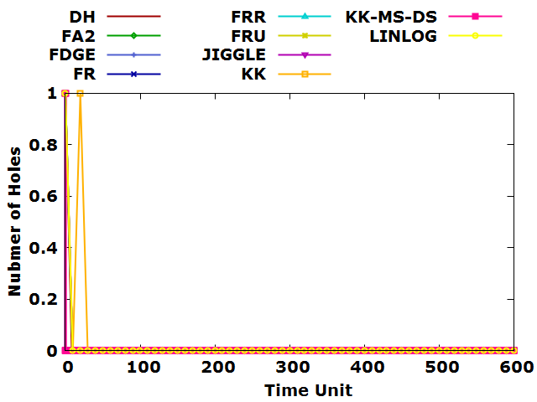

(a)

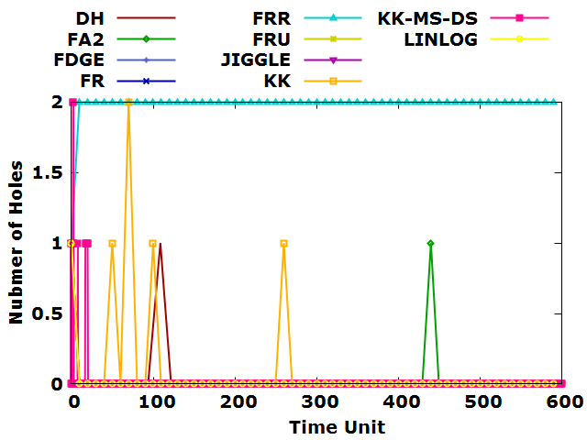

(b)

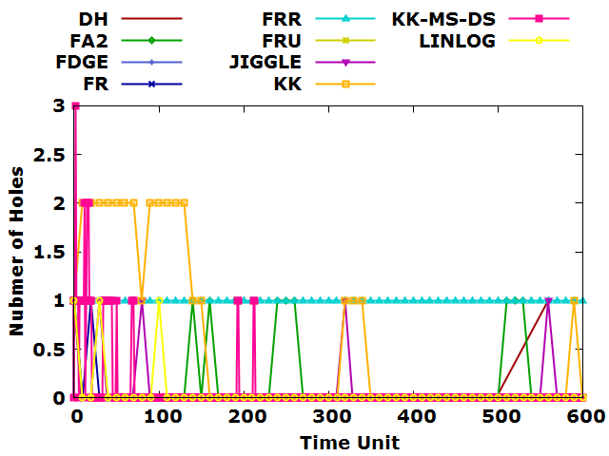

(c)

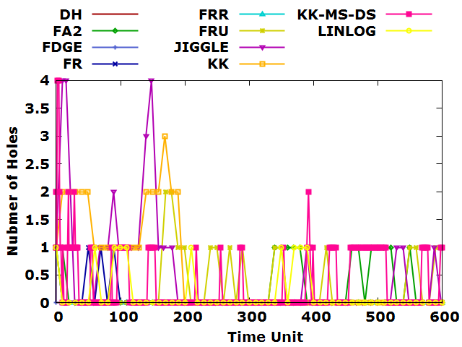

(d)

Figure 40 Hole Count Statistics of (a) 500, (b) 1000, (c) 2000, (d) 3000 nodes and average degree 12 in uniform sensor networks.

Table 13: Mean, standard deviation, maximum and minimum hole count of average degree 12 in uniform sensor network.

|  |  |  |  |  |  |  |
| --- | --- | --- | --- | --- | --- | --- |
| **Average Degree** | **Number of Nodes** | **Force-directed algorithm** | **Standard Deviation of Hole Count** | **Mean of Hole Count** | **Maximum Hole Count** | **Minimum Hole Count** |
| 12 | 500 | DH | 0 | 0 | 0 | 0 |
| FA2 | 0 | 0 | 0 | 0 |
| FDGE | 0 | 0 | 0 | 0 |
| FR | 0 | 0 | 0 | 0 |
| FRR | 0 | 0 | 0 | 0 |
| FRU | 0 | 0 | 0 | 0 |
| JIGGLE | 0 | 0 | 0 | 0 |
| KK | 0.017834 | 0.000318 | 1 | 0 |
| KK-MS-DS | 0.129099 | 0.016667 | 1 | 0 |
| LINLOG | 0 | 0 | 0 | 0 |
| 1000 | DH | 0.145865 | 0.021277 | 1 | 0 |
| FA2 | 0.129099 | 0.016667 | 1 | 0 |
| FDGE | 0 | 0 | 0 | 0 |
| FR | 0 | 0 | 0 | 0 |
| FRR | 0 | 2 | 2 | 2 |
| FRU | 0 | 0 | 0 | 0 |
| JIGGLE | 0 | 0 | 0 | 0 |
| KK | 0.125495 | 0.012719 | 2 | 0 |
| KK-MS-DS | 0.334039 | 0.083333 | 2 | 0 |
| LINLOG | 0 | 0 | 0 | 0 |
| 2000 | DH | 0.316228 | 0.1 | 1 | 0 |
| FA2 | 0.342803 | 0.133333 | 1 | 0 |
| FDGE | 0 | 0 | 0 | 0 |
| FR | 0.129099 | 0.016667 | 1 | 0 |
| FRR | 0 | 1 | 1 | 1 |
| FRU | 0 | 0 | 0 | 0 |
| JIGGLE | 0.251549 | 0.066667 | 1 | 0 |
| KK | 0.333395 | 0.090909 | 3 | 0 |
| KK-MS-DS | 0.812856 | 0.516667 | 2 | 0 |
| LINLOG | 0.18102 | 0.033333 | 1 | 0 |
| 3000 | DH | 0 | 0 | 0 | 0 |
| FA2 | 0.41545 | 0.216667 | 1 | 0 |
| FDGE | 0 | 0 | 0 | 0 |
| FR | 0.219784 | 0.05 | 1 | 0 |
| FRR | 0 | 0 | 0 | 0 |
| FRU | 0.523731 | 0.283333 | 2 | 0 |
| JIGGLE | 1 | 0.5 | 4 | 0 |
| KK | 0.609626 | 0.362934 | 4 | 0 |
| KK-MS-DS | 0.833446 | 0.516667 | 3 | 0 |
| LINLOG | 0.360085 | 0.15 | 1 | 0 |

Figure 40 illustrated the experimental results of force-directed algorithms in terms of variant number of nodes and a specific average degree. The experimental result of force-directed algorithms was plotted against the average degree 15 and with number of nodes 500, 1000, 2000 and 3000 in uniform sensor network. No holes existed in the dataset with the average degree 15. Therefore, if any holes are detected from the layout of force-directed algorithm which indicates that the layout of force-directed algorithm fails to recover to the layout in ground truth dataset. That mean, the layout of force-directed algorithm and the ground truth may look totally different. Moreover, we summarized the mean, minimum and maximum count of holes in Table 14.

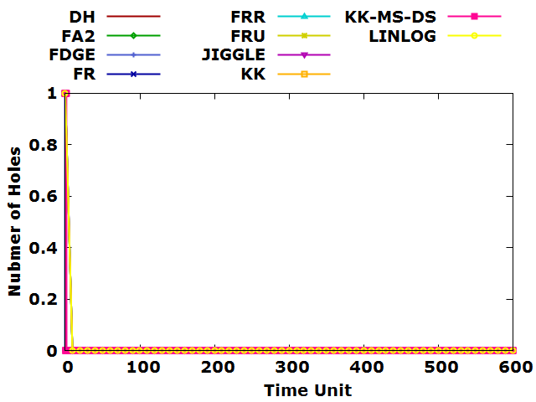

(a)

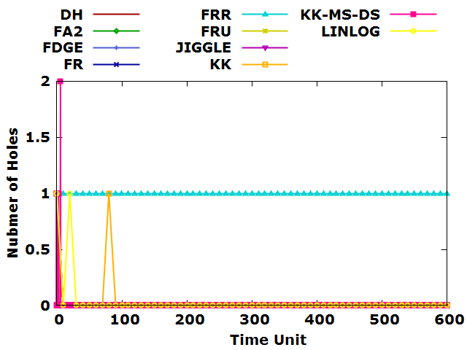

(b)

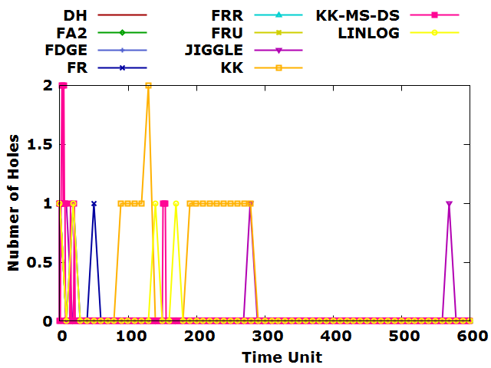

(c)

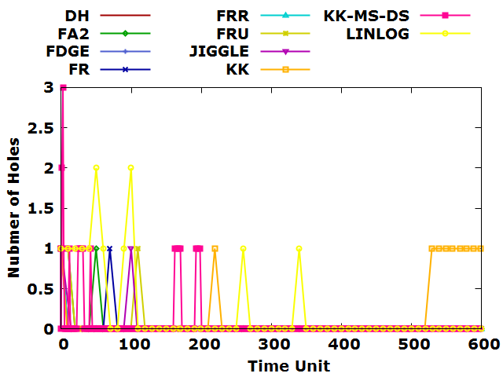

(d)

Figure 41 Hole Count Statistics of (a) 500, (b) 1000, (c) 2000, (d) 3000 nodes and average degree 15 in uniform sensor networks.

Table 14: Mean, standard deviation, maximum and minimum hole count of average degree 15 in uniform sensor network.

|  |  |  |  |  |  |  |
| --- | --- | --- | --- | --- | --- | --- |
| **Average Degree** | **Number of Nodes** | **Force-directed algorithm** | **Standard Deviation of Hole Count** | **Mean of Hole Count** | **Maximum Hole Count** | **Minimum Hole Count** |
| 15 | 500 | DH | 0 | 0 | 0 | 0 |
| FA2 | 0 | 0 | 0 | 0 |
| FDGE | 0 | 0 | 0 | 0 |
| FR | 0 | 0 | 0 | 0 |
| FRR | 0 | 0 | 0 | 0 |
| FRU | 0 | 0 | 0 | 0 |
| JIGGLE | 0 | 0 | 0 | 0 |
| KK | 0.041783 | 0.001748 | 1 | 0 |
| KK-MS-DS | 0 | 0 | 0 | 0 |
| LINLOG | 0 | 0 | 0 | 0 |
| 1000 | DH | 0 | 0 | 0 | 0 |
| FA2 | 0 | 0 | 0 | 0 |
| FDGE | 0 | 0 | 0 | 0 |
| FR | 0 | 0 | 0 | 0 |
| FRR | 0 | 1 | 1 | 1 |
| FRU | 0 | 0 | 0 | 0 |
| JIGGLE | 0 | 0 | 0 | 0 |
| KK | 0.080043 | 0.004587 | 2 | 0 |
| KK-MS-DS | 0.129099 | 0.016667 | 1 | 0 |
| LINLOG | 0.129099 | 0.016667 | 1 | 0 |
| 2000 | DH | 0 | 0 | 0 | 0 |
| FA2 | 0 | 0 | 0 | 0 |
| FDGE | 0 | 0 | 0 | 0 |
| FR | 0.18102 | 0.033333 | 1 | 0 |
| FRR | 0 | 0 | 0 | 0 |
| FRU | 0 | 0 | 0 | 0 |
| JIGGLE | 0.219784 | 0.05 | 1 | 0 |
| KK | 0.227802 | 0.038741 | 2 | 0 |
| KK-MS-DS | 0.482461 | 0.266667 | 2 | 0 |
| LINLOG | 0.219784 | 0.05 | 1 | 0 |
| 3000 | DH | 0 | 0 | 0 | 0 |
| FA2 | 0.18102 | 0.033333 | 1 | 0 |
| FDGE | 0 | 0 | 0 | 0 |
| FR | 0.129099 | 0.016667 | 1 | 0 |
| FRR | 0 | 0 | 0 | 0 |
| FRU | 0.18102 | 0.033333 | 1 | 0 |
| JIGGLE | 0.18102 | 0.033333 | 1 | 0 |
| KK | 0.333245 | 0.084034 | 3 | 0 |
| KK-MS-DS | 0.360085 | 0.15 | 1 | 0 |
| LINLOG | 0.480113 | 0.2 | 2 | 0 |

1. Ethics and Professional Conduct

There are privacy issues with data aspects. The input is a sensor network which may represent a network structure of an application or company, etc. The output is the holes and nodes of the holes of the input sensor network, this is a serious security issue if exposed. It is possible that hackers can attack the whole system from the hole. In a military application, the holes may to be used by the enemy and bury traps if the result sensor network exposed. Moreover, our system of Hole Detection does not retain user data, the most important is to ensure the user's data source and how to keep the results safely.

The program of the approach Contour Tracing Algorithm (CTA) for hole detection in sensor networks is original code, the library we used is OpenCV (Open Source Computer Vision Library). That is an open source computer vision and machine learning software library, being a BSD-licensed product, OpenCV Can be used for free in business and research. The program has been tested and debugged repeatedly, more than 30,000 run times without errors. From design to implementation, the entire system for hole detection complies with Macau law. There is no problem to ensure that the source of the data is legal and the output data is used legally.

1. Conclusion

We presented an approach of hole detection by CTA that based on image processing for the sensor networks. According to our experiments, CTA achieve high accuracy on detecting holes in sensor networks. The approach of hole detection by CTA include realizing automatic scale node coordinates and calculating suitable canvas, outputting visualized hole-marked image and the text file with nodes of holes.

The main idea of CTA is contour detection and recognize nodes on the boundary of hole. In the first step, pre-processing the data for hole detection. In the second step, detect the contoured area and find the matching nodes on contour. In the last step, draw the image of sensor network have been hole-marked.

There are two performance evaluations of hole detection by CTA that is also based on layout of ground truth datasets and the layout of force-directed algorithms - Node Identifier Matching and Hole Count Statistics.

In performance evaluation of Node Identifier Matching, we can know from the statistical graph of the experimental results that all the accuracy of force-directed algorithms decreased in sparse and uniform sensor networks when the number of nodes increased. Nevertheless, the accuracy of KK-MS-DS algorithm always has the highest performance regardless of the average degree and number of nodes in sparse and uniform sensor network, it can reach more than 80% in most cases. Moreover, all the accuracy of force-directed algorithms increased when the average degree increased in sparse and uniform sensor network, even all reached more than 90% when the average degree is 12 or above.

About the statistical graph of recall, it can be observed that all the recall of force-directed algorithms decreased in sparse sensor network when the number of nodes increased. For example, when the average degree arrived 10, all the recall of force-directed algorithms reached 0 in uniform sensor networks.

In another performance evaluation of Hole Count Statistics, the statistical graph showed that high number of holes has been captured by KK-MS-DS, FDGE, FR, FA2, FRU, KK, JIGGLE algorithms especially when the number of nodes is less than 3000. However, DH, FRR and LinLog algorithms captured the smallest number of holes regardless of the average degree and number of nodes in sparse sensor networks.

The experimental result showed that there are few numbers of holes existed in datasets when the average degree is 10. No holes existed in the dataset with the average degree 12 and 15. Therefore, if any holes are detected from the layout of force-directed algorithm which indicates that the layout of force-directed algorithm fails to recover to the layout in ground truth dataset.

In our future works, the research attempt is to investigate an improved Sobel edge detection [21], The proposed algorithm combines Sobel edge detection operator and soft threshold wavelet denoising to perform edge detection on images containing Gaussian white noise. In addition, T.D. Haig, et al [22] describes a co-recursive algorithm obtained from the new boundary definition. The algorithm authors provide uses another method to avoid the paradox of connectivity and restores the invariance of the result in the case of color changes.

1. Reference

[1] R. Tamassia, *Handbook of graph drawing and visualization*. Chapman and Hall/CRC, 2013.

[2] S. Suzuki, "Topological structural analysis of digitized binary images by border following," *Computer vision, graphics, and image processing,* vol. 30, no. 1, pp. 32-46, 1985.

[3] P. K. Sahoo, J.-P. Sheu, and K.-Y. Hsieh, "Target tracking and boundary node selection algorithms of wireless sensor networks for internet services," *Information Sciences,* vol. 230, pp. 21-38, 2013.

[4] G. Destino and G. T. F. de Abreu, "Network boundary recognition via graph-theory," in *2008 5th Workshop on Positioning, Navigation and Communication*, 2008, pp. 271-275: IEEE.

[5] S. Funke, "Topological hole detection in wireless sensor networks and its applications," in *Proceedings of the 2005 joint workshop on Foundations of mobile computing*, 2005, pp. 44-53.

[6] K.-Y. Hsieh and J.-P. Sheu, "Hole detection and boundary recognition in wireless sensor networks," in *2009 IEEE 20th International Symposium on Personal, Indoor and Mobile Radio Communications*, 2009, pp. 72-76: IEEE.

[7] Y. Wang, J. Gao, and J. S. Mitchell, "Boundary recognition in sensor networks by topological methods," in *Proceedings of the 12th annual international conference on Mobile computing and networking*, 2006, pp. 122-133.

[8] A. Dabba and R. Beghdad, "BCP: A Border Coverage Protocol for wireless sensor networks," in *2014 Science and Information Conference*, 2014, pp. 632-640: IEEE.

[9] I. M. Khan, M. Z. Khan, H. Mokhtar, and M. Merabti, "Enhancements of the self-detection scheme for boundary recognition in wireless sensor networks," in *2011 Developments in E-systems Engineering*, 2011, pp. 448-453: IEEE.

[10] T. M. Fruchterman and E. M. Reingold, "Graph drawing by force‐directed placement," *Software: Practice and experience,* vol. 21, no. 11, pp. 1129-1164, 1991.

[11] T. Kamada and S. Kawai, "An algorithm for drawing general undirected graphs," *Information processing letters,* vol. 31, no. 1, pp. 7-15, 1989.

[12] R. Davidson and D. Harel, "Drawing graphs nicely using simulated annealing," *ACM Transactions on Graphics (TOG),* vol. 15, no. 4, pp. 301-331, 1996.

[13] M. Jacomy, T. Venturini, S. Heymann, and M. Bastian, "ForceAtlas2, a continuous graph layout algorithm for handy network visualization designed for the Gephi software," *PloS one,* vol. 9, no. 6, 2014.

[14] D. Holten and J. J. Van Wijk, "Force‐directed edge bundling for graph visualization," in *Computer graphics forum*, 2009, vol. 28, no. 3, pp. 983-990: Wiley Online Library.

[15] A. Efrat, D. Forrester, A. Iyer, S. G. Kobourov, C. Erten, and O. Kilic, "Force-directed approaches to sensor localization," *ACM Transactions on Sensor Networks (TOSN),* vol. 7, no. 3, pp. 1-25, 2010.

[16] S.-H. Cheong and Y.-W. Si, "CWBound: boundary node detection algorithm for complex non-convex mobile ad hoc networks," *The Journal of Supercomputing,* vol. 74, no. 10, pp. 5558-5577, 2018.

[17] D. Tunkelang, "JIGGLE: Java interactive graph layout environment," in *International Symposium on Graph Drawing*, 1998, pp. 413-422: Springer.

[18] A. Noack, "Energy Models for Graph Clustering," *J. Graph Algorithms Appl.,* vol. 11, no. 2, pp. 453-480, 2007.

[19] S.-H. Cheong and Y.-W. Si, "Accelerating the Kamada-Kawai algorithm for boundary detection in a mobile ad hoc network," *ACM Transactions on Sensor Networks (TOSN),* vol. 13, no. 1, pp. 1-29, 2016.

[20] S.-H. Cheong. (2017, March 2, 2020). *CNCAHNetGenerator - CNCAH Network Generator*. Available: <http://eric.lostcity-studio.com/system-design/cncahnetgenerator-cncah-network-generator/>

[21] Wenshuo Gao, Xiaoguang Zhang, Lei Yang and Huizhong Liu, "An improved Sobel edge detection," 2010 3rd International Conference on Computer Science and Information Technology, Chengdu, 2010, pp. 67-71, doi: 10.1109/ICCSIT.2010.5563693.

[22] T. D. Haig, Y. Attikiouzel and M. D. Alder, "Border following: new definition gives improved borders," in IEE Proceedings I - Communications, Speech and Vision, vol. 139, no. 2, pp. 206-211, April 1992, doi: 10.1049/ip-i-2.1992.0029.

1. Appendix

The pseudo code of reading the input file in Algorithm 2

Algorithm 2.  Pseudo code of $DatasetParser()$

$$Open file f$$

$$foreach line l in f do \{$$

$$nodes ←Parse nodes from the l;$$

$$edges ←Parse edges from the l;$$

$$foreach n ∈nodes do \{$$

$$l_{coor}←n$$

$$\}$$

$$foreach e ∈edges do \{$$

$$l_{edge}←e$$

$$\}$$

$$\}$$

Algorithm 2 Pseudo code of CTA

The pseudo code of handling the coordinate of node to positive in Algorithm 3

Algorithm 3.  Pseudo code of $shiftCoorPositive()$

$$foreach u ∈l_{coor}do \{$$

$$Cx← u_{x}$$

$$Cy← u_{y}$$

$$\}$$

$$\min_{x}←The minimum value in Cx$$

$$\min_{y}←The minimum value in Cy$$

$$if \min_{x}< 0 then \{$$

$$foreach u ∈l_{coor} do \{$$

$Cx=Cx+\min_{x}* -1$*/*shift the coordinate*/*

$$\}$$

$$\}$$

$if \min_{y}< 0 then \{$

$$foreach u ∈l_{coor} do \{$$

$Cy=Cy+\min_{y}* -1$*/*shift the coordinate*/*

$$\}$$

$$\}$$

Algorithm 3 Pseudo code of CTA

The pseudo code of enlarging the coordinate in Algorithm 4

Algorithm 4.  Pseudo code of $enlargeCoor()$

$$canvas size=node size*number of node$$

$$node ratio=min((canvas size/\min_{x}), (canvas size/\min_{y}))$$

$$initialize the origin O←\left(0,0\right)$$

$$foreach u ∈l_{coor} do \{$$

$$// scale the u_{x} and u_{y} to fit the canvas size$$

$$u_{x}=O_{x}+node ratio*\left(u_{x}-O_{x}\right)$$

$$u_{y}=O_{y}+node ratio*(u_{y}-O_{y})$$

$$\}$$

Algorithm 4 Pseudo code of CTA

The pseudo code of calculating the minimum area for hole detection in Algorithm 5

Algorithm 5.  Pseudo code of $calMinArea()$

$$// when number of nodes is 1000, the canvas size is 4000 * 4000, and the minimum area is 5000 pixels$$

$ratio of mimimum area=5000/4000$

$$// calculate the mimimum area for hole detection according to the canvas size$$

$${area}_{min}=ratio of mimimum area*canvas size$$

Algorithm 5 Pseudo code of CTA

The pseudo code of drawing edges on the canvas in Algorithm 6

Algorithm 6.  Pseudo code of $drawAllEdges()$

$$initialize the C_{tmp} be a temporary canvas$$

$$foreach e ∈l_{edge} do \{$$

$$let u, v be the start and end nodes of the edge e$$

$$draw a line between nodes u and v on C_{tmp}$$

$$\}$$

Algorithm 6 Pseudo code of CTA

The pseudo code of finding the hole in Algorithm 7

Algorithm 7.  Pseudo code of

<https://felixniklas.com/imageprocessing/binarization>)

Algorithm 7 Pseudo code of CTA

The pseudo code ofdraw and output the result image in Algorithm 8

Algorithm 10.  Pseudo code output a bitmap of holes BitmapOut()

$$Input:Edges of sensor network l_{edge}$$

$$Input:Holes of sensor network l_{hole }$$

$$Output:a bitmap of the layout of sensor network C_{output}$$

$$//draw and output the result image$$

$$Create a new canvas C_{output} for result showing$$

$$foreach e ∈l_{edge}do \{$$

$$let u, v be the start and end nodes of the edge e$$

$$draw a line between nodes u and v$$

$$\}$$

$$foreach h∈l_{hole } do \{$$

$$draw the contours with h$$

$$put an order number in the middle of h$$

$$\}$$

$$foreach u ∈l_{node}do \{$$

$$draw u on C_{output} at the poisiton (u.x, u.y).$$

$$\}$$

**return $C_{output}$** ;

Algorithm 8 Pseudo code of bitmap output of holes

The pseudo code of finding the matching node id on hole in Algorithm 9

Algorithm 9.  Pseudo code of $holeNodeOut()$

$$initialize l_{ node of one hole } to store the node of one hole$$

$$foreach {a∈l}_{contour} do \{$$

$$foreach u ∈l_{node}do \{$$

$$if u on the a then \{$$

$$l_{ node of one hole }←u$$

$\}$

$\}$

$$if count( l_{ node of one hole })>3 then \{$$

$$l_{hole node}← l_{ node of one hole }$$

$\}$

$$\}$$

$$sort l_{hole }from ascending order$$

$$// output node id$$

$$foreach u ∈l_{hole node}do \{$$

$$write u on T_{output}$$

$$\}$$

**return $T_{output}$** ;

Algorithm 9 Pseudo code of CTA